**Module 5 – Nuclear and Atomic Physics: Quiz 2a**

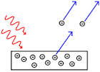

1. Find the energy of 520 nm light photons in eV.
2. What is the minimum frequency of light needed to make photoelectrons when this light strikes a metal with a work function of 2.25 eV? What wavelength light is this in nm?

Answers:

1. 



1. 