**Electrostatics Notes**

1 – Charges and Coulomb’s Law

* Matter is made of particles which are ________________ or ______________ charged.
* The unit of charge is the __________________ ( )
* Charges are ________________, meaning that they cannot be…

It is thought that the total charge of the entire universe is constant and neutral.

* Charges are also ____________, meaning that they occur in finite packages.

The smallest unit of charge is called the _________________ _______________ which is equal to the charge on one proton (+) or one electron (-).

Coulomb determined that the force between two charged objects is proportional to their charges   
and inversely proportional to the square of their distances or:

Where: q1 =

q2 =

r =

k =

There are four important things to notice from this equation.

* ________________________________________________________________
* ________________________________________________________________
* ________________________________________________________________
* ________________________________________________________________

There is a very important difference between gravitational and electrostatic forces:

Gravity ALWAYS…

Electrostatic force can…

When solving for electrostatic forces we will NOT…

Instead we will determine the direction of the force based on…

Example:

Two point charges of 1.8x10-6 C and 2.4x10-6 C produce a force of 2.2x10-3 N on each other. How far apart are these two charges?

Example:

Two 85 kg students are 1.0 m apart. What is the gravitational force between them?

If these two students each have a charge of 2.0x10-3 C, what is the electrostatic force between them?

Example:

A charge of 1.7x10-6 C is placed 2.0x10-2 m from a charge of 2.5x10-6 C and 3.5x10-2 m from a charge of -2.0x10-6 as shown.

What is the net electric force on the 1.7x10-6 charge?

1.7x10-6 C

2.5x10-6 C

-2.0x10-6 C

**Electrostatics Notes**

2 – Electric Field on a Single Charge

There are many similarities between **gravitational** and *electrostatic* forces. One such similarity is that both forces can be exerted on objects that are not in contact.

In the same way that any mass is surrounded by a **gravitational field**, we will imagine that any charged object is surrounded by an **electric field**.

Similar to gravitational fields, an electric field will depend on:

_____________________ and ______________________ the charge.

In fact we define an electric field as the force per unit charge:

Where: E =

FE =

q =

We can substitute in Coloumb’s Law to get:

In the case of electric fields we are dealing with another example of a ______________ ________________.

Therefore the field is a ____________________ ___________________.

In order to show this we always draw the field lines as ______________.

Again there is an important difference between gravitational fields and electric fields due to the fact that…

We therefore define the direction of an electric field as…

Example:

What is the electric field strength at a point where a -2.00 uC charge experiences an electric force of 5.30x10-4 N?

Example:

At a distance of 7.50x10-1 m from a small charged object the electric field strength is 2.10x104 N/C. At what distance from this same object would the electric field strength be 4.20x104 N/C?

3 – Electric Field from Multiple Charges

We have already seen how charged particles emit electric fields, but how do these fields interact when two or more charges act on each other?

Consider two positively charged particles: Now, two negatively charged particles:

Note that the electric field lines point _________ _____________ _______________. Because this electric field is a force field, it is a vector. So when multiple fields overlap we simply ____________

OK, now try two opposite charges:

Again the two fields interact, only this time they_________________________

Example:

Two 5.25 uC charges are 0.40 m apart. What is the strength of the electric field between them at a point 0.10 m away from the first charge and 0.30 m away from the second?

Example:

What is the strength of an electric field midway between a 2.00 uC charge and a -4.00 uC that are 0.60 m apart?

Example:

Find the magnitude and direction of the electric field at the point P due to the charges as shown.

6.0 m

4.5 m

**P**

Suppose that a proton was placed at point P. What would its initial acceleration be?

**Electrostatics Notes**

4 – Electric Potential and Electric Potential Energy

First let’s examine **electric potential energy**. If a charged object is in an electric field it has electric potential energy - that is it has the potential to move in that field. Note that the potential energy it has could be used to…

A non-uniform field, such as that provided by a point, is one which has a different…

In this case we can derive a formula for the electric potential energy in a NON-UNIFORM FIELD:

Again note the similarities between…

Example:

How much work must be done to bring a 4.0 uC charged object to within 1.0 m of a 6.0 uC charged object from a long way away?

NOTE:

1. Potential energy is a …
2. We **WILL** …

In this case, bringing a positive charge near another positive charge requires ______________ therefore the work is ____________________.

Example:

How much work is done when a -7.0 uC charged object is brought to within 0.5 m of a 5.0 uC charged object from a long way away?

In this case, bringing a negative charge near a positive charge ______________________ energy therefore work is _____________________.

Electric Potential

Now we need to consider a new quantity, electric potential (V). Electric potential is defined as the electric potential energy per unit charge.

Which becomes,

**NOTE**:

1. The electric potential is defined in terms of the moving of a positive charge. Therefore…

+ charges…

- charges...

1. The unit for potential is…

1

2

3

**P**

5.0 cm

7.0 cm

5.0 cm

4.0 uC

40o

50o

-2.0 uC

3.0 uC

Example:

Calculate the potential at point P as shown in the diagram.

NOTE:

1. Potentials are…
2. We WILL use…

**Electrostatics Notes**

5 – Equipotential Lines and Changes in Energy

Equipotential Lines

* As a charge moves along an electric field line, work is done by the electrical force. The energy gained or lost by this charge moving in the field is a form of *potential energy*, and so associated with the electric field is an *electric potential*, V, which has units of Energy per charge or Joules per Coulomb (also call Volts).
* Since voltage is potential energy per unit charge, voltage increases when going from a negative charge towards a positive charge. (The kinetic energy of a positive charge would increase when going from a higher potential to a lower potential.)
* A surface along which the potential is constant is called an *Equipotential*. On a piece of paper, the equipotential is represented by a line on which the voltage is constant.

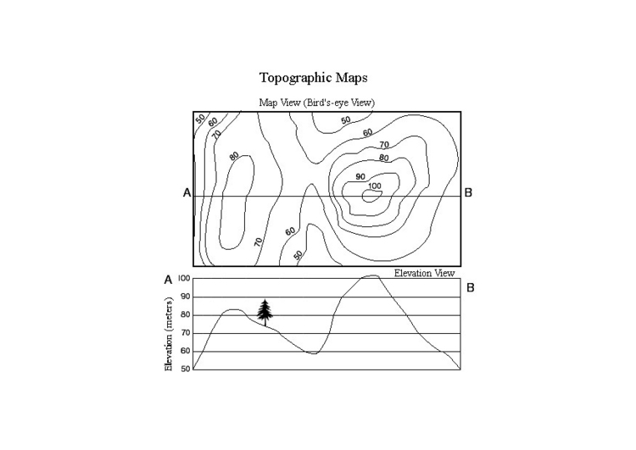

Topographical Maps:

* Since gravitational potential energy depends on height, lines of constant height would be gravitational equipotentials. A map of such lines is called a topographical map. Typically, a topographical map shows equally spaced lines of constant elevation.
* Where the lines are most closely spaced the elevation is changing most sharply, in other words the terrain is steep.

Potential Difference

We sometimes want to determine the electric potential between two points. This is known as the **potential difference**.

For example, given two points A and B, the potential difference between A and B is:

NOTE: When we talk about potential at a point we are talking about the potential difference between that point and infinity, where the potential at infinity is ZERO.

Example: What is the potential difference between points A and B due to the charge shown?

A

B

8.00 uC

1.00 m

0.50 m

Changes in Energy

A 4.0 x10-9 C charge of mass 2.4 x10-21 kg, is initially located at point **A**, 3.0 m from a stationary 6.0x10-8 C charge.

a) How much work is required, by an external agent, to move the 4.0x10-9 C charge to a point **B**, 0.50 m from the stationary charge?

b) If the 4.0x10-9 C charge is now released from point **B**, what will be its velocity when it passes back through point **A**?

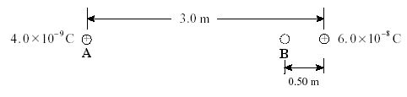

**Electrostatics Notes**

6 – Electric Potential in Uniform Electric Fields

If we examine the electric field   
between charged plates we will   
find that it is…

Notice that the density of the lines is also…

We have seen that the electric   
field surrounding a point   
charge is not uniform –   
that it…

In a uniform electric field we cannot use our previous formula:

This formula is only valid for describing the strength of non-uniform fields (point charges only!!!)

To find an equation for uniform fields, we will once again draw a parallel with gravitational potential energy.

Consider a mass sitting in a uniform *gravitational* field at some height.

The mass will tend to move from…

As it does it…

If we allow the mass to fall the work done on it (W = ) is negative. If we want to lift the mass to a certain height we need to do positive work on it.

A charged object in an electric field will behave in the same way, accelerating from an area of…

As it does it…

In the same way that we would do positive work on an object to lift it against gravity, we need to do work to bring a positive charge near a plate with positive potential.

To calculate the work done in this case we can use the formula:

W = Δ Ep = Fd

It is often easier, however, to describe the work done in a uniform field using the potential difference between the two plates.

Recall that potential difference:

∆V =

A potential difference is generated any time we have areas of high and low potential energy, just like those generated by gravitational fields.

In order to determine the electric field between two charged plates we must use the formula:

Where: E =

∆V =

d =

Example:

An electron is accelerated from rest through a potential difference of 3.00x104 V. What is the kinetic energy gained by the electron?

Example:

Calculate the electric field strength between two parallel plates that are 6.00x10-2 m apart. The potential of the top plate is 6.0 V and the bottom plate is -6.0 V.

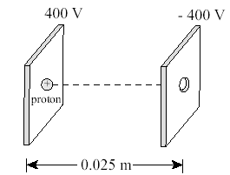

Example:

A proton, initially at rest, is released between two parallel plates as shown.

a) What is the magnitude and direction of the electric field?

b) What is the magnitude of the electrostatic force acting on the proton?

c) What is the velocity of the proton when it exits the - 400 V plate?