Chemical Bonding – Types of Bonds

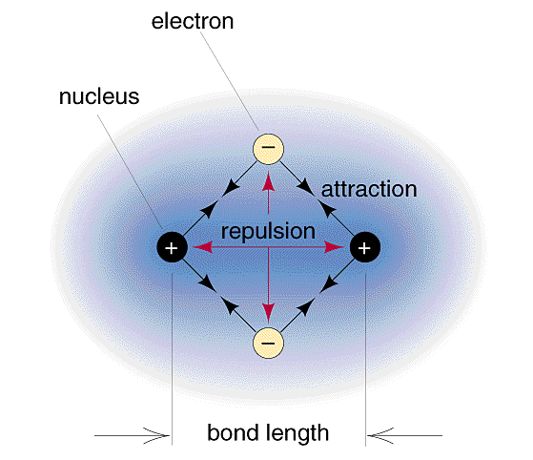
Question: What causes a chemical bond?

- The negative electron cloud of the atoms exert ______________ forces on each other
- Each nucleus begins to ______________ the approaching atom’s outer electron cloud
- If the attractive forces between the atoms are _____________ than the repulsive forces, a chemical bond forms between them

Atoms are like children when it comes to electrons…
Sharing… | Not Sharing…
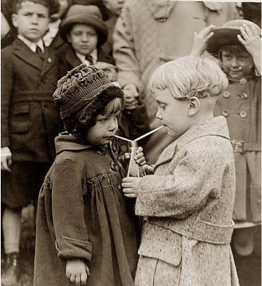 | 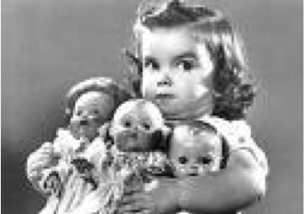
Ionic Bonding

Formed between two atoms with large differences in their _____________________ and ________________________

An electronegativity _______________________ can be classified as an _______________________

In this case we can essentially say ________________________ from one atom to another

What compound is formed when the following elements combine?

Ca and Br ____________________ ____________________

Al and O ____________________ ____________________

Be and O ____________________ ____________________

To determine the difference in electronegativity use the Absolute value of the EN difference of the two elements. Do not take subscripts or charges into consideration.

Covalent Bonding

Formed between two atoms with almost ___________________ in their ionization energies and electronegativity’s

An ________________________________________ can be classified as a covalent bond

Warning!!!! Not everything is black and white!

Ionic and covalent are the ____________________ of bonding. Think right wing and left wing extremists!

Between these extremes are covalent bonds involving ____________________

Polar Covalent Bonding

Electrons are still shared between two atoms but ____________________

Electrons are drawn closer to the atom with higher _____________________

One side of the bond has a partially ________________ “pole” and the other a partially _________________ “pole” creates a bond “dipole”

Example:
HCl

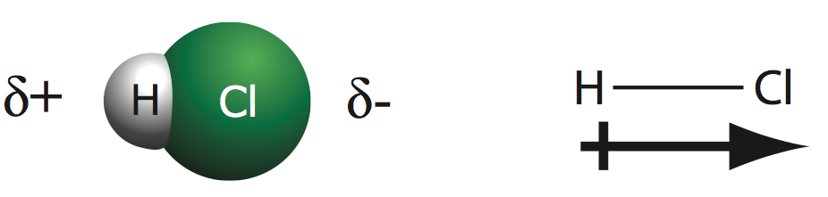
ΔEN | Bond Type
0 | Non-Polar
< 0.5 | Covalent (Mostly Non-Polar)
0.5– 1.6 | Polar Covalent
> 1.6 | Ionic

- Calculate the ΔEN value for the bonds in the following compounds. Then arrange the compounds in order from those containing bonds in which the electrons are shared most equally to those in which the electrons are shared most unequally.
a. H₂O | b. PCl₃ | c. Cl₄ | d. SiO₂ | e. AlN

- Complete the following table:

Elements | Formula | ΔEN value | Nature of Bonds | Atom Possessing Greater Electron Density
C and S
B and Cl
Al and O
N and I
Ca and F

