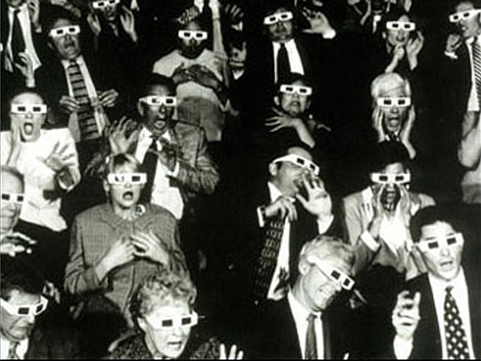
Shapes and Behaviour of Molecules 3D

In order to understand the shapes the molecules form we must adhere to the same rules we have been following throughout this section

- Electrons all have the same negative charge
- Like charges repel
- Bonded pairs surrounding the nucleus repel other bonded pairs and other electrons
- Lone pairs surrounding the nucleus repel other bonded pairs and other electrons
- Valence electrons are oriented in such a way as to be as far from each other as possible

Molecule | Shape | Molecular Geometry | Reason for Shape
BeCl₂  (AX₂) | 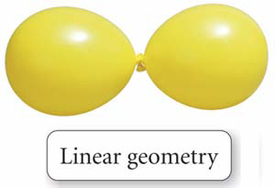
BF₃  (AX₃)  (AX₃E₂) | 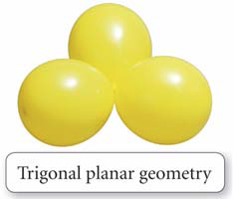
CH₄  (AX₄) | 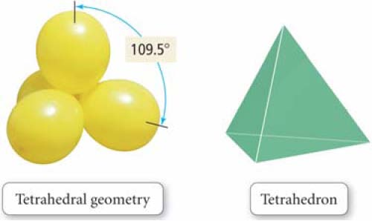
NH₃  (AX₃E) |  | 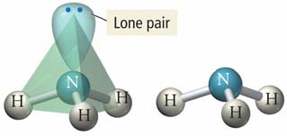
H₂O  (AX₂E₂) |  | 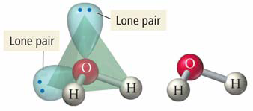
PCl₅  (AX₅)  ( | 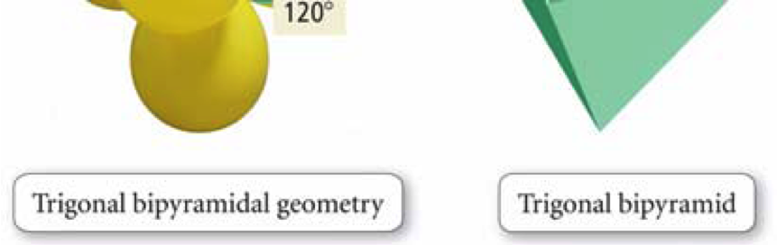  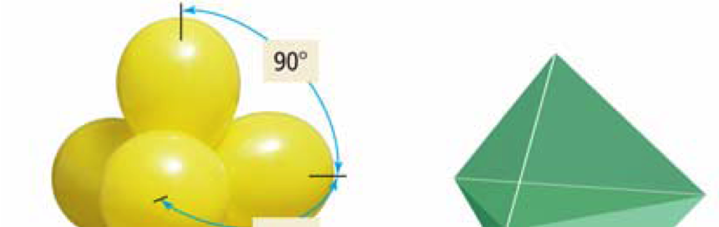
SF₆  (AX₆) | 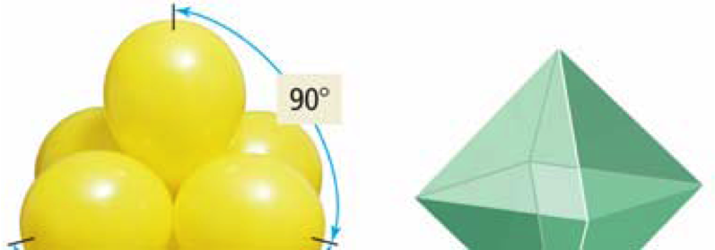  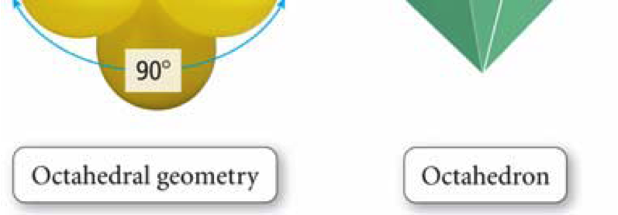
XeF₄  (AX₄E₂) |  | 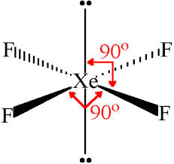
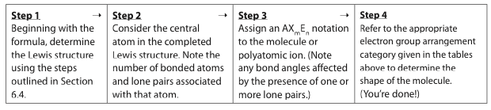
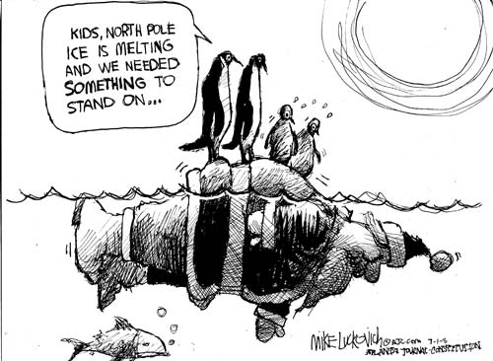
Polar vs. Non-Polar

Molecules are said to be polar is the electron density is NOT evenly spread around the molecule

This causes part of the molecule to be partially positive and part of the molecule to be partially negative

Two factors determine if a molecule is polar

- Electronegativity

- Symmetry of the Molecule

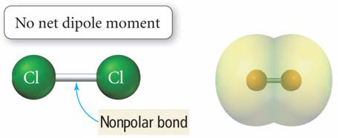

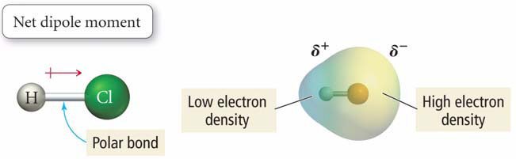

In molecules with more than one bond, the shape and the polarity of the bonds determine whether the molecule is polar.
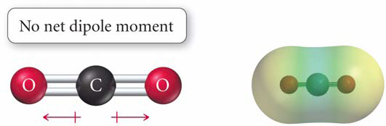
Polar or not polar? ______________________________

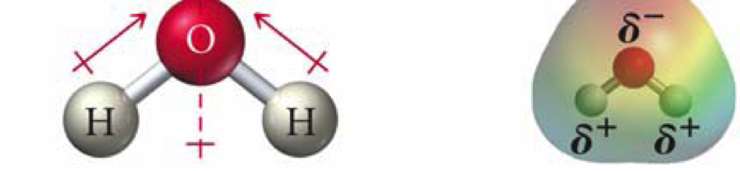
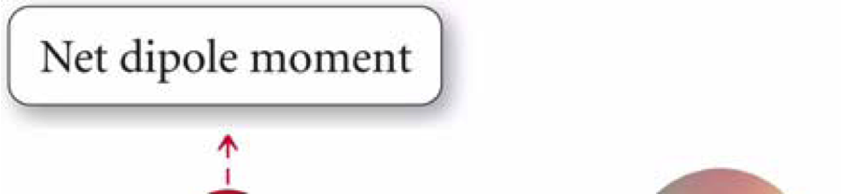

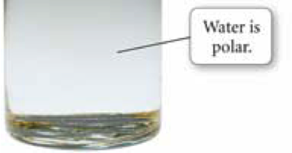
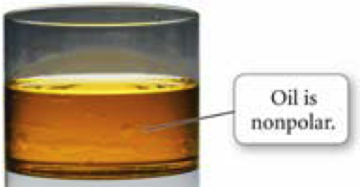
Polar or not polar? __________________

The extent of polarity depends of the size of the dipole. The dipole depends on the difference in electronegativities and the symmetry of the molecule.

Polarity Practice Worksheet

For each of the following pairs of compounds, determine which is most polar based on their Lewis structures.

1) methyl chloride (CHCl₃) or methyl bromide (CHBr₃)

2) water or hydrogen sulfide (H₂S)

3) hydrochloric acid (HCl) or hydroiodic acid (HI)

4) bromoacetylene (C₂HBr) or chloroacetylene (C₂HCl)

