|  |  |
| --- | --- |
| **Science 10 – Chemistry**  **Factors Affecting Rates of Reactions** | **Name: Date: Block:** |

## **Objectives***:*

## To review Kinetic Molecular Theory (Grade 9)

## To understand that a chemical reaction involves collisions between particles (Collision Theory)

## To be able to describe the four factors which will affect the rate of a chemical reaction.

# What is a rate of reaction? __________________________________________________________________________

# Rates of Reaction

## A chemical reaction involves a _______________________ between particles.

## The particles collide and make _______________________

## The particles which react are called the ________________________

## The substances which are made are called the ____________________________

# Kinetic Molecular Theory: (***whiteboard activity***)

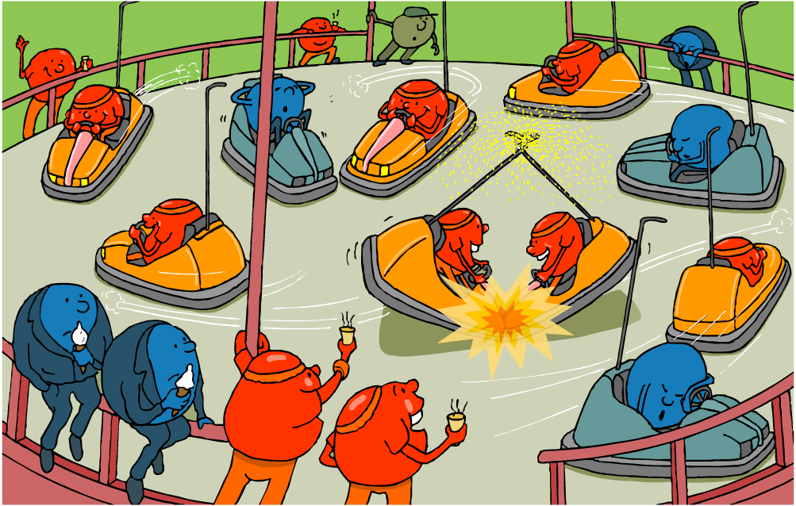

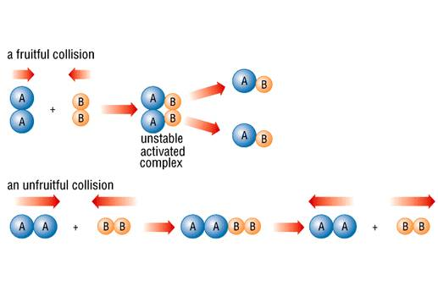When particles collide….

## Collision theory states that for a ______________________________ to take place the particles must have a _______________________, and the correct ____________________ (*alignment*)

# Reactions take place when particles collide with a certain amount of energy

The rate of reaction depends on **two things:**

* the ______________________ of collisions between the particles
* the ______________________ with which the particles collide

If particles collide with less energy than the activation energy, they ***will not react***

## ***4 Factors that lead to an increased rate of reaction***:

1. increased _________________________
2. increased ________________________ of dissolved reactants, and increased _________________ of gaseous reactants
3. increased ________________________ surface area of solid reactants
4. use of a ___________________________

|  |
| --- |
| **1. Temperature- for all phases!** |

* + When the temperature is increased, the particles have ____________________________ energy.
  + Will result in more frequent and more forceful collisions.
  + More frequent and more forceful collisions result in more successful collisions.
  + If the temperature increases the reaction rate will _________________________________.

|  |  |
| --- | --- |
| **CA9 pat cartoon** |  |

Cold Hot

|  |
| --- |
| **2. Concentration – Only for a liquid or gas!** |



Concentration is the ***amount of “stuff”*** in a given space or volume

* + As the reactant concentration increases, there are more particles to collide with each other.
  + Creates ***more opportunity*** for successful collisions
  + If the concentrations increase the reaction rate will _________________________________.

|  |  |
| --- | --- |
|  |  |

|  |
| --- |
| **3. Surface Area – Only for a solid!** |

Surface is the ***amount of “stuff”*** ***exposed***. Solids with low surface area have stuff hidden beneath the surface.

* + The greater the surface area exposed, the greater the locations where the reaction can take place
  + Allows for _________________________ in reaction rate. <http://www.youtube.com/watch?v=TAdElO1FCSM>

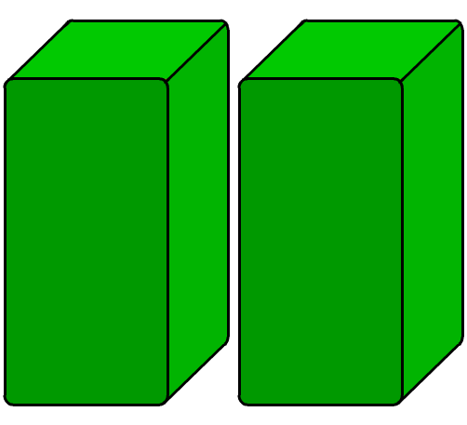

**low surface area**

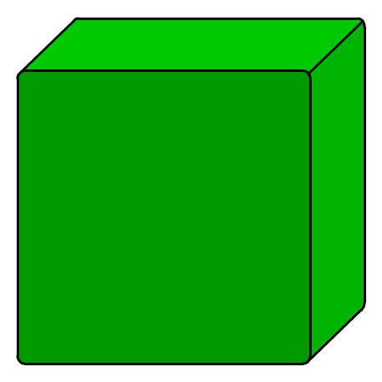

**high surface area**

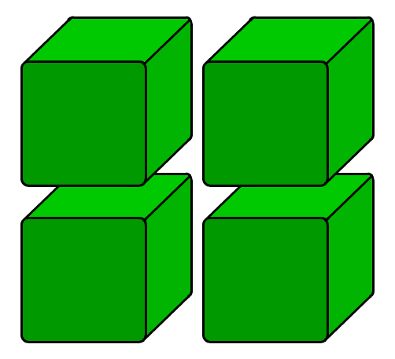

|  |
| --- |
| **4. Catalyst – For all reactions** |

A catalyst is a substance that increases the rates of chemical reactions ***without being used us***.

* + *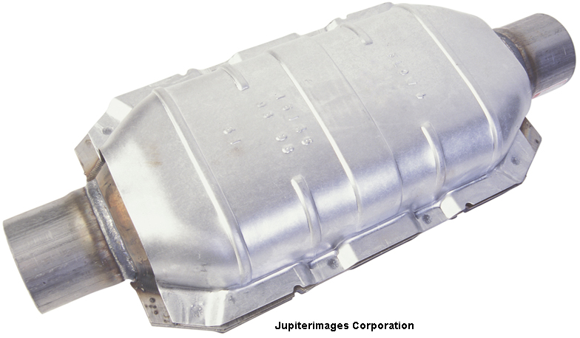(An inhibitor is a species that reduces the rate of a chemical reaction by combining with a reactant to stop it from reacting in its usual way.)*
  + A biological catalyst is known as an ______________________________

*Catalytic Convertor used in a car!*

**Homework: Collect the Reaction Rate Worksheet from the front of the room + Complete Online Survey**