Notes: Bohr Theory

Why do Blimps Float?

Because they are filled with a gas less dense than air

Electromagnetic Radiation

Light is one of the forms of energy

Light is one type of a more general form of energy called electromagnetic radiation

Electromagnetic radiation travels in waves

Characteristics of a Wave

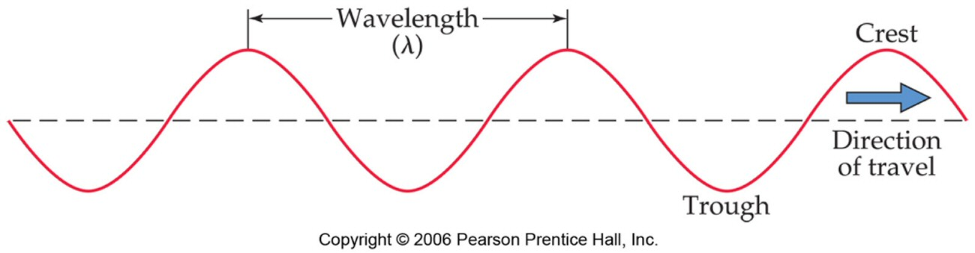

Wavelength = distance from peak to peak

Amplitude = height of the peak

Frequency = the number of wave peaks that pass in a given time

Speed = rate the waves travel

Particles of Light

Scientists in the early 20th century showed that electromagnetic radiation was composed of particles we call photons

photons are particles of light energy

Each wavelength of light has photons that have a different amount of energy

the longer the wavelength, the lower the energy of the photons

The Electromagnetic Spectrum

Light passed through a prism is separated into all its colors = continuous spectrum; colors blend into each other

Color of light is determined by its wavelength and frequency

Electromagnetic Spectrum: Light’s Relationship to Matter

Atoms can absorb energy, but they must eventually release it

When atoms emit energy, it is released in the form of light = emission spectrum

Atoms don’t absorb or emit all colors, only very specific wavelengths; the spectrum of wavelengths can be used to identify the element

Emission Spectrum or Line Spectrum Electromagnetic Spectrum
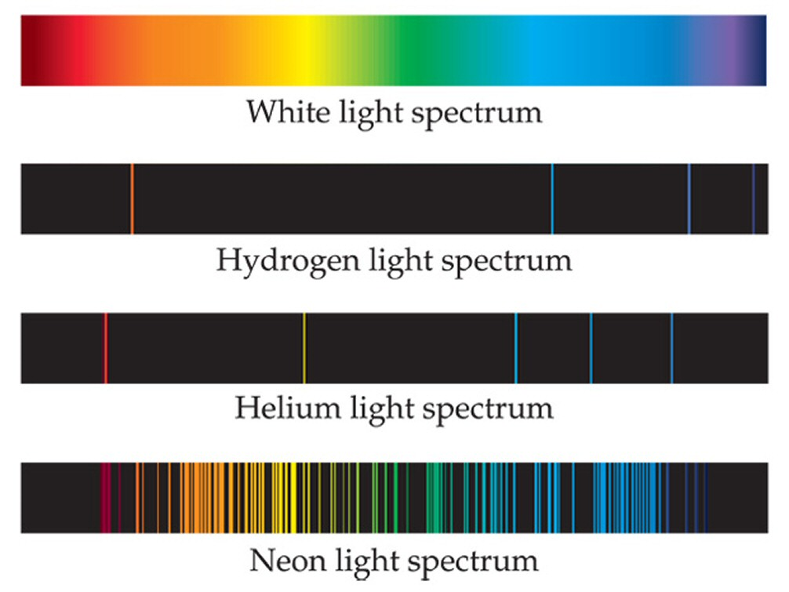 | 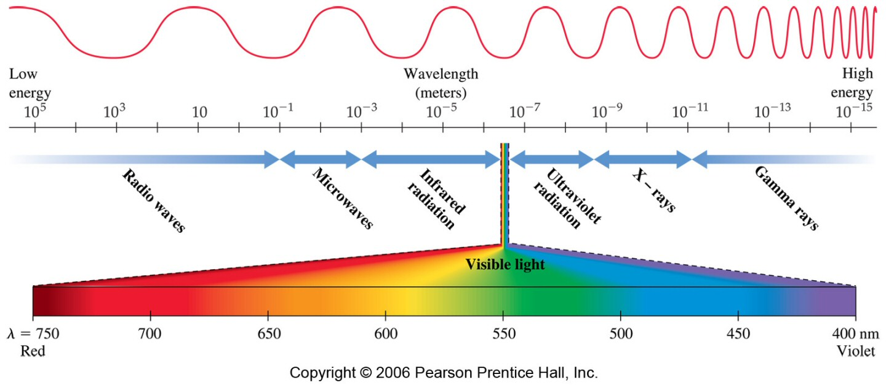

Line Spectra = specific wavelengths are emitted; characteristic of atoms

The Bohr Model of the Atom

Nuclear Model of atom does not explain how atom can gain or lose energy

Neils Bohr developed a model to explain how structure of the atom changes when it undergoes energy transitions

Bohr postulated that energy of the atom was quantized, and that the amount of energy in the atom was related to the electron’s position in the atom

Quantized: means that the atom could only have very specific amounts of energy
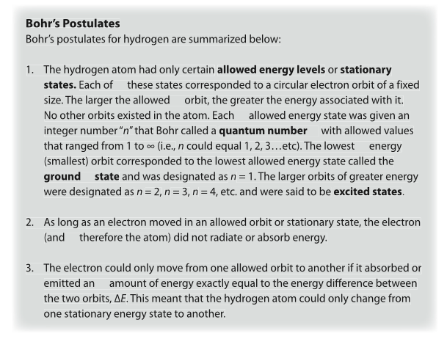

In the Bohr Model, electrons travel in orbits or energy levels around the nucleus

The farther the electron is from the nucleus the more energy it has
Quantized Energy States | Hydrogen Spectrum Series
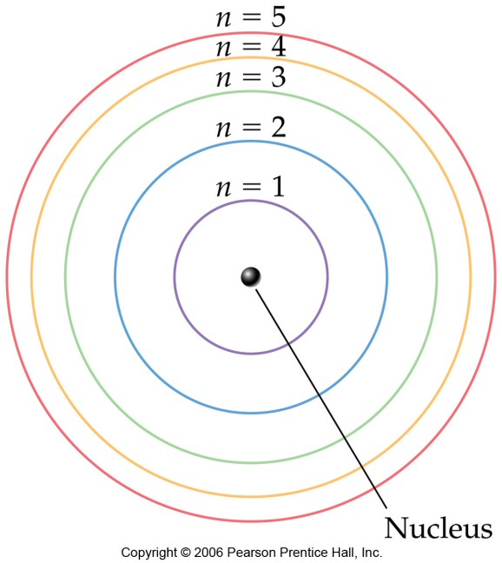 | 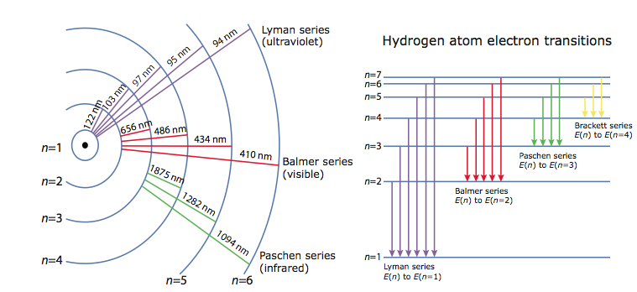

The Bohr Model of the Atom:
Orbits and Energy

Each orbit (energy level) has a specific amount of energy

Energy of each orbit is symbolized by n, with values of 1, 2, 3 etc; the higher the value the farther it is from the nucleus and the more energy an electron in that orbit has

The Bohr Model of the Atom: Energy Transitions

Electrons can move from a lower to a higher (farther from nucleus) energy level by absorbing energy

When the electron moves from a higher to a lower (closer to nucleus) energy level, energy is emitted from the atom as a photon of light

The Bohr Model of the Atom: Ground and Excited States

Ground state – atoms with their electrons in the lowest energy level possible; this lowest energy state is the most stable.

Excited state – a higher energy state; electrons jump to higher energy levels by absorbing energy

