Dilutions  The Mole | Name: __________________________  Date: _________________

In a dilution:

- water is ____________________
- volume _____________________
- concentration _________________________
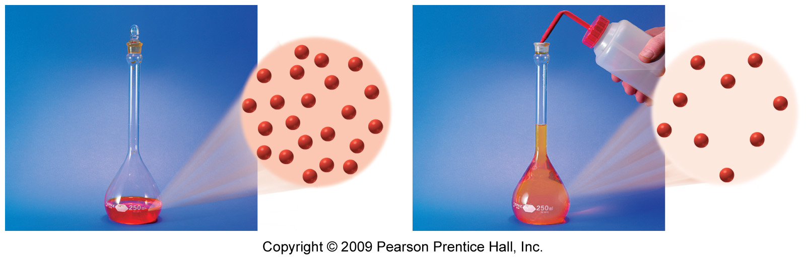
In the initial and diluted solution:
- the moles of solute are _______________________.
- the concentrations and volumes are related by the following equation:

M₁V₁ = M₂V₂
initial diluted

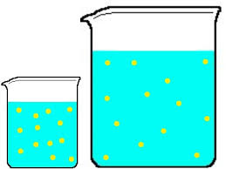

What volume of a 2.00 M HCl solution can be prepared by diluting 25.0 mL of 14.0 M (m/v) HCl solution?
Prepare a table:

Solve dilution equation for unknown and enter values:

What is the molarity of a solution prepared by diluting 10.0 mL of 9.00M NaOH to 60.0 mL?

What is the final volume (mL) of 15.0 mL of a 1.80 M KOH diluted to give a 0.300 M solution?

