Science 10 – Chemistry  Nuclear Reactions | Name: _______________  Date: _______________  Block: _______________
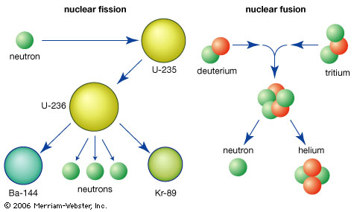
Nuclear reactions are divided into…

Fission – splitting of a nucleus

Fusion – joining of two nuclei

Nuclear FISSION

Nuclear Fission is when a large nucleus ______________ into two smaller nuclei, it releases _____________________ and _____________________.
- Heavier nuclei tend to be unstable. WHY? _________________________________________________________

During Nuclear Fission, a small amount of _____________ is lost and converted to ______________________

Matter and energy are interchanged in a nuclear reaction (the mass of the product is slightly less than the mass of the reactant).

All nuclear power generation is accomplished through nuclear fission.

Chemical Reactions | Nuclear Reactions
- Mass is __________________ and energy changes are relatively small.  - There are no changes to the _______________ of the nuclei in chemical reactions. | - The actual _______________ of the atom changes.  - Protons, neutrons, electrons and/or gamma rays can be ___________ or ___________.  - Small changes in mass =
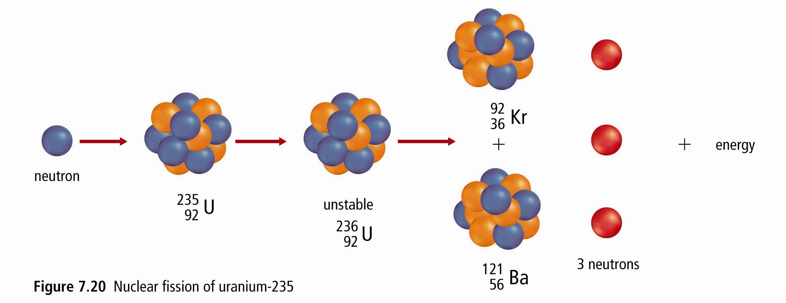
Example: Nuclear Fission of U-235

Equation: ___________________________________________________________________________________

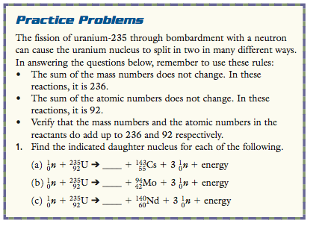
Practice Problems:

Find the indicated daughter nucleus for each of the following… (Projected on the board!)

Chain Reactions  - Once the nuclear fission reaction has started, it can keep going  - The neutrons released ___________________ more reactions on other U-235 atoms.  - This chain reaction can quickly get quickly get out of control  - Materials that absorb neutrons help to control the chain reaction.  - Nuclear bombs are __________________________ reactions. | 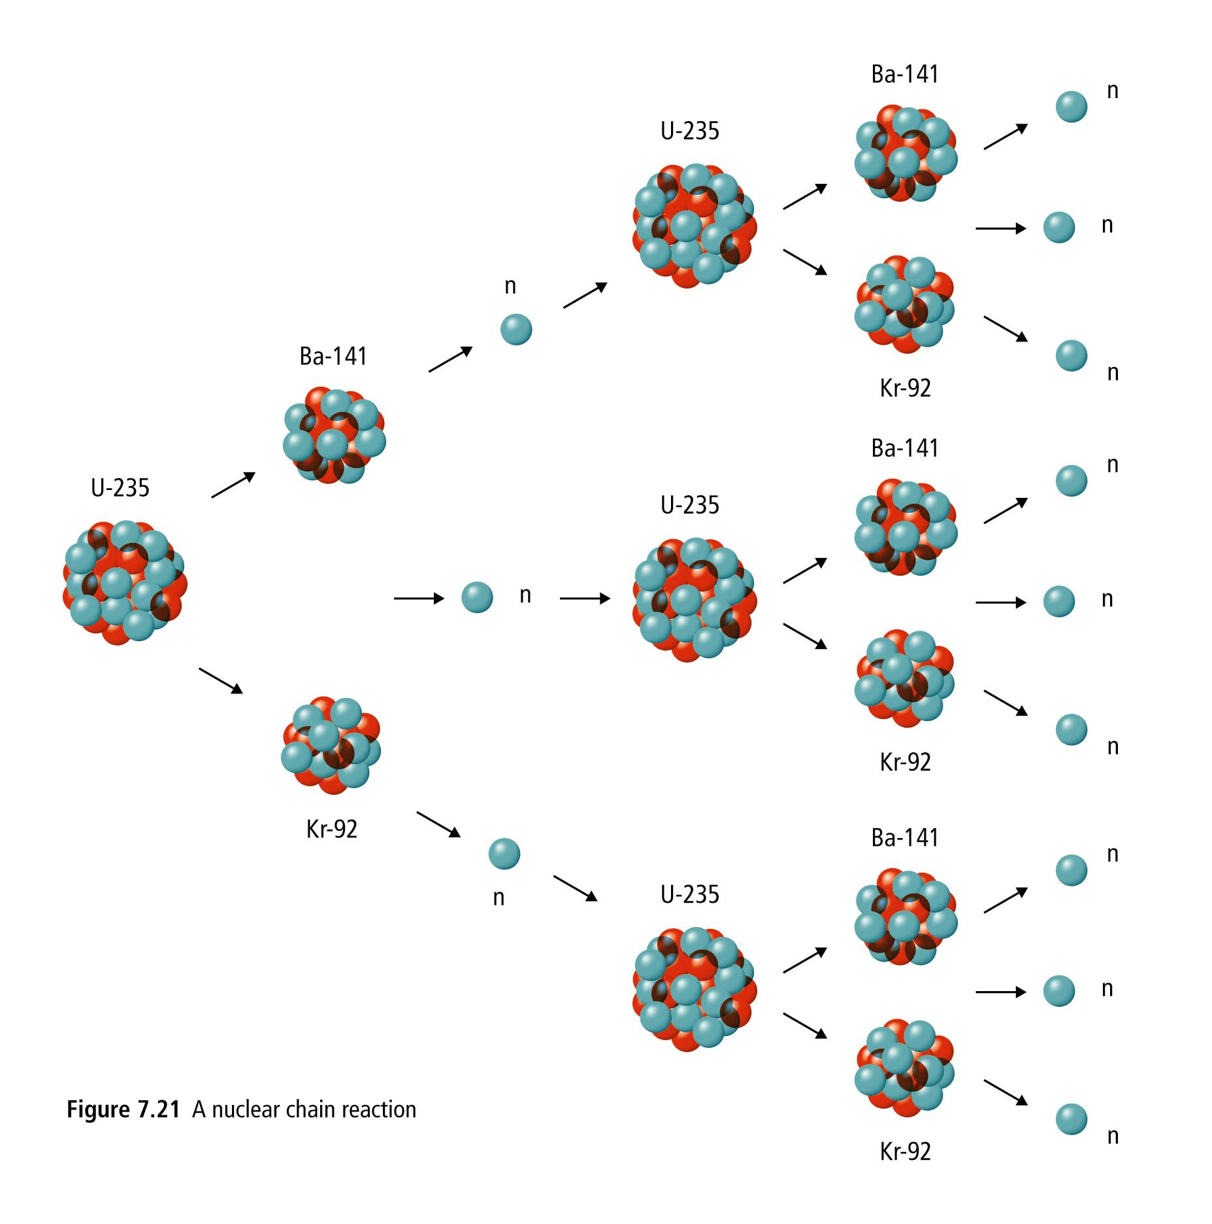

Nuclear FUSION

Nuclear Fusion is when two small nuclei join together into one larger nuclei, releasing _______________.

Nuclear Fusion produces much more energy for a given mass of fuel than nuclear fission.

Equations: ______________________________________________________________________________________
Examples of nuclear fusion:
- The sun and other stars (Grade 9)
- A Hydrogen Bomb (needs a fission bomb to ignite it!)

Fusion in stars like the sun __________________ the heavier elements in the universe

While heavier elements can be made in the heart of stars, if they are heavier than Iron they will be unstable, and begin to decay.

As an energy source it is clean and plentiful, however, it is very hard to control as it needs very high temperature.
- Scientists cannot yet find a safe, manageable method to harness the energy of nuclear fusion.
- So-called “cold fusion” would occur at temperatures and pressure that could be controlled.

