Things get Strange:

Note: this is stuff that you do not need to know for the test, but it is cool and very useful for a full understanding of quantum mechanics.)

Well the quantum thing was odd – nobody expected that atoms would behave as they did. But stranger things were yet to come. So far things had gone well. Once the wave thing was figured out for particles, all the odd stuff seemed to make sense. But this was only a momentary illusion.

This is where a dude named Verner Heisenberg comes in. Newton had shown that the universe was a predictable place; governed by the laws of physics. So naturally scientists were confident that with proper instruments, careful technique, and a little delicacy, don't you know, all the secrets of the universe could be extracted. By that, it is meant that anything observable could be measured to any degree of accuracy if you just had the right instrument. Physicists jumped in with both feet and set out to pin down those electrons and see exactly what they were doing. However this was not to be. Heisenberg in the late 20’s experienced some problems with gathering data on these little subatomic particles. He came to realize that the quantum mechanical world was quite different than the everyday world. After careful study, he found that he could determine the position of an electron with great accuracy or he could accurately measure the momentum of an electron, but he could not do both at the same time. As you try to zero in on the electron's location, the less certain you become of its momentum and vice versa. This is because the act of measuring a thing changes the thing you are observing. It’s like those anthropologists who set out to study a primitive tribe in the mountains of New Guinea. Here these backward natives are, totally ignorant of the rest of the world – busy worshiping rocks or trees or perhaps a large coconut. All of a sudden here’s a bunch of scientists with Sony Walkman cassette players, camcorders, flashlights, and polyester pants. The tribe will never be the same again. They are no longer ignorant savages – the very appearance of the scientists has changed the people and their society forever. This is what happens when you try to study electrons. The very act of measuring what they are doing changes the thing they are doing, so you can’t be certain about it.

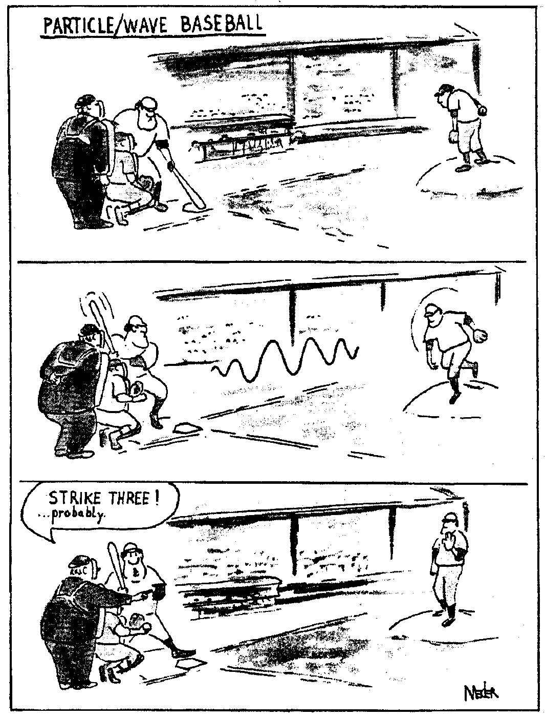
The idea that you cannot know the momentum and the position is called the uncertainty principle. Heisenberg found that the uncertainty in the momentum multiplied by the knowledge of the position was equal to Planck's constant. What a weird thing.
From Marilyn vos Savant: The answer was “uncertainty principle”. Here are some questions:

What was Heisenberg’s justification for prenuptial agreements? Karl Hester, Seattle, Washington.

What underlies the rhythm method of birth control? Wayne Wilkinson, New Orleans, La

What’s the name for the fear of a husband who can’t remember if today is the birthday of his wife or girlfriend? Gerald Swick, Clarksburg, W. Va.

Heisenberg might have slept here. -- Anonymous

Planck's constant is a measure of the “graininess” of the universe. Think of the universe as a sort of magazine photograph. When you do your normal look at a magazine picture, you see a nice sharp image, but if you magnify it – look at it close up - you find that it is made up of bunches of little dots. The closer you get to the picture, the more you notice the dots. You can still make out the subject of the picture, but you have to work at it. As you get closer and closer, the picture gets grainier and grainier – harder and harder to make out. Eventually all you see are these big old dots that just lie there, not making much sense. The picture is gone. In fact, beyond these little dots, there is nothing that can be known. Turns out the universe is the same way.
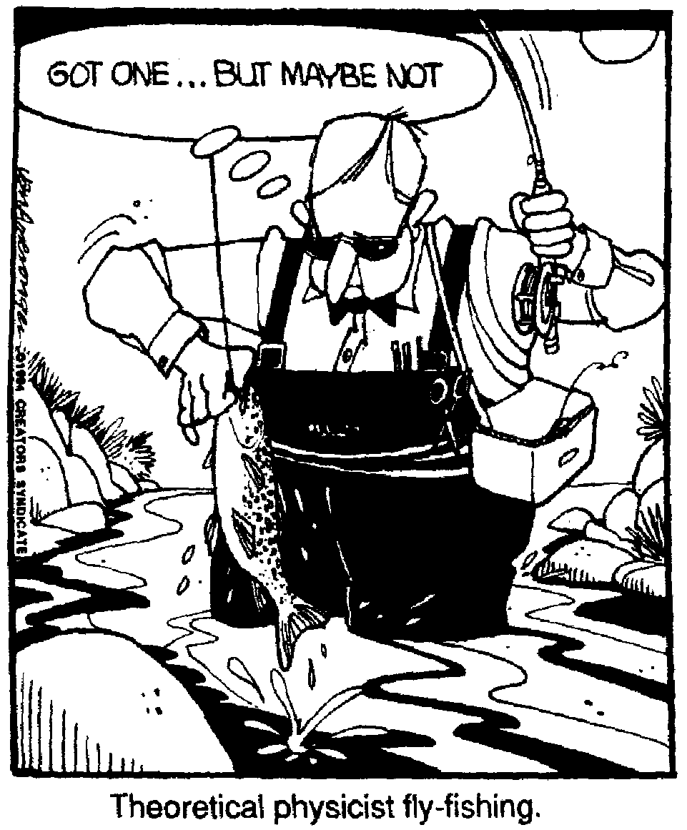
Heisenberg had discovered the uncertainty principle.

Uncertainty principle ≡ It is impossible to know simultaneously the exact position of an object, such as an electron, and its momentum.

It also was learned that the act of measuring a quantity would change the quantity. This makes it even more unlikely that anything can be truly known.

Einstein had trouble accepting the uncertainty principle. He recognized that quantum mechanics worked, but felt that the uncertainty was a result of the lack of refinement in the theory and that, with a little work, the uncertainty would vanish and we would be able to truly know some ultimate things. He believed that the laws of the universe are simple, elegant, and beautiful – like special relativity. Quantum mechanics was none of those things. Thus he opposed it, mainly on philosophical grounds. His really famous quote, which he made about uncertainty, is, "I cannot believe that God plays dice with the universe." Of course Niels Bohr’s answer was, “Who is Einstein to tell God what to do?”

Heisenberg is out for a drive when he's stopped by a traffic cop. The cop says "Do you know how fast you were going?" Heisenberg says "No, but I know where I am."

Quantum mechanics is not governed by hard, discrete laws as the rest of physics is, instead it is governed by probability and statistics. When we discuss electrons, we discuss the probability that they will be in a certain place or having a certain energy or momentum. If you deal with a large number of them, you are okay, and can make accurate predictions, but when you deal with just a few or one, then you cannot be certain and your prediction will be unreliable.

Again, it is important to recognize that this uncertainty only happens when we deal with very small events. When we deal with anything material, the numbers of particles are so vast that the probability effect becomes a certainty. Which is why we can get away with ignoring the whole thing -- most of the time.

Bruce Baskir
"Electrons all jumbled like rice?"
Quoth Einstein, "That's too high a price."
In reply, answered God
"Well I don't find it odd.
So shut-up and let me play dice."

Schrodinger's Cat: A really weird outcome of quantum mechanics is that, under certain conditions, matter can exist in more than one state or position at the same time.
This is a wild concept. There is a probability (pretty small and most highly unlikely) that the atoms that make up the seat you sit on could, all at one time, go somewhere else leaving you to fall to the floor. It really could happen. Be pretty cool if it did too don't you think (as long, one needs point out, that it happens to someone else)?

Schrodinger came up with a marvelous way to illustrate the weirdness of this dilemma. In 1926 he proposed a puzzling thought experiment. Imagine that a cat is placed in a sealed box and its fate - whether it lives or dies - depends on whether or not an atom undergoes radioactive decay. The atom is hooked up to a flask of poison gas. If the atom decays, the gas is released and the cat croaks. We cannot predict what the individual atom will do - decay or not decay, so we consider its probability of decaying. This probability is, let us say, 50 – 50. The presence of the atom's decayed and undecayed quantum states translates into a cat that is both dead and alive at the same time - a highly counterintuitive idea. So is the cat dead or is it living? If you open the box, the cat will automatically be killed (by making our measurement we have changed the state), so there is no way to know what the cat's state is or was or will be.

We get around this by defining the cat’s state as being both alive and dead.

When we observe felines, we don't expect our observations to influence whether the kitty dies or stays alive--or to see one of the critters both dead and alive. But you must remember that we don't live in a quantum world (well, actually we do, but we aren't aware of it because the graininess of the quantum is far smaller than our threshold of noticing things).

The Cat in the Tree
by Peter Price
Another great Dane has made free
With a question of Be or Not be.
Now might Schrodinger’s puss,
In descending by Schuss,
Leave one track on each side of a tree?

The quantum mechanical universe is like so strange. For example, take your largest atom. This would be, of course, good old cesium, which is a really nasty, highly reactive alkaline metal. Cesium atoms are big because the outermost electron is not very tightly held, so the electron's orbital is quite large. A cesium atom is about 6.68 angstroms across (0.0000000263 inch), which is not all that more spectacularly bigger than many other atoms. But this is the atom in its ground state, when it is unexcited. What happens when the atom absorbs energy? Well, them atoms can get a whole bunch bigger when they absorb photons of energy -- electrons can jump into a higher energy quantum level, which effectively makes the atom larger. Out there in its higher orbital, the electron can be easily lost, leaving the atom smaller than a normal one. Or the energized electron can also re-emit the light photon (falling back to a lower excited state), restoring the atom to normal size. In the real world, energized atoms almost always emit a photon or lose their outer electron within a fraction of a second. But it's theoretically possible for an atom to be energized to any size, even as large as the whole universe. Now that, the is weird.

Quantum mechanics has had a huge effect on our perception of the universe. It effectively tossed out Newton’s idea of a clockwork universe. We now realize that the universe is a place full of uncertainties and things that we cannot know or even find out. Not only do we have trouble figuring out the location of an electron, the darn thing can even be in two places at the same time!

Here’s a Niel’s Bohr story related by a physics professor, one Ed Schweber. One of his professors when he was in grad school in the early 70's, Aage Peterson, had worked with Bohr early in Peterson's career and toward the end of Bohr's career.

Once Bohr, Peterson and some colleagues went to see an American western movie and began talking about the film afterward. What follows is the gist of what transpired. The exact dialog is an approximation. "What did you think?" they asked Bohr and he replied,

"Too Implausible."

"Come on Bohr, its just a movie, you can't subject it to too rigorous an analysis."

Bohr kept responding, "Too implausible."

Finally they relented. O.K. Bohr, why is it implausible?"

"That a man runs off with a woman - that I can accept - it happens all the time. That the woman had a jealous brother who chased after them - that too I can accept - there certainly are jealous brothers. That the brother caught up with his sister - that too I can accept. One person must have the faster horse and one the slower horse, That the brother caught his sister as they were crossing a bridge - that I can accept as well. The brother has to catch his sister somewhere. And that the bridge collapsed just as everyone was crossing it - even that I can accept. Bridges do collapse and the people on them must have some reason for being there. And you don't make movies of everyday events. But that at the precise moment the bridge collapsed, a movie crew should just happen to have been in the ravine to film it -- too implausible!”

