LEWIS DIAGRAMS – notes Name: ___________________

Also called: Lewis-Dot Diagrams

- What are valence electrons? ______________________________________________________________

- Lewis Diagrams are similar to Bohr models but what is missing? _______________________________

______________________________________________________________________________________________

We will only use the first 20 elements so:

Elements in column 1 have how many valence electrons? _______

Elements in column 2 have how many valence electrons? _______

Element in column 13 – 18 have a range of how many valence electrons? ______________

Making Lewis Diagrams for Atoms

Quick Method – place electrons singly - equally around the shell until 4 are places, after which add in electrons to make pairs.

Magnesium Sulphur

Making Lewis Diagrams for Covalent Compounds - elections are __________________

How many electrons make a full outer shell? ________ Except for He and H that require _________ electrons.
A covalent bond (also known as a bonding pair) is shown with a line connecting the elements.
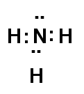
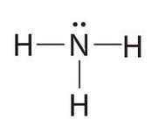 | 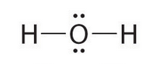

Label the bonding pairs and lone pairs above.
Draw a Lewis diagram for…. Carbon Tetrafluoride Phosphorus Trichloride

Making Lewis Diagrams for Ionic Compounds – electrons are _________________

Draw the Lewis Diagram for…. Calcium Chloride Potassium Fluoride

Step 1: Draw Lewis Diagrams
of all element, show transfer
of electrons from metals to
non-metals

Step 2: Place square brackets
around each ion. Include the
charge of each ion on the top
right corner

