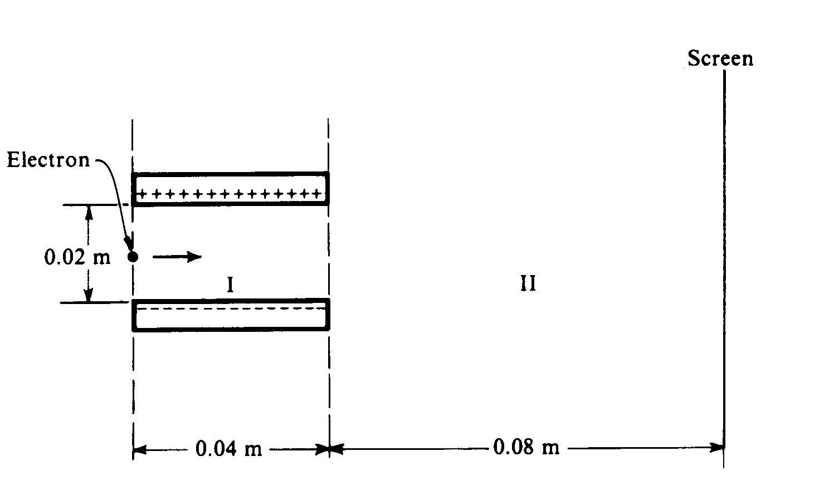

***CRT TUBES***

An electron initially moves in a horizontal direction and has a kinetic energy of 2.0 × 103 electron–volts (1 eV = 1.6 x 10-19 J) when it is in the position shown to the right. It passes through a uniform electric field between two oppositely charged horizontal plates (region I) and a field–free region (region II) before eventually striking a screen at a distance of 0.080 meter from the edge of the plates. The plates are 0.040 meter long and are separated from each other by a distance of 0.020 meter. The potential difference across the plates is 250 volts. Gravity is negligible.

1. Calculate the initial ***horizontal speed*** of the electron as it enters region I.

***KE = (2.0 × 103 eV)(1.6 × 10–19 J/eV) = 3.2 × 1016 J***

***KE = ½ mv2 gives v = 2.7 × 107 m/s***

1. Calculate the magnitude of the electric field E between the plates, and indicate its direction on the diagram above.

***E = ΔV/d = (250 V)/(0.020 m) = 1.25 × 104 V/m***



1. Calculate the magnitude of the electric force F acting on the electron while it is in region I.

**F = qE = 2.0 ×10–15 N**



1. On the diagram to the right, sketch the path of the electron in regions I and II.

***Path curves parabolically toward the upper plate in region I and moves in a straight line in region II.***

***Millikan’s Oil Drop Experiment***



Robert Millikan received a Nobel Prize for determining the charge on the electron. To do this, he set up a potential difference between two horizontal parallel metal plates. He then sprayed drops of oil between the plates and adjusted the potential difference until drops of a certain size remained suspended at rest between the plates, as shown above. Suppose that when the potential difference between the plates is adjusted until the electric field is 10,000 N/C downward, a certain drop with a mass of 3.27 × 10–16 kg remains suspended.

1. What is the magnitude of the charge on this drop?

***ΣF = 0 gives qE = mg and q = mg/E = 3.27 × 10–19 C***

1. The electric field is downward, but the electric force on the drop is upward. ***Explain why***.

***The drop must have a net negative charge. The electric force on a negative charge acts opposite the direction of the electric field.***

1. If the distance between the plates is 0.01 m, what is the potential difference between the plates?

***V = Ed = 100 V***

1. The oil in the drop slowly evaporates while the drop is being observed, but the charge on the drop remains the same. Indicate whether the drop remains at rest, moves upward, or moves downward. Explain briefly.

***The drop moves upward. The reduced mass decreases the downward force of gravity on the drop while if the charge remains the same, the upward electric force is unchanged.***