**DISTANCE VS TIME and SPEED GRAPHICALLY** NAME _______________

DATE ______________

***In this set of notes we will cover:***

*- Explain the relationship of distance and time interval to speed for objects in uniform motion*

*- Analyze graphically the relationship between distance and time interval*

**Background: Slope**

From math you have learned (or will learn) that between two points: 

In general, slope is the _________________ that the y-variable changes as you increase the x-variable.

Consider the following four scenarios for the distance a car travels compared to time.

Come up with a ***plausible*** explanation for each situation

Scenario 1 Scenario 2 Scenario 3 Scenario 4

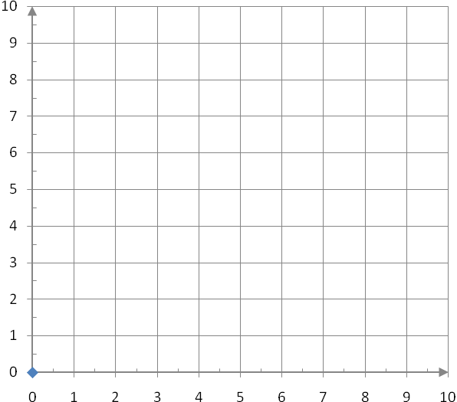

Negative slope



*Car starts 2km away drives away for 5 minutes.*

time (min)

distance (km)

Positive slope



Undefined slope



No slope

distance (km)

distance (km)

distance (km)

time (min)

time (min)

time (min)

To calculate the slope for each scenario we use the two points, (x1,y1) and (x2,y2), on the line segment: 

|  |  |  |  |
| --- | --- | --- | --- |
| **Scenario 1:**  (0,2) and (5,9) | **Scenario 2:**  (0,5) and (6,5) | **Scenario 3:**  (0,7) and (5,2) | **Scenario 3:**  (4,8) and (4,0) |
|  |  |  |  |

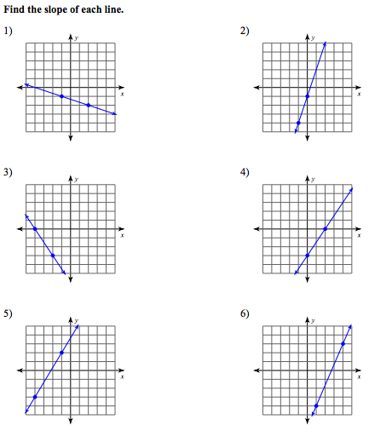



**Distance vs. Time Graph – Used to describe Motion**

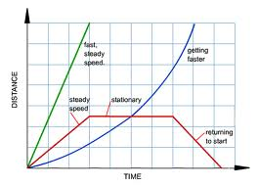

**Average Speed**

When you travel on a trip you might _________________ several times for things like: fuel, food and bathroom breaks. Your _________________ is also likely changing as you go up hills, around __________________ and through towns. At any given ______________ you can measure your ___________________ speed. But, all these changes prevent you from measuring a constant uniform speed. However you can calculate an average speed:

 Where  is the total change in distance and  is the total change in time

**Scalar examples involving Uniform Motion**

1. A remote control powered car travels along a straight track at a constant speed of 1.5m every second.

1. Fill in a data table for the first 5 seconds and draw/label a distance vs. time graph.



|  |  |
| --- | --- |
| **Time**  **(s)** | **Distance**  **(m)** |
| 0 | 0 |
| 1 |  |
| 2 |  |
| 3 |  |
| 4 |  |
| 5 |  |

distance (km)

1. Calculate the slope of the line

time (min)

1. What is the relationship between the slope of the line of the graph and the speed of the car?
2. The remote control car travels along a straight track at a constant speed of 1.5km every minute and then suddenly stops for 3 minute.

a) Fill in a data table for the first 8 seconds and draw/label a distance vs time graph.

|  |  |
| --- | --- |
| **Time**  **(min)** | **Distance**  **(km)** |
| 0 | 0 |
| 1 |  |
| 2 |  |
| 3 |  |
| 4 |  |
| 5 |  |
| 6 |  |
| 7 |  |
| 8 |  |



distance (km)

time (min)

b) What is the speed during the first 5 minute? Is this the same as slope?

c) What is the speed of the car during the 5-8 minute?

1. The remote control car travels along a straight track at a constant speed of 1.5 km for every min for 5 minutes and then suddenly stops for 3 minutes and suddenly travels 1 more min at 1.5km per minute. Fill in a data table for the first 9 minutes and draw/label a distance vs time graph.

|  |  |
| --- | --- |
| **Time**  **(min)** | **Distance**  **(km)** |
| 0 | 0 |
| 1 |  |
| 2 |  |
| 3 |  |
| 4 |  |
| 5 |  |
| 6 |  |
| 7 |  |
| 8 |  |
| 9 |  |

distance (km)

time (min)

1. A control car travels along a straight track at a constant speed of 1.5km every minute and then suddenly stops for 3 minute and suddenly travels 1 more minute at 1.5km per minute.



|  |  |
| --- | --- |
| **Time**  **(min)** | **Distance**  **(km)** |
| 0 | 0 |
| 1 | 1.5 |
| 2 | 3.0 |
| 3 | 4.5 |
| 4 | 6.0 |
| 5 | 7.5 |
| 6 | 7.5 |
| 7 | 7.5 |
| 8 | 7.5 |
| 9 | 9.0 |
|  |  |

distance (km)

time (min)

1. What is the total change in distance? _______________________
2. What is the total change in time? _______________________
3. What is the average speed of the RC car?
4. Calculate the slope of the first line segment (before RC car changed speed) on the graph.