So, What Are The Aurorae?

Contrary to the myths surrounding the aurora, this phenomenon is not your ancestors jiving across the sky, nor is it some kind of luminous bridge into the other world.
The Aurora is caused by the Sun rudely belching its charged gassy particles all over Earth’s outer atmosphere. Now, this may sound horribly uncouth, but it is a most appropriate metaphor for the physical reality. Let’s take a closer look at the Sun… the long-winded explanation if you will.
Some Alka-Seltzer for the Sun, Please
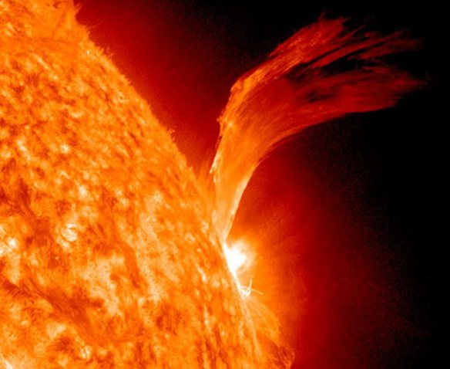
A solar flare erupts from the Sun’s raging photosphere
The Sun is a star. And like all stars, its’ incredible mass causes unending catastrophic nuclear reactions in its hellish interior. Convection – great currents of outward-bound surges of intense heat – transports mass to the surface of the Sun from its molten interior. As you can imagine, the surface of the Sun is anything but Swan Lake. It’s an intense bubbling conflagration of scalding heat.
Great bubbles of burning gas ride these convection currents like the turtles in Finding Nemo and, in a prodigious release of energy, blast out of the Sun’s photosphere. This eruption of energy is known as a solar flare and it is a truly devastating phenomenon that can represent a staggering 17% of the Sun’s entire energy output per second… that’s approximately 600,000,000,000,000,000,000,000,000 joules of energy.

These flares, which erupt out of the Sun’s corona, belch out obscene clouds of electrons and charged atoms, which stream out into space and collide with anything and everything in their path. Sometimes, that anything and everything, is our humble little planet.
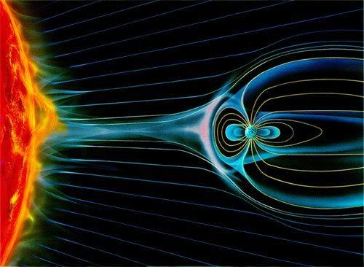
Solar activity and its effect on the Earth. The circular lines surrounding the sun-facing side of our planet represent our magnetic field and how it shields us from much of the incoming solar radiation.
Even though our tiny blue planet lies 15 billion kilometers (93 million miles) away, the streams of charged particles emitted by the Sun still reach us, typically within a day or two of a solar flare occurring. This incomprehensible distance represents a leisurely stroll in the park for solar radiation, which doesn’t only consist of the light we perceive as daytime, but rather the entire electromagnetic spectrum, from high-energy gamma rays (dangerous) to sluggishly slow and lazy radio waves (not dangerous).
These charged particles slap against the outer reaches of our atmosphere, which can damage the little microchips in satellites, disrupt power grids, interfere with radio signals and… *drumroll* cause the sky to incandesce with beautiful otherworldly lights!
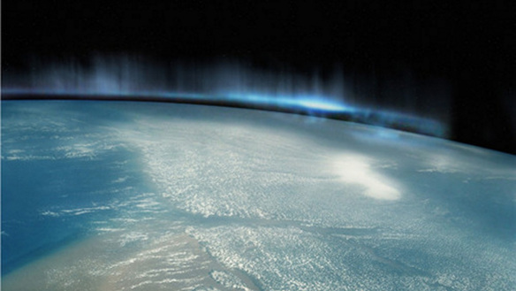
The aurora borealis, or “Nothern Lights” from space

A Charged Particle from the Sun Walks into a Bar…
Charged particles from the Sun smack into the gas molecules that make up our atmosphere, exciting their electrons into higher energy orbits. When these electrons have had a chance to chill out, they sink back into their normal orbits, releasing the excess energy they had in the form of light.
In plain English: A charged particle from the Sun walks into a bar and straight up to an oxygen atom. It smacks oxygen right in the face, enraging oxygen that, as a result of its excited state, goes bright green with anger at the impudence of this charged solar particle. If the molecular victim in this analogy was nitrogen, it would have glowed red or blue.

On a vast scale of thousands of square kilometers, the effects of charged solar particles walking into zillions of bars and smacking zillions of oxygen molecules in the faces is staggeringly beautiful. And in spite of the violence of it all, the resultant visual spectacle looks like gentle waves of brilliant light caressing the night sky.
This mechanism may sound horribly confusing, but just because I used “charged” and “particle” in the same sentence doesn’t mean that comprehension is totally beyond you. Just like the atoms/molecules discussed you should be “excited” by this new found knowledge! In fact, we are surrounded by examples of the very same mechanism that cause the aurorae. Neon is a gas and when its atoms are excited, they too incandesce and emit a powerful glow. In the case of neon lights, the source of excitement is electricity.
Aurora Borealis, Aurora Australis

You may have heard of either, but they are essentially the same thing. Australis means “southern” in Latin – think Australia or Australopithecus, “southern man,” our earliest ancestor who was thusly dubbed because his (or her) crumbly ancient remains were discovered in southern African soil.
Borealis means “northern.” So if you live in or visit the icy clutches of the extreme north, in the countries bordering on the Arctic Ocean, you stand a chance of witnessing the aurora borealis, while those in the extreme southern latitudes, the aurora Australis.
The next question you should asking yourself… The earth has a magnetic field!?

