Rotational Dynamics
4 – Rotational Kinematics

In Kinematics, we studied motion along a straight line and introduced such concepts as displacement, velocity, and acceleration. Two-Dimensional Kinematics dealt with motion in two dimensions. Projectile motion is a special case of two-dimensional kinematics in which the object is projected into the air, while being subject to the gravitational force, and lands a distance away. In the next few sections, we consider situations where the object does not land but moves in a curve.

When objects rotate about some axis, for example, when a CD (compact disc) rotates about its center each point in the object follows a circular arc.  The ________________ ____________ is the amount of rotation and is analogous to __________________ distance. We define the rotation angle ______ to be the ratio of the arc length to the radius of curvature.  Where: Δθ =  Δs =  r =  _____ = _____ revolution | 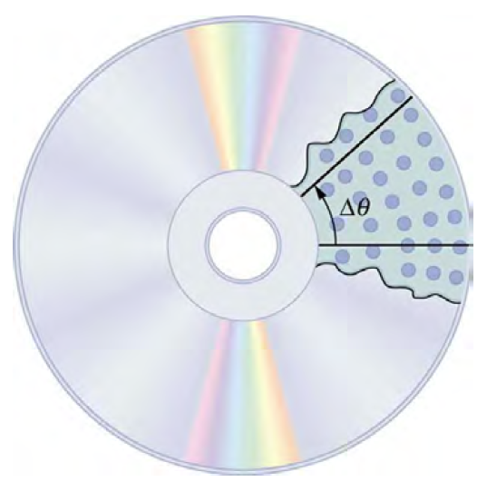

Angular Velocity (______): A measure of the rate of ________________ of the __________________ ____________________.

Note: Units for Angular Velocity are ___________________.

Example:  Calculate the angular velocity of a 0.300 m radius car tire when the car travels at about 54 km/h.  What would the angular velocity be for a car traveling at the same speed that had tires which were four times larger? | 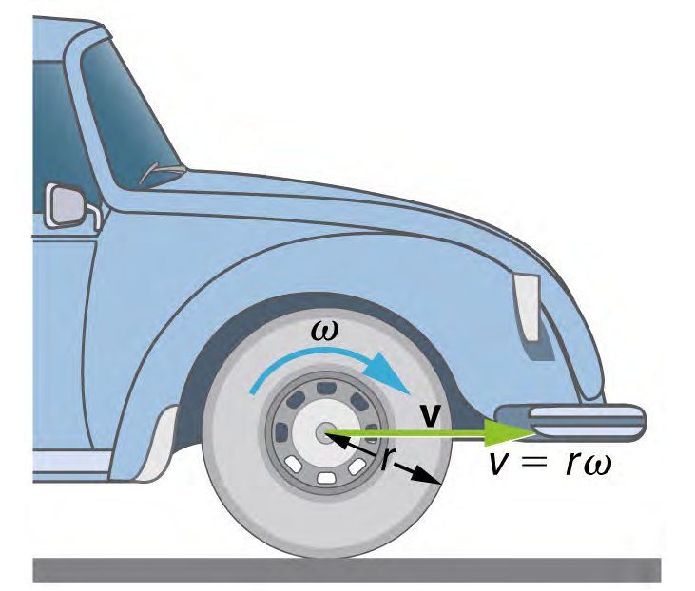
Angular Acceleration (_______): the rate of change of angular ________________________.

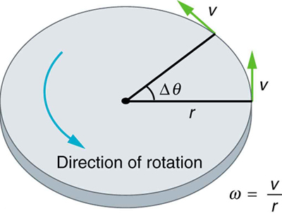

Example:  Suppose a Rockridge student puts their bicycle on a stand and starts the rear wheel spinning from rest to a final angular velocity of 250 rpm (revolutions per minute) in 5.00 s.  (a) Calculate the angular acceleration in rad/s². (Hint: how many rad’s are there in 1 revolution?) | 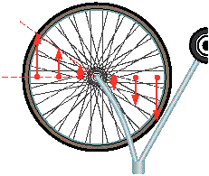
(b) If they now slam on the brakes, causing an angular acceleration of – 87.3 rad/s², how long does it take the wheel to stop?

But what about the connection between circular motion and linear motion?
In circular motion, _________ acceleration (__) occurs as the magnitude of the _________________ changes: linear acceleration is ___________________ to the motion and therefore we use _____. | 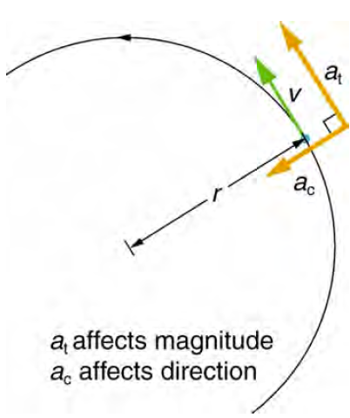
Example:  A powerful motorcycle can accelerate from 0 to 108 km/h in 4.20 s. What is the angular acceleration of its 0.320 m radius wheels? | 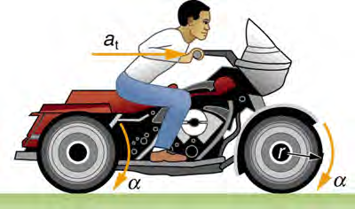
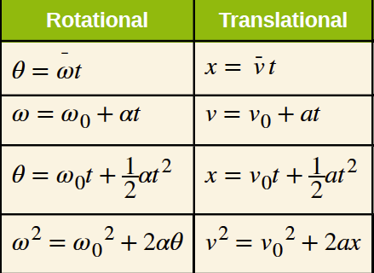
The good news is our understanding of linear kinematics allows us to explore rotational kinematics.

Example: A deep-sea fisherman hooks a big fish that swims away from the boat pulling the fishing line from his fishing reel. The whole system is initially at rest and the fishing line unwinds from the reel at a radius of 4.50 cm from its axis of rotation. The reel is given an angular acceleration of 110 rad/s² for 2.00 s.
a) What is the final angular velocity of the reel? | b) At what speed is fishing line leaving the reel after 2.00 s elapses?
c) How many revolutions does the reel make? | d) How many meters of fishing line come off the reel in this time?

Rotational Dynamics
5 – Rotational Inertia, Angular Momentum and Kinetic Energy

In the previous section we explored the _______________ of rotational motion, in this section we explore the ________________ of rotational motion.

Example:
If you open two doors with the same dimensions pushing with the same force, the first made of Balsa wood (160 kg/m³) and the second made with Black Ironwood (the densest known wood 1355 kg/m³), which door opens faster? Why?

Newton’s Second Law:

But remember in this unit we also explored ______________!

If an object is rotating in a circle _______.

Newton’s First Law: States that an object in motion will ____________ in motion.

This is related to the ______________ of the object.

Rotational Inertia (________): effectively tells us the ___________________ for objects moving in a circle to _____________ moving in a circle.

If ___________________ objects are moving in a circle we must _________ _____ __________of their Rotational Inertia’s to find the Moment of Inertia (I).

Units for moment of inertia are _________.

And because…

Mass Distribution

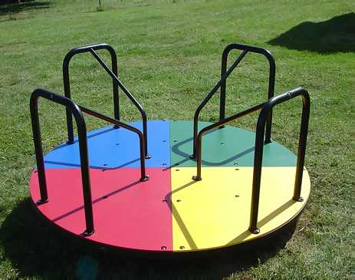
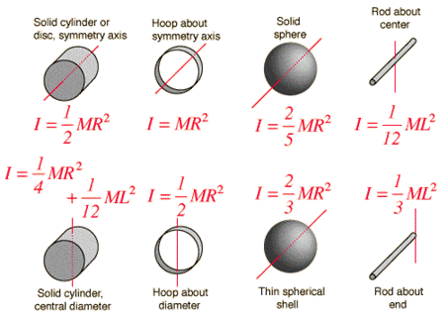
Different shapes have different ____________ _________________ and as a result have different moments of inertia.
Example:
A playground merry-go-round starts at rest and is accelerated uniformly, completing 4.00 rotations in 6.00 s.
(a) Calculate its angular acceleration.

(b) If the merry-go-round is disk-shaped, with a mass of 115 kg and a radius of 1.8 m, calculate the net torque acting on the merry-go-round.

Example:
Find the net torque required for your hip muscles to swing your leg at an angular acceleration of 5.0 rad/s², if you assume the leg is a solid rod with mass = 20 kg and length of 0.90 m.

Example:
Find the net torque required to accelerate a DVD from rest to its operating speed of 4.0 rad/s, in 2.0 seconds, if the DVD is 52 grams and has a diameter of 20. cm.

Example:
A bicycle rim has a diameter of 0.65 m and a moment of inertia (measured about its center) of 0.19 kg.m². What is the mass of the rim?

In this unit we have connected our understanding of Linear Kinematics/Dynamics to Rotational Kinematics/Dynamics. Well why stop there!?

Name: | Linear Momentum | Angular Momentum
Symbol:
Formula:
Units

Name: | Linear Impulse | Angular Impulse
Symbol:
Formula:
Units:
Example:
Suppose that a figure skater has a moment of inertia of 6.5 kg m² when her arms are outstretched and 3.8 kg m² when her arms are pulled in. She is initially spinning with an angular velocity of 8.2 rad/s with her arms outstretched and then pulls her arms in. What is her final angular velocity?

How does her does her initial rotational energy compare to her final rotational energy?
Name: | Linear Kinetic Energy | Rotational Kinetic Energy
Symbol:
Formula:
Units:
Example:

A ball is rolled down a ramp with a height of 5.0 m. What is its velocity at the bottom of the ramp?

Assumptions:
- The ball acts as a…

- The ball rolls without…

