**Thermodynamics**

1 – Transforming Energy

Energy: *CANNOT* (*forget Einstein for now ☺*) be ____________ or ____________ but *CAN* be ____________ from one form to another.

ΔE = ΔEK + ΔEP + ΔEH …. = W

We often convert one from to another in order to utilize the energy.

* _____________ **Energy** of gasoline is converted to ______________ **Energy** in a car, which in turn is converted to _____________ **Energy** to move the car.
* _____________ **Energy** of water in a dam is converted to _____________ **Energy** as it falls, which is then converted to _____________ **Energy** by a turbine.

During these processes we often say Energy is lost… but this can’t be true. ***Energy can neither be created or destroyed***.

In fact energy is not lost, but instead converted to an _____________ form. (Often _____________ **Energy**)

We use the term _____________ to describe the effectiveness of an energy conversion.

|  |  |
| --- | --- |
| Example:  A 75 W incandescent light bulb produces 2.8 W of visible light. **Calculate of the efficiency of the bulb**.  A 15 W light CFB (Compact Fluorescent Bulb) produces the same visible light. **Calculate the efficiency of the bulb**.  How many times more efficient is a CFB than an incandescent light bulb? | Example:  Cranes are often used to increase an objects potential energy. Crane 1 used 25 kJ of energy to lift a 200 kg box to the top of a building. Crane 2 uses 10 kJ to lift a 120 kg box to the same roof. Which crane is more efficient? |

Energy in the Body: Bio again…. ☹

In the cells of our body _____________ is converted into energy.

C6H12O6 + 6O2 🡪 6CO2 + 6H2O + Energy

The energy is then stored in a molecule called adenosine triphosphate (______). This energy is released to do the work of life!

_____of glucose releases ~ _______of Energy

|  |  |  |  |  |  |  |  |  |  |  |  |  |  |  |  |  |  |  |  |  |  |  |  |  |  |  |  |  |  |  |  |  |  |  |  |  |  |  |  |
| --- | --- | --- | --- | --- | --- | --- | --- | --- | --- | --- | --- | --- | --- | --- | --- | --- | --- | --- | --- | --- | --- | --- | --- | --- | --- | --- | --- | --- | --- | --- | --- | --- | --- | --- | --- | --- | --- | --- | --- |
| |  |  |  | | --- | --- | --- | | **Eating Calories** | | | | **Food** | **E content in Cal** | **E content in kJ** | | Fried Egg | 100 | 418 | | Apple | 125 | 523 | | Beer (can) | 150 | 628 | | Latte | 260 | 1088 | | Slice of Pizza | 300 | 1255 | | Apple Pie Slice | 400 | 1674 | | |  |  | | --- | --- | | **Burning Calories (70 kg person)** | | | **Activity** | **Rate at which we consume E (W)** | | Typing | 125 | | Walking @ 5 km/h | 380 | | Cycling @ 15 km/h | 480 | | Swimming (Fast Front Crawl) | 800 | | Running @ 15 km/hr | 1150 | |

1 Cal = _________ kJ

|  |
| --- |
| Example:  A 12 oz can of beer contains 150 cal of beer. If all that energy is stored in the simple carbohydrate Glucose how many g’s of sugar are in the beer? |

|  |  |
| --- | --- |
| Example:  A cyclist racing in the Gran Fondo pedals for 5.0 hrs at a speed of 15 km/hr. How much metabolic energy (in kJ’s) is required? How much energy goes to forward propulsion is the process is only 25% efficient. | Example:  How many flights of stairs could you climb on the energy contained in a 12 oz can of beer? Assume that your mass is 70 kg and that each flight of stairs has a vertical displacement of 3.0 m. Again assume 25% efficiency. |

**Thermodynamics Notes**

2 – Thermal Energy, Temperature and Heat OH MY!

In the space below, create a **Venn Diagram** for the terms Thermal Energy, Temperature and Heat.

Include all the ways the terms are _______________ and _______________. ***Start in pencil!***

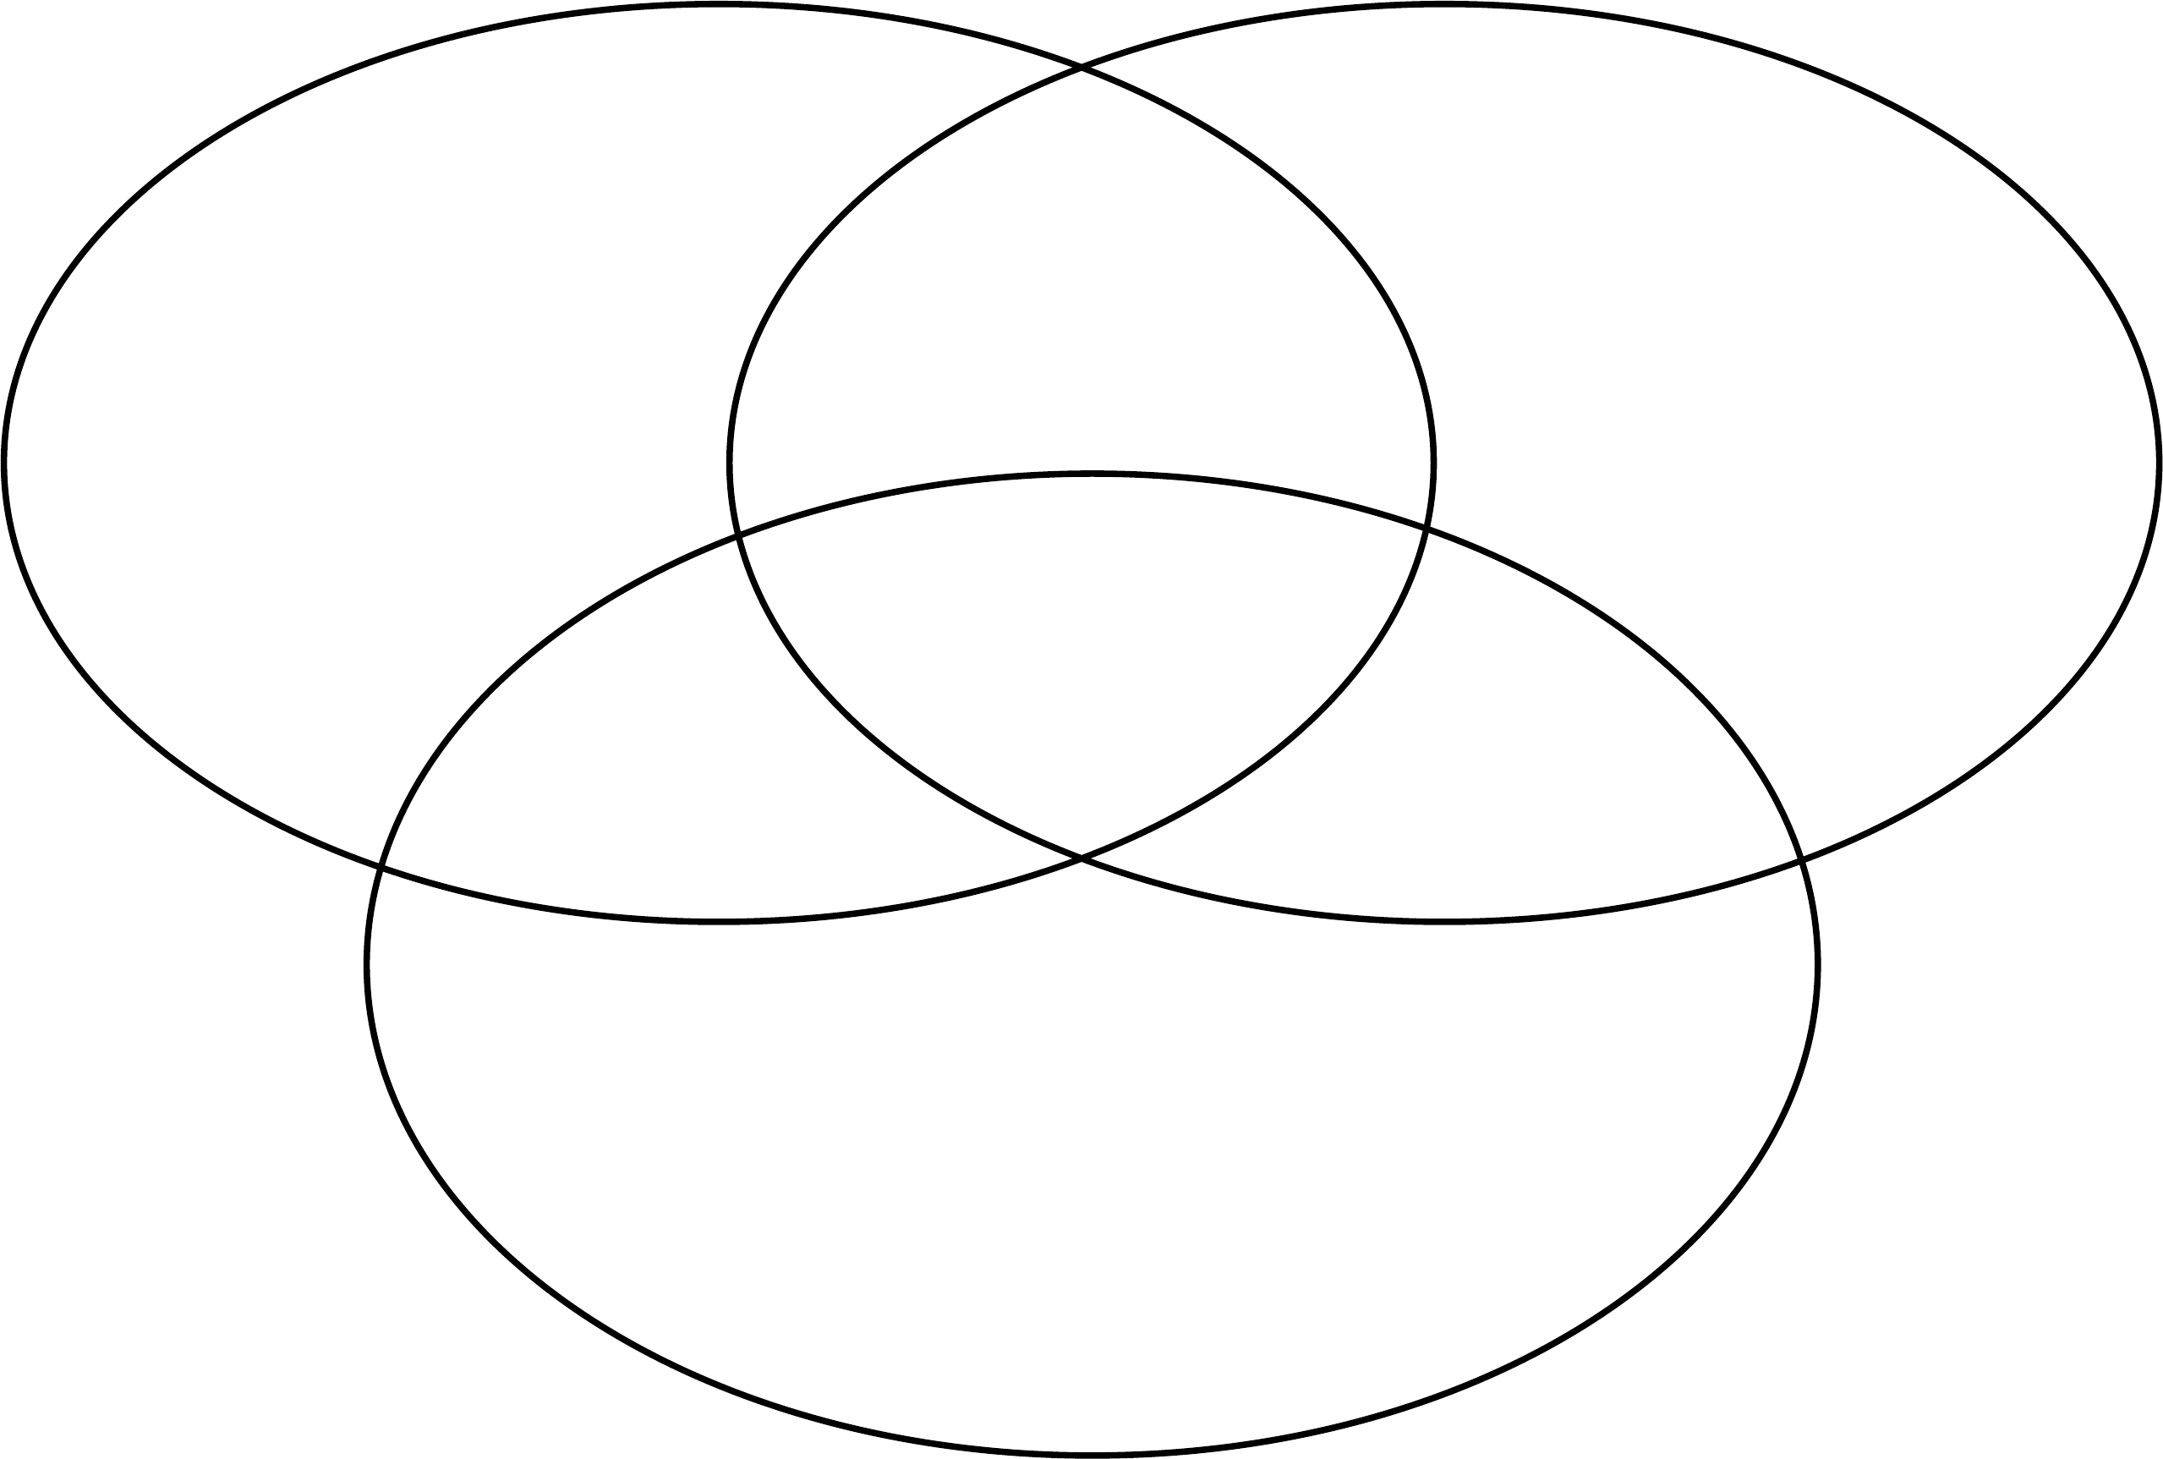

Thermal Energy (____): the ________________ kinetic energy of all the moving atoms in a gas

Temperature (____): the ________________ kinetic energy of the atoms in a gas.

|  |  |
| --- | --- |
| oC vs. K   * Spacing between divisions is ______________. * Abs Zero (-273.15 oC and 0 K) is the temp at which all particles __________________. * In labs, particles have been slowed to speeds corresponding to ________________. |  |

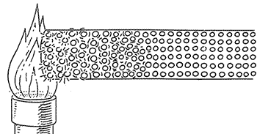

Heat (___): the ___________ of thermal energy (caused by a ____________ in temp)

**Thermal E** is transferred from the ____________ moving atoms to the ____________ moving atoms.

The process is known as _____________.

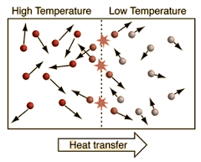Due to the **Law of Conservation of Energy**, Heat _____________ by one object must equal Heat _____________ by the second object.

|  |  |
| --- | --- |
| Example:  Three samples of gases made of the same element, sample 1, sample 2 and sample 3, have the same thermal energy. Sample 1 has twice as many atoms are sample 2. Sample 3 has twice as many atoms are sample 1. What can you say about the temperatures of the three samples?   1. T1>T2>T3 2. T3>T2>T1 3. T3> T1>T2 4. T2>T1>T3 5. T1=T2=T3   Example:  The temperature of the gas (air) inside a basketball is increased when pumped up. This means that…   1. Total EK of the gas decreases and Avg. EK of the molecules decreases 2. Total EK of the gas decreases and Avg. EK of the molecules decreases 3. Total EK of the gas increases and Avg. EK of the molecules increases 4. Total EK of the gas increases and Avg. EK of the molecules decreases | Example:  Hydrogen has a boiling point of 20.28 K. Find its temperature in Celsius.  Example:  A piece of metal at exactly 80 oC has its Celsius temperature tripled. By what does its Kelvin temperature increase? |

***Before we go any further we must ask ourselves… what the heck is Thermodynamics?***

**Up Next**: Laws of Thermodynamics

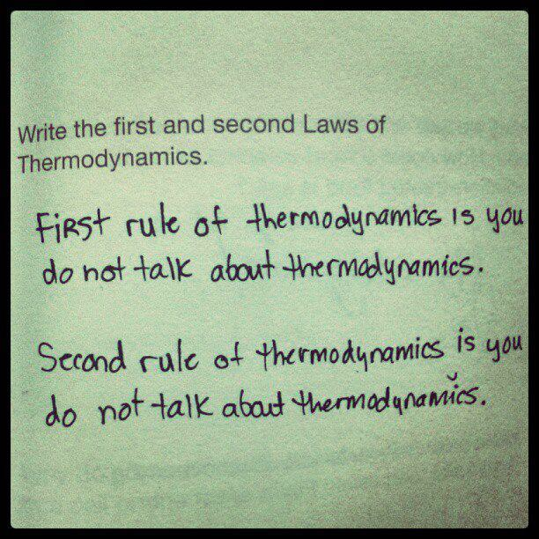 **Thermodynamics**

3 – Laws of Thermodyamics

Thermo…. …..Dynamics

In short… Thermodynamics deals with systems that are not ___________ changing, that are not ____________, but whose _____________ are _____________.

Where: ΔU=

W =

Q =

W > 0 Work done ____ the system. W < 0 Work done ____ the system.

Q > 0 Thermal Energy transferred ___ the system. Q < 0 Thermal Energy transferred _______ the system.

Since all the E terms cancel we are left with what is known as the __________________________

|  |  |
| --- | --- |
| Example:  Suppose we get our hands on an insulated container (Swell or Klean Kanteen), so that no gas can escape. If a piston is used to compress the gas what happens to the ***temperature*** of the gas? | Example:  If you mix food in a magic bullet the motor does work on the system (food inside the bullet!). This work can warm up food. Suppose the Magic Bullet operates at 250 W for 100 s. During this time 4500 J of heat flow from the now warm food to the surroundings. How much does the internal energy of the food change? |

*Whoops… We forgot something. Actually Everyone did…* ***The Zeroth Law of Thermodynamics***

|  |  |
| --- | --- |
| Zeroth Law of Thermodynamics: Thermal energy will be transferred from a _____________ object to a _____________ object until thermal equilibrium is reached.  Due to the Law of Conservation of Energy, Heat _____________ by one object must equal Heat _____________ by the second object  This was actually stated ***AFTER*** the First and Second Laws but scientists deemed it important that it preceded both Laws |  |

**Energy Transfer Diagrams**

|  |
| --- |
| Though Experiment:  If you drop a ***small*** hot rock in the Atlantic Ocean… What happens to the temperature of the ocean? |

Energy Reservoir: an object or part of the environment (________________) that is so _______________ its temperature does not change when thermal energy is transferred between the system and the reservoir.

|  |  |
| --- | --- |
| Cold Reservoir | Hot Reservoir |
| Temperature of ________ Reservoir ___ | Temperature of ________ Reservoir ____ |
| QC = The amount of ____ transferred to or from a ***cold*** reservoir | QH = The amount of ______ transferred to or from a ***hot*** reservoir |
|  |  |

Heat Engine: as heat is transferred from a _____________ reservoir to a _____________ reservoir, energy can be extracted and used in other ***useful*** forms!

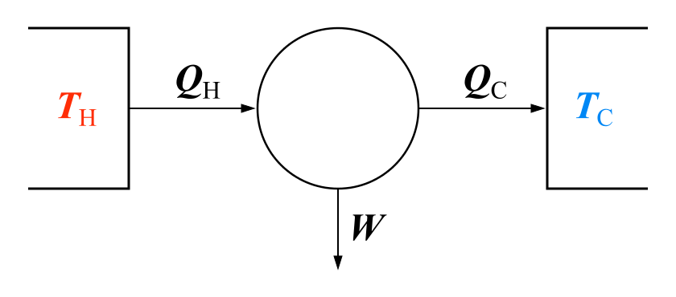

Heat engines are often judged on their efficiency. (note: Temperature ***must*** be in _____________.)



Therefore the bigger the _____________ between _____ and _____ the more efficient the Heat Engine will be.

|  |  |
| --- | --- |
| Example:  When one gallon of gasoline is burned in a car engine, 1.30 x 108 J of internal energy is released. Suppose that 1.12 x 108 J of this energy flows directly into the surroundings (engine block and exhaust system) in the form of heat. If 1.32 x 105 J of work is required to make the car go one km, what is the efficiency of the car?    How many km’s can the car travel on one gallon of gas? | |
| Example:  In the core of a nuclear reactor nuclear reactions produce steam at extremely high pressures at a temperature of 310 oC. The steam is used to generate energy (in a steam turbine) and condensed to water at 22 oC. The excess heat is transferred to a nearby lake. What is the maximum possible efficiency of the nuclear reactor? | Example:  Based on the options below, which will ***increase*** the efficiency of a heat engine?   1. Increase TC 2. Increase TH 3. Decrease TC 4. Decrease TH |



***Why not build a perfect Heat Engine you say?!***

Carnot’s Perfect Heat Engine: The most efficient heat engine allowed by ***Physical Laws***. (*check out the reading online for more details!*)

No heat engine can be ______ efficient. Some fraction of heat must be exhausted to the ____________________.

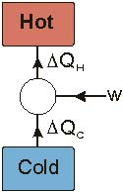This is a fundamental law of nature! (As stated by the _______________________________)

**Heat Pumps, Refrigerators and Air Conditioners (AC)**

Heat Pump: The _________ of a heat engine… transfers energy from a ______ reservoir to a ______ reservoir.

In order for this to “___________”…___________ must be done on the _____________! ☺

Inside a refrigerator, a heat pump moves _______ from it’s interior (___) to the outside air (___).

**2nd Law of Thermodynamics**

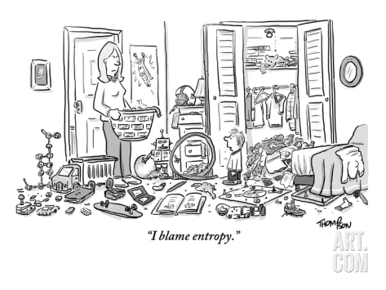

Entropy (S) (*Quantitatively*): the _____________ that a certain state will occur…. (confusing)

Entropy (S) (*Qualitatively*): a measure of ________… greater S = greater _______ (less confusing)

If left to it’s own devices ***order*** turns into ***disorder/randomness/chaos***…

*If your bedroom is currently in an extremely clean state: High Entropy/Low Entropy?*

The 2nd Law… **S ≥ 0** *Entropy of an isolated system never* _____________*.*



|  |
| --- |
| ***Do living organisms violate the 2nd Law***?  The argument goes evolution is a decrease of entropy, because it involves things getting more ***organized*** over time, while the second law says that things get more ***disordered*** over time. ***So evolution violates the second law.*** Do you ***agree*** or ***disagree***? Explain below. |
| Energy Conservation  We have been asked for years to turn of lights, bike to work/school, and to turn down the heat. But if energy can neither be created or destroyed why are we “*conserving energy*”? How can there be an energy crisis? Explain your thoughts below. |

**Thermodynamics**

4 – Ideal Gases

A _____________ is a _____________ that allows us to measure the _____________ of something.

1 mole of a substance = _______________ particles of that substance

|  |
| --- |
| Example:  A system contains 200.0 g of nitrogen gas. How many moles does it contain? How many molecules? |

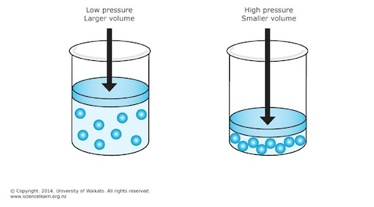Ideal Gases

Unlike solids and liquids… gases are ____________________.

If you increase the temperature of a gas it should make sense that the average _________________ energy also increases.

**Energy of the Particles:**_____________ *is a direct measure of the* _____________ *Kinetic Energy of the particles.*

In fact we can describe the relationship between temperature and kinetic energy with the following equation…

|  |  |
| --- | --- |
| Where: kavg =  kb =  T =  And…  Where: E =  N =  n =  R = | |
|  |  |
| Example:  A science classroom contains 7.0 x 1027 molecules of air. Find the energy required to raise the temperature from 11 oC to 25 oC. How long would it take if the radiator operates at 960 watts and is 90% efficient? | |

If _____________ in a gas is due to _____________ of a particle with the walls of a container… *determine the following relationships*.

|  |  |  |
| --- | --- | --- |
| When ***temperature*** of the gas particles increases, ***pressure*** will… | When ***volume*** of a container increases, ***pressure*** will… | When the ***number of gas particles*** increases, ***pressure*** will… |
| P α | P α | P α |

Therefore…

Where: C =

More traditionally written as….

|  |  |  |
| --- | --- | --- |
|  | |  |
| Where: N =  kb = | | Where: n =  R = |
| Example:  What volume (in litres) is occupied by 2.0 moles of an ideal gas at 2.00 atm and a temperature of -2.0 oC? | Example:  A cylindrical container of radius 15 cm and height 0.30 m contains 0.60 mol of gas at 433 K. Find both the pressure (in kPa) in the container and force extered on the lid of the container. | |

**Thermodynamics**

5a – Ideal Gas Processes

|  |  |
| --- | --- |
| **PV Diagrams** | |
| * A _____________ vs. _____________ Graph. * Represents an ideal _____________. * Each point on a PV diagram represents a _____________ of Values (_____________). |  |

**4 Processes** **– Iso**choric, **Iso**baric, **Iso**thermal, and Adiabatic

Remember… **Iso** = _____________

|  |  |  |
| --- | --- | --- |
| **Isochoric Process** | | |
| * Constant _____________ process. * While _____________ is constant… _____________ is ***not***! * The gas is _______________ in a _______________ container (Vi = Vf) |  |  |

|  |  |
| --- | --- |
| Example:  A certain Gas of volume 0.40 m3, pressure of 4.5 bar and temperature of 1300 oC is heated to in a cylinder to 9.0 bar when the volume remains constant. Calculate the temperature (in Kelvin) at the end of the process. (1 bar = 100,000 Pa) | Example:  On a cold morning the pressure inside a car tire is 28.0 psi when the temperature is 2.0 oC. As the sun comes out the tire warms the black tire and the temperature reaches 28 oC. What is the tire pressure (in psi) at this temperature. (1 atm = 14.7 psi) |

|  |  |  |
| --- | --- | --- |
| **Isobaric Process** | | |
| * Constant _____________ process. (Pi = Pf) * Constant _____________ can be achieved with a __________ when __________ is applied to the gas. |  |  |

|  |
| --- |
| Example:  A movable piston is placed on a 3.0 L cylinder containing a gas at 60.0 oC. The gas is then cooled until the final temperature is 20 oC. What is the final volume that the gas occupies? |

|  |  |  |
| --- | --- | --- |
| **Isothermal Process** | | |
| * Constant _____________ process. (Ti = Tf) * Can be achieved by using a _________________.   ________________: (or _______________) is a thermodynamic system with a **heat** capacity that is large enough that when it is in thermal contact with another system of interest or its environment, its temperature remains effectively constant. *Remember the rock in the Atlantic Ocean?* |  |  |

|  |
| --- |
| Example:  A south pacific pearl diver takes a deep breath at the surface of the ocean. She fills her lungs with 4.5 L of air, and then dives to a depth of 6.0 m. At this depth what is the volume of air occupied by the pearl diver’s lungs? *Wait… do we need to remember something from the previous unit? Classic Flawson…* |

***Isothermal*** ______________ occurs when the gas ______________ and does work on the ________________.

***Isothermal*** ____________ occurs when the gas _____________ and the _____________ does work on the gas.

|  |  |
| --- | --- |
| **Adiabatic Process** | |
| * Constant ______________ process. (Q = 0) * Change in ______________________! * Therefore… from the ____________________________   An adiabatic ______________________________ the temp of the gas.  An adiabatic ______________________________ the temp of the gas.  This process allows one to use ____________ instead of ____________ to change the temperature of a gas. |  |

**Thermodynamics**

5b – Thermodynamics of an Ideal-Gas Process

Remember that _________ and _________ are just two different ways to add ___________ to a system.

When a gas expands (an expanding piston) the gas can do work on their surroundings.

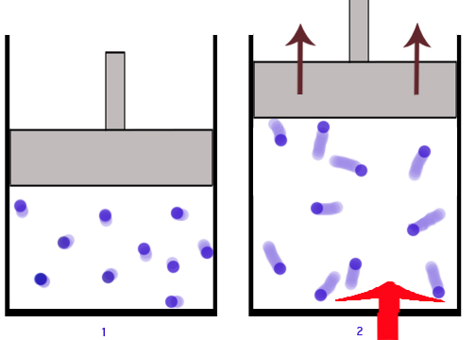

When a *constant Force* pushes ***down*** on a piston object Work can be calculated….

|  |  |
| --- | --- |
|  |  |

And equally important…. Work is the _____________ under PV graph between Vi and Vf. (ΔV)

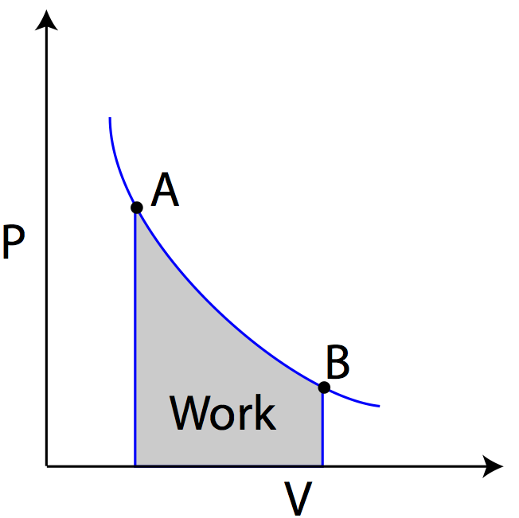

**Ok… A couple of important details**

* In order for a _______ to do work its _____________ must change
* You will ________ see simple shapes (Squares, Rectangles, Triangles) on a PV Diagram
* _____________ must be in Pascal’s (Pa); _____________ in m3
* Wgas 0 if the gas _____________; (think about it… Energy is being transferred _______ of the system)
* Wgas 0 if the gas is _________________; (Energy is being transferred ________ of the system)

**A very useful Table!**

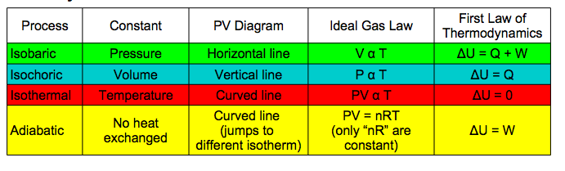

|  |
| --- |
| Example:  A substance undergoes a cyclic process shown in the graph. Heat transfer occurs during each process in the cycle.   1. What is the work output during process ***a*** 🡪 ***b***? 2. How much work input is required during process ***b*** 🡪 ***c***? 3. What is the net (total) work done during the cycle?   Note: 1 atm = 1.01 x 105 Pa  Note: 1 L = 0.001 m3 |

|  |
| --- |
| Example:  A heat engine’s cycle is shown in the PV diagram to the right.  ***P1*** = 345 kPa, ***P2*** = 245 kPa, ***P3*** = 125 k Pa, and ***P4*** = 225 kPa. ***V1*** = 35.0 L and ***V2*** = 85.0 L.  What is the net work done during one cycle of the engine?  Note: 1 L = 0.001 m3 |

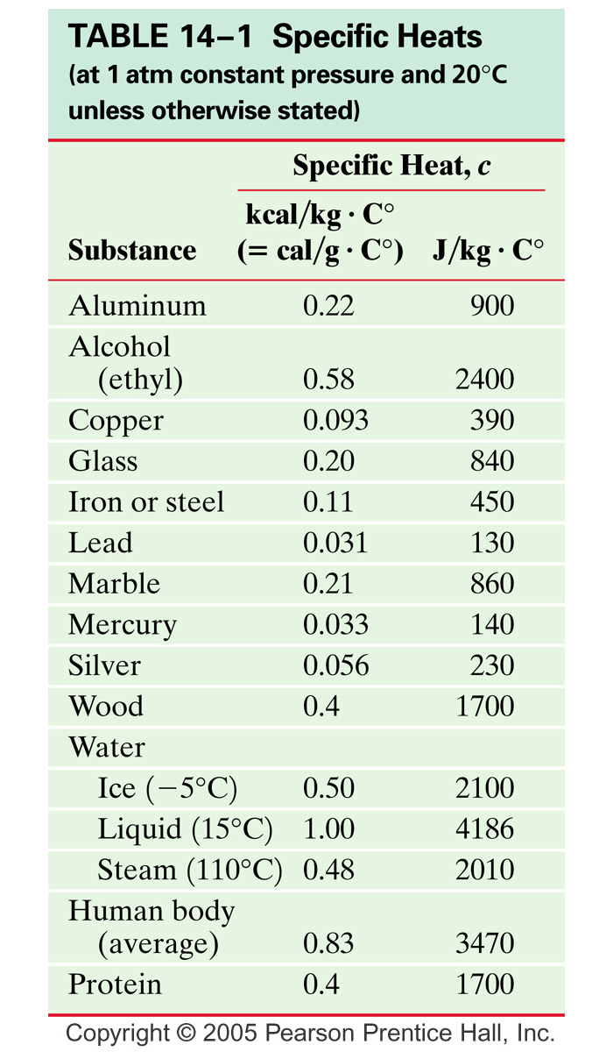 **Thermodynamics**

6 – Specific Heat

Specific Heat (____): refers to the _______________________ required to ____________ the temperature of 1 kg of a substance by 1 K (or 1 OC).

But what if you had ***more*** (or ***less***!) than 1 kg…

Where: Q =

m =

c =

ΔT =

|  |  |
| --- | --- |
| Example:  Copper vs. Water  cwater = 4186 J / kg oC  ccopper = 389 J / kg oC  Starting with 1 gram of copper at 0 oC and 1 gram of water at 0 oC. If you then raised the temperature of each by 1oC which substance required a larger heat input? Why? | Example:  Mr. Sandor, who currently weighs in at 85 kg’s, just caught the flu (***oh no…*** ***☹***). His body temperature increased from 37.0 oC to 39.0 oC. How much energy was required to raise the body’s temperature? |

Hot Object added to a Cold Liquid

|  |  |
| --- | --- |
| ΔQ = 0 (if it’s a __________ system)  Q heat _____ = Q heat _______  Q ________ = Q _________  In this case….  -Qhot = Qcold  -mhotchot(Tfinal - Thot) = mcoldccold(Tfinal-Tcold) | Example:  500. grams of 20.0o C water is added to 700. g of 85o C water. What is the final temperature of the mixture? |
| Example:  We wish to determine the specific heat of a new alloy. A 0.150 kg sample of the alloy is heated too 540 oC. It is then quickly placed in 400. g of water at 15.0o, which is contained in a 200. g aluminum calorimeter cup. (*Assume that the insulating jacket insulates well, so the temperature does not change significantly*). *The final temperature of the mixture is 30.5 oC*. ***Calculate the specific heat of the alloy***. | |

Phase Change: When a substance changes state (example: _____________; OR _____________)

|  |  |
| --- | --- |
|  |  |

Notice how at certain points _____________ is added to the system but _____________ does not increase….

Energy is required to separate ____________ from each other and therefore does not increase their __________ energy (***temperature***)

Where: Q =

m =

Lf =

Lv =

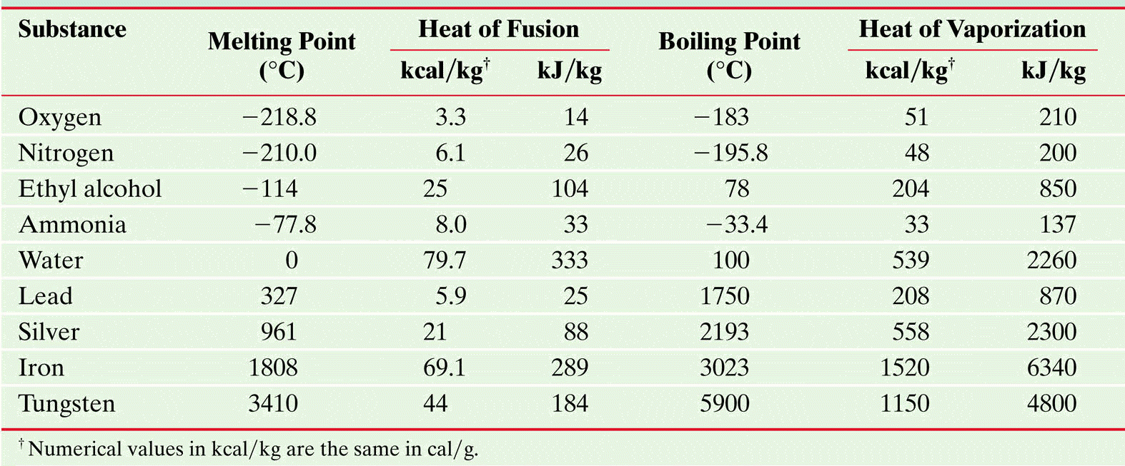

|  |
| --- |
| Example:  How much energy does a refrigerator have to remove from 1.5 kg of water at 20.0 oC to make ice at -12 oC. |

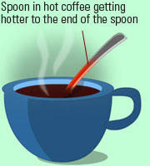Conduction: Thermal Energy can be _____________ from one material to another in a _______________ known as ***heat***.

The only requirement for heat transfers is a difference in ___________________.

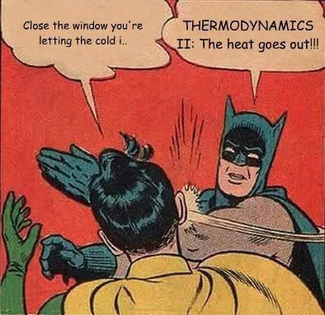

**Ok… A couple *MORE* important details**

* Q increases if the ___________________________ (ΔT) is increased
* Q increases if the _____________ of the object increases
* Q increases if the _____________ of the object is decreased
* Some _____________ transfer heat better than others… (k = thermal conductivity)

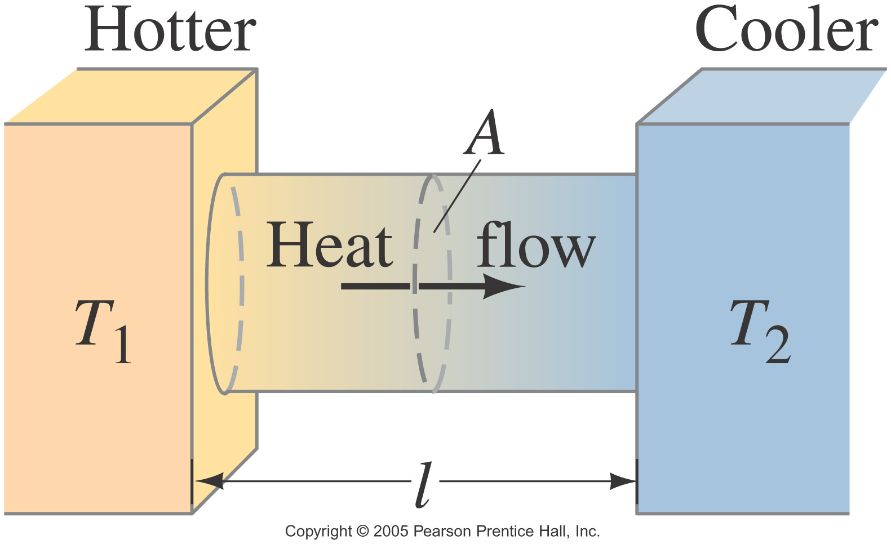

Where: Q =

Δt =

k =

A =

ΔT =

L =

|  |  |
| --- | --- |
| Example:  If air has such a low thermal conductivity (0.22), why do we need to wear clothes? If we omit the obvious answer… ***decency***!  Example:  Suppose you sit down on a 8.0 oC concrete bench. You are only wearing a thin layer of clothing that provides negligible insulation and therefore your core temperature (37 oC) is only protected by 1.2 cm thick layer of fat (*on your bum!*) that touches the bench. Let’s estimate the area of contact between your self and the bench to be 0.10 m2. What is the heat loss due to conduction? |  |

***FYI***… There are two other means to transfer thermal energy…

|  |  |
| --- | --- |
| Convection: Transfer of thermal energy by __________ in fluids. | Radiation: transfer of thermal energy through ______________________ waves. |
|  | |

Putting it all together!

|  |
| --- |
| Example:  When the weather gets cold, the air we breathe in is heated when it comes in contact with warm lung tissue. The energy to heat the air comes from our body. The inhaled air warms to nearly the temperature of the interior of a human body 37 oC. When humans exhale, some heat is retained by the body, but most if lost. We will assume the exhaled air is about 30 oC.  A typical person takes 12 breaths each minute, with each breath taking in about 0.50 L of outside air. If the air outside is -10 oC and is heated to 30 oC…   1. What is the volume of exhaled air with each breath? 2. Find the heat and the heat power required to warm one breath of air (MM = 29 g/mol and specific heat = 1.01 kJ/(kg oC)). (*the gases are exchanged as you breath – Oxygen to Carbon Dioxide – but to a good approximation the number of atoms, stay the same*).   Note: consider only the energy required to warm the air, not the energy lost to evaporation from the tissues of the lungs. |

**Thermodynamics**

7 – Thermal Expansion

Thermal expansion results from a ____________ in the _____________________between the constituent atoms in a solid, liquid or gas.

|  |  |
| --- | --- |
| Imagine that the atoms are connected by stiff springs. (*See to the right*)  At ordinary temperatures the average spacing between the atoms is about 10-10 m while oscillating about their equilibrium positions with an amplitude of approximately 10-11 m at a frequency of approximately 1013 Hz.  As the temperature of the solid _____________, the atoms oscillate with greater amplitudes; as a result, the average separation between them _______________.  Consequently, the object _____________. |  |

We can quantify both the _____________ and the _____________ expansion of materials using the following formula’s:

|  |  |
| --- | --- |
| Where: ΔL/ΔV =  α/β =  Lo/Vo =  ΔT = |  |

|  |  |
| --- | --- |
| Example:  A steel railroad track has a length of 30.000 m when the temperature is 0.0 oC. What is its length when the temperature increases to 40.0 oC? | Examples:  A glass (*made of glass*) filled water with ***EXACTLY*** 1.0 liter is ***completely*** filled at 5°C. How much water will spill out of the glass when the temperature is raised to 85°C? |