Fluids Notes
1 – Hydrostatic Pressure

Fluid: a substance that _____________. Fluids can be both _____________ and ____________.

While gases can be ________________ (due to empty ___________ between particles) ______________ (like solids) cannot.

Gases can also _________________ when volume is increased.
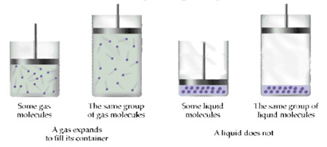
Density: the ________________ of something in a given ________________.

Mass Density…
Where: ρ =  m =  V = | Material ρ (kg/m³)  Air (20 ºC) 1.2  Air (0 ºC) 1.28  Helium (0 ºC) 0.179  Liquid hydrogen 70  Mercury 13,546  Water (fresh) 1,000  Water (salt) 1,030  Gasoline 680  Ethyl Alcohol 790  Blood 1060  Glycerin 1260

Example:  Rank samples A,B,C in order of ascending densities.  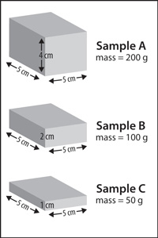 | Example:  What is the mass of air in a living room with dimensions 4.0 m x 6.0 m x 2.5 m?  If the living room was converted into a swimming pool what would the mass be of the same swimming pool filled with BLOOD!? Mr. Lawson did you just go there!?

Some other interesting Densities…
Entity ρ (kg/m³)  Interstellar medium 1 × 10⁻¹⁹  The Earth 5,515  The inner core of the Earth 13,000  The core of the Sun 33,000–160,000  Super-massive black hole 9 × 10⁵  White dwarf star 2.1 × 10⁹  Atomic nuclei 2.3 × 10¹⁷  Neutron star 1 × 10¹⁸  Stellar-mass black hole 1 × 10¹⁸ | Example:  How large would a white dwarf star be if it has the same mass as planet Earth?  Example:  What is denser an atomic nuclei or neutron star? What does this suggest?

Pressure: a ratio of the _________________ exerted vs. the _____________ it is exert on.

Where: p =  F =  A =  We will mostly use ________________ and ________ (1 atm = the weight of 1 atmosphere)  Did you know…? 99% of the mass of the atmosphere is below 30 km? | 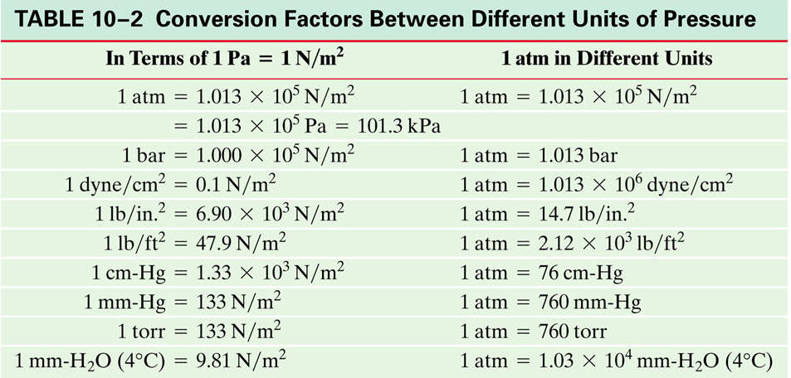

Hydrostatic Pressure: The pressure exerted by a fluid at ________________ at a ________________________ within the fluid.

We can determine the pressure within a liquid by using a ________________.

Where: P =

P_{o} =
ρ =
g =
d =

Example:  A submarine cruises in the ocean at a depth of 300. m. What is the pressure at this depth? Give your answer in both Pascal’s and atmospheres. | Example:  A fresh water research submarine has a circular 20. cm diameter window that is 8.0 cm thick. The manufacturer says the window can withstand forces 1.0 x 10⁶ N. What is the submarine’s maximum safe depth at sea? The pressure inside the submarine is 1.0 atm.
Gauge Pressure is used when fluids exist in a ______________________, like _______________________.

Gauge Pressure = Absolute Pressure – Atmospheric Pressure = _______________

Pascal’s Principle….

When _____________ is applied to a confined fluid, the _________________________ is transmitted ________________ to all parts of the fluid.  This principle is used in _______________ (a liquid moving in a confined space under pressure) lifts….  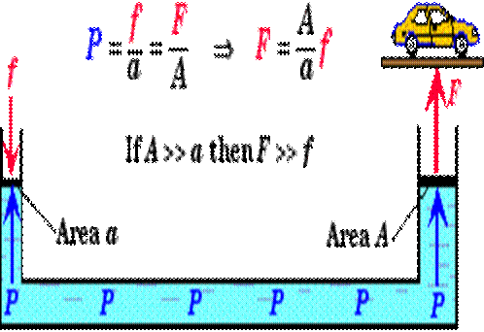 |  | 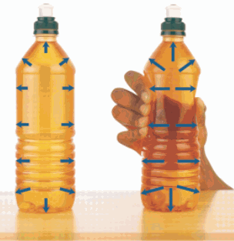
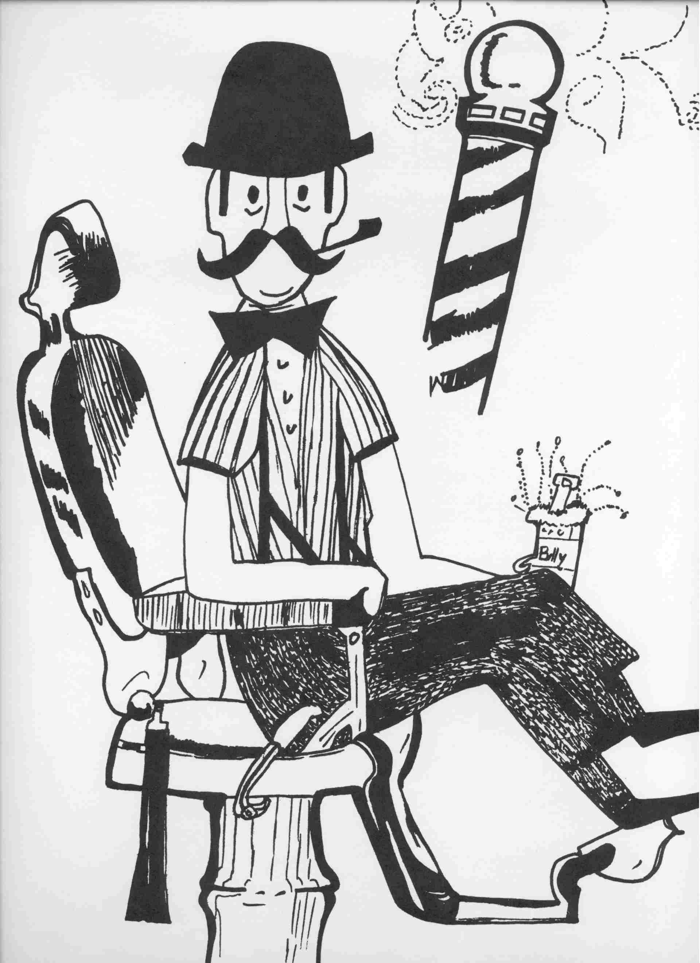  Example:  A barber raises his customer’s chair by applying a force of 150 N to a hydraulic piston of area 0.010 m². If the chair is attached to a piston of area 0.10 m², how massive a customer can the chair raise? Assume the chair itself has a mass of 5 kg. | Example:  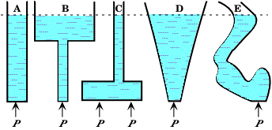  Which of the following is under the great pressure at point p?

Devices to measure gas pressure
Manometer | Barometer
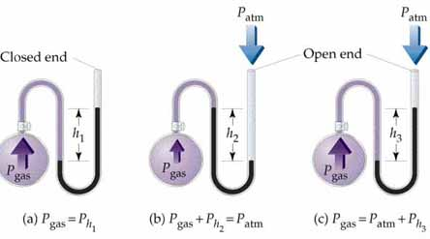 | 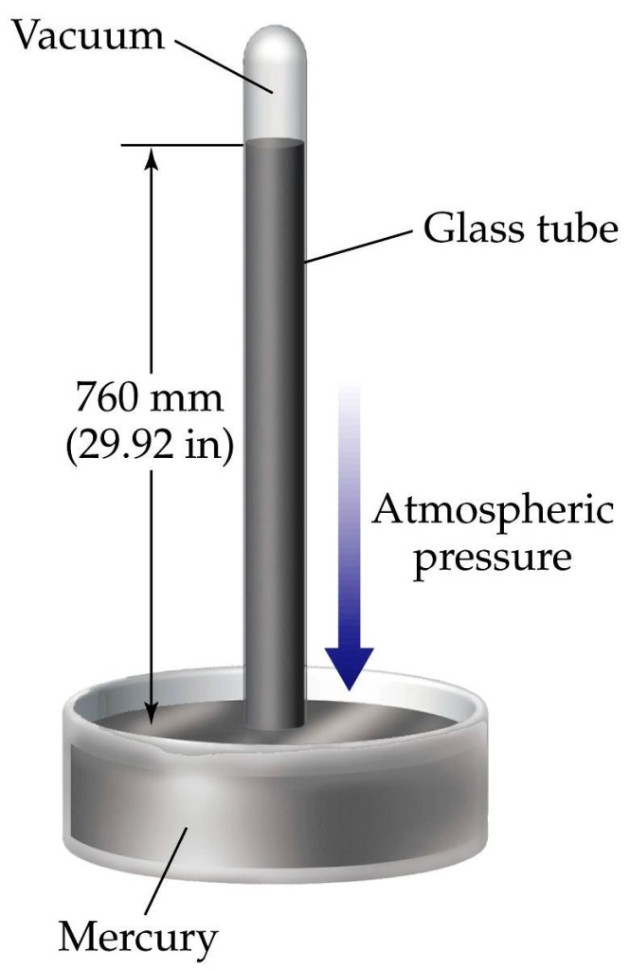
U-shaped tube connected to __________ at one end and ______________________ at the other  Tube is filled with a liquid (often _____________)  The liquid exists in __________________________________ (forces are ___________) | The glass tube is filled with mercury inverted and placed on a dish of mercury  While some of the mercury _____________ the tube, P_{atm} pushed ________ on the dish eventually creating ____________________________.
Blood Pressure – Bio Connect…. I know… Eww

On average, a human heart beats ___________________ in _____________ (___________________)

The heart circulates blood to all parts of the body, allowing _____________________ and ___________ to diffuse substances _______ and ________ of cells.

Arteries carry ______________________ blood to cells due to the contraction of heart muscles causing arteries to become ______________________.
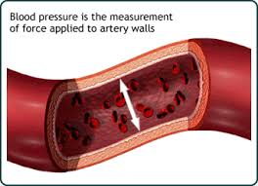
Blood pressure is measured using both…

Systolic: the ________________ blood pressure Diastolic: __________ blood pressure
120/80

Example:
Postural hypotension is the occurrence of low (systolic) blood pressure when standing up too quickly from a reclined position, causing fatigue or lightheadedness. For most people, a systolic pressure of less than 90 mm Hg is considered low. If the blood pressure in your brain is 120 mm when you are lying down, what would it be (in mm Hg) when you stand up? Assume that your brain is 40 cm from your heart. Note: normally blood vessels contract and expand to keep your brain blood pressure stable when you change your posture.

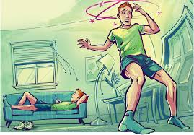

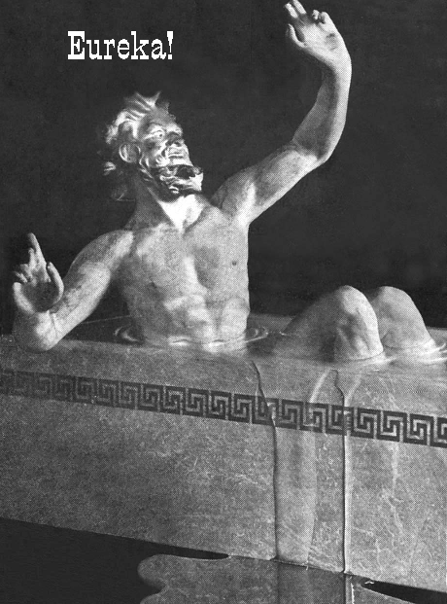
Fluids Notes
2 – Buoyant Force

The Story of Archimedes…

The story handed down through the generations is that Hiero, a king of the Greek city of Syracuse, gave a goldsmith a lump of gold and told him to make a royal crown. When the goldsmith brought the crown to the king, it weighed the same as the lump of gold Hiero had given to him. King Hiero began to ponder on the honesty of this craftsman. He was not certain, but he suspected that the goldsmith had kept some of the gold for himself and had mixed silver with the rest of it to make the crown heavy. That is when Hiero called Archimedes and asked him to discover the truth, but without melting the crown down.
Archimedes knew this would be a difficult problem to solve and wondered how to go about it. The answer came suddenly! One day as Archimedes was lowering himself into one of the public baths in the city, he noticed that some water flowed over the sides of the tub. It is said that he became so excited that he ran out of the bath house through the streets of Syracuse, yelling, "Eureka! Eureka!" In Greek it meant, "I found it! I found it!"
Archimedes then needed to make an experiment to prove this idea of his. First, he weighed the crown. Then, he took a lump of gold and of silver, each weighing the same as the crown. The silver lump was larger because silver is lighter than gold. It takes much more silver to weigh as much as the lump of gold.
He put each lump in a vessel. The vessels were filled to the rim with water. The larger amount of silver caused more water to overflow than the lump of gold did, although both weighed the same. Archimedes knew then that any solid material will push away an amount of water equal to its own bulkiness, or volume. If the crown were pure gold, it would have to push away, or displace the same amount of water as the lump of pure gold that weighed the same.
But the crown made more water overflow than the lump of gold had. Was the goldsmith honest or dishonest? He was dishonest. He had added silver to the crown to make it bulkier. The king found him guilty of stealing.
Archimedes continued experimenting and found that what he learned could be used as a rule. This rule could be used for things that could float as well as for things that sink. Any object that floats will displace its own weight of water. Any object that sinks will displace an amount of water equal to its own volume. Volume is the amount of space an object takes up.
What is weight? Weight tells how heavy something is. What is volume? Volume tells us how much space it takes up. Do a pound of butter and pound of marshmallows both weigh the same? Yes! But, if you make a pile from a pound of marshmallows, you discover that it takes up much more space, or volume.
Which apple falls faster…? Draw and FBD for each!

Apple Dropped in Air | Apple Dropped in Water
 | 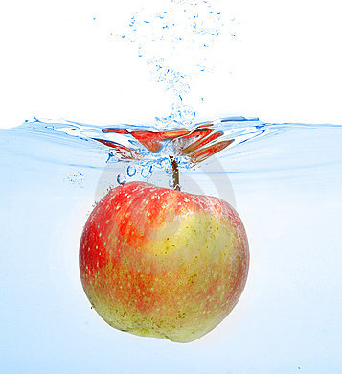

Archimedes’ Principle: A fluid exerts an ______________________ on an object that is immersed in or floating in a _____________.

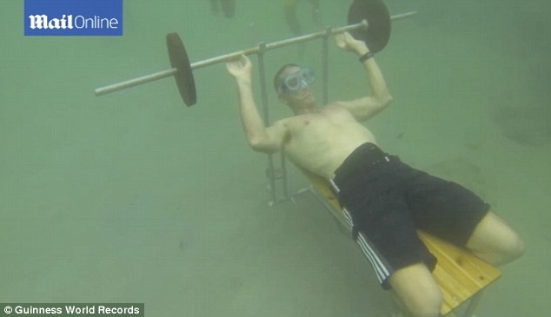
You’ve probably noticed this principle while _________________________ (or yourself) in pools, lakes or oceans!

In fact the world record for bench-pressing 110 lbs is currently 36 reps! (Highly Beatable!)

That upward force is known as _____________________ (____) and due to the pressure difference at the ________ and ___________ of an object in a fluid.
Forces due to pressure of Fluid | FBD
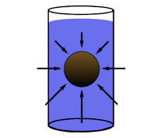

We can derive F_{b} from the pressure differential at the Top and Bottom of an object in water.

Where: F_{b} =

ρ_{f} =
V =
g =
Example:  A crown weighing 8.30 N is suspended underwater from a string. The tension in the string is measured to be 7.81 N. Is the crown pure gold? (Density of gold = 19,300 kg/m³)  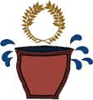 | 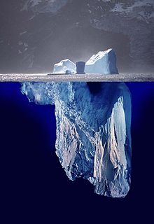  Example:  An iceberg floating in seawater is extremely dangerous because much of the ice is below the surface. The hidden ice can damage a ship (remember the Titanic?) that is still a considerable distance from the visible ice. What fraction of the iceberg lies below the water level? (ρ_{ice} = 917 kg/m³)

Floating objects that are not fully immersed are at ______________________________.

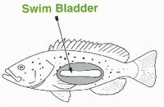
Swim Bladders

Fish have built-in mechanisms that allow them to move up and down and side to side in their environment.

Most fish rise and sink in the water the same way a hot air balloon rises and sinks in the air.

Most fish have an _________________________; much like a human lung that allows it to ________________ or _______________ the volume of water it displaces without changing it’s _________________ appreciably.
This allows it to ____________ or _____________.

Float or Sink?

Determine if an object floats or sinks we must compare…. ____________________ with ______________________.

 | 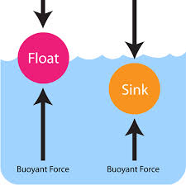 |  | If the object is ____________ dense than water it will ______________.  If the object is __________ dense than water it will ___________.
Example:  A ferryboat is 4.0 m wide and 6.0 m long. When a truck pulls onto it, the boat sinks 4.00 cm in the water. What is the weight of the truck?  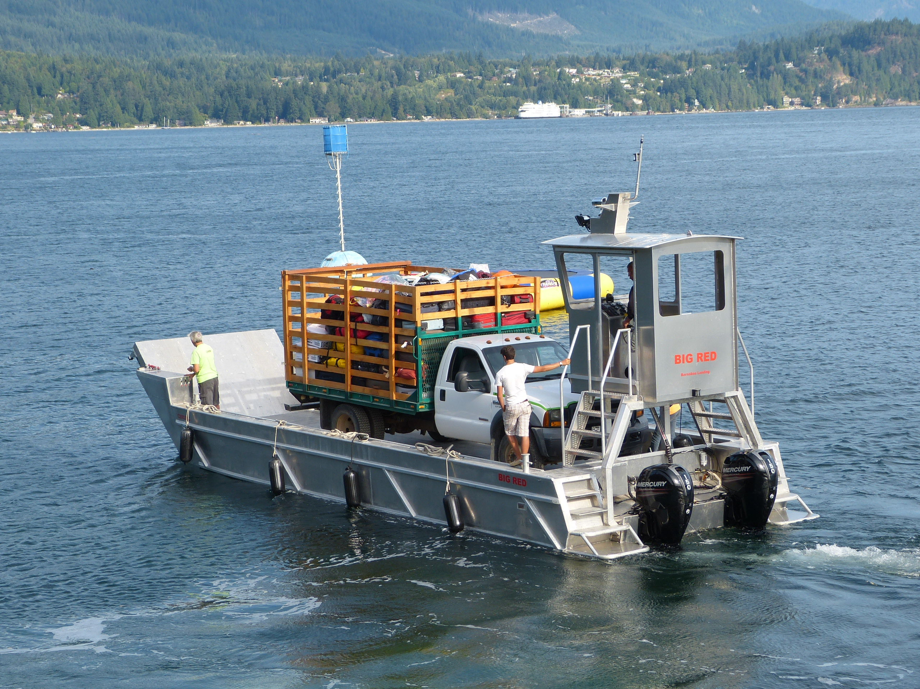 |  | Example:  An empty rubber balloon has a mass of 0.0120 kg. The balloon is filled with helium at 0°C, 1 atm pressure. The filled balloon has a radius of 0.500 m and is perfectly spherical. What is the magnitude of the buoyant force acting on the balloon?  What is the magnitude of the net force acting on the balloon?

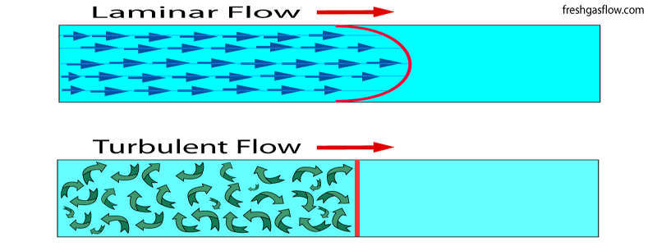
Fluids Notes
3 – Hydrodynamics

So far we have only dealt with fluids at _____________ (Hydrostatics).

Now we will address fluids in ______________ (Hydrodynamics)
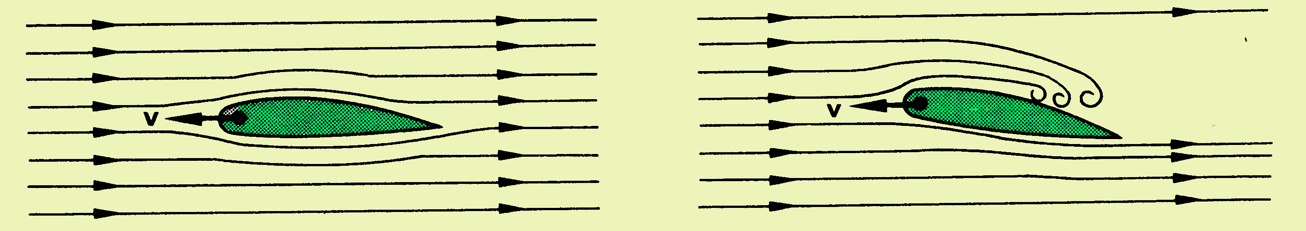
Before we do so we must made 3 assumptions

- Fluids are _______________________________.
- Laminar flow; Fluids flow is _____________________ and therefore it’s flow rate is _____________________.
- Fluid flow is ________________ (the higher the ______________ the more resistant to flow Ex: ______________________)
Flow Rate (ƒ): _______________ of fluid that passes a particular point in a given _______________.

Where: V =
A =
ν =

Equation of Continuity: _______________ is constant at _____________ points in a closed tube.
Since ____ of a fluid entering one part of a tube or pipe much be matched by an equal ____ of the same fluid at another part of a tube or pipe.  Fluids flow ____________ at the narrower parts of the tube/pipe and ____________ at the wider parts of the tube.  This is really just a statement of the Law of Conservation of ___________… |  | 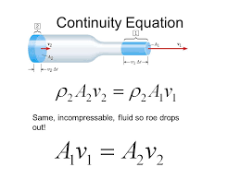
Example:  The radius of the aorta is about 1.0 cm and the blood flowing through it has a speed of about 30 cm/s. Calculate the average speed of the blood in the capillaries given the total cross section of all the capillaries is about 2000. cm². | Example:  A garden hose has an inside diameter of 16 mm. The hose can fill a 10. L bucket in 20. s. What is the speed of water out of the end of the hose?  What diameter nozzle would cause the water to exit with a speed 4 times greater than the speed inside the hose?

Continuity describes a moving fluid but _________________ the fluids moves…
Venturi Meter
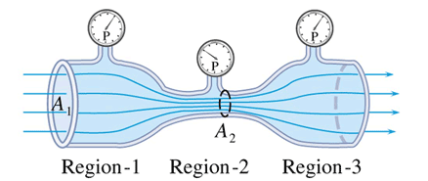

Which area(s) have the highest pressure? Region 1 Region 2 Region 3

Energy due to ______________ gets converted into energy due to _______________ (____________ energy)

The higher the _______________ the lower the _____________... this is stated in _____________________…

Example:
A small ranger vehicle has a soft, ragtop roof. When the car is at rest the roof is flat. When the car is cruising at highway speeds with its windows rolled up, does the roof
- bow upward
- remain flat
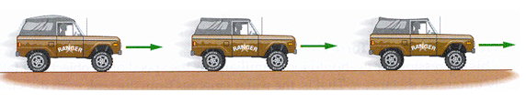
- bow downward?

Bernoulli’s Equation… A Statement of the Law of Conservation of _______________

Law of Conservation of Energy: Energy can neither be ________________ nor ____________ in a pipe/tube.

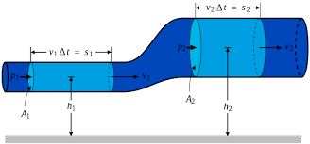
Derivation…

Bernoulli’s Equation Where: P =
ρ =

v =
g =
h =

Example:  Water at a pressure of 385035 Pa at street level flows into an office building at a speed of 0.60 m/s through a pipe 5.0 cm in diameter. The pipes taper down to 2.6 cm in diameter by the top floor, 20.0 m above. Calculate the flow velocity and the pressure in such a pipe on the top floor. | Example:  A very large storage tank, open to the atmosphere at the top and filled with water, develops a very small hole in its side at a point 9.2 m below the water level. If this hole is 2.0 m above the ground, how far (measured horizontally) from the base of the tank does the water strike the ground?  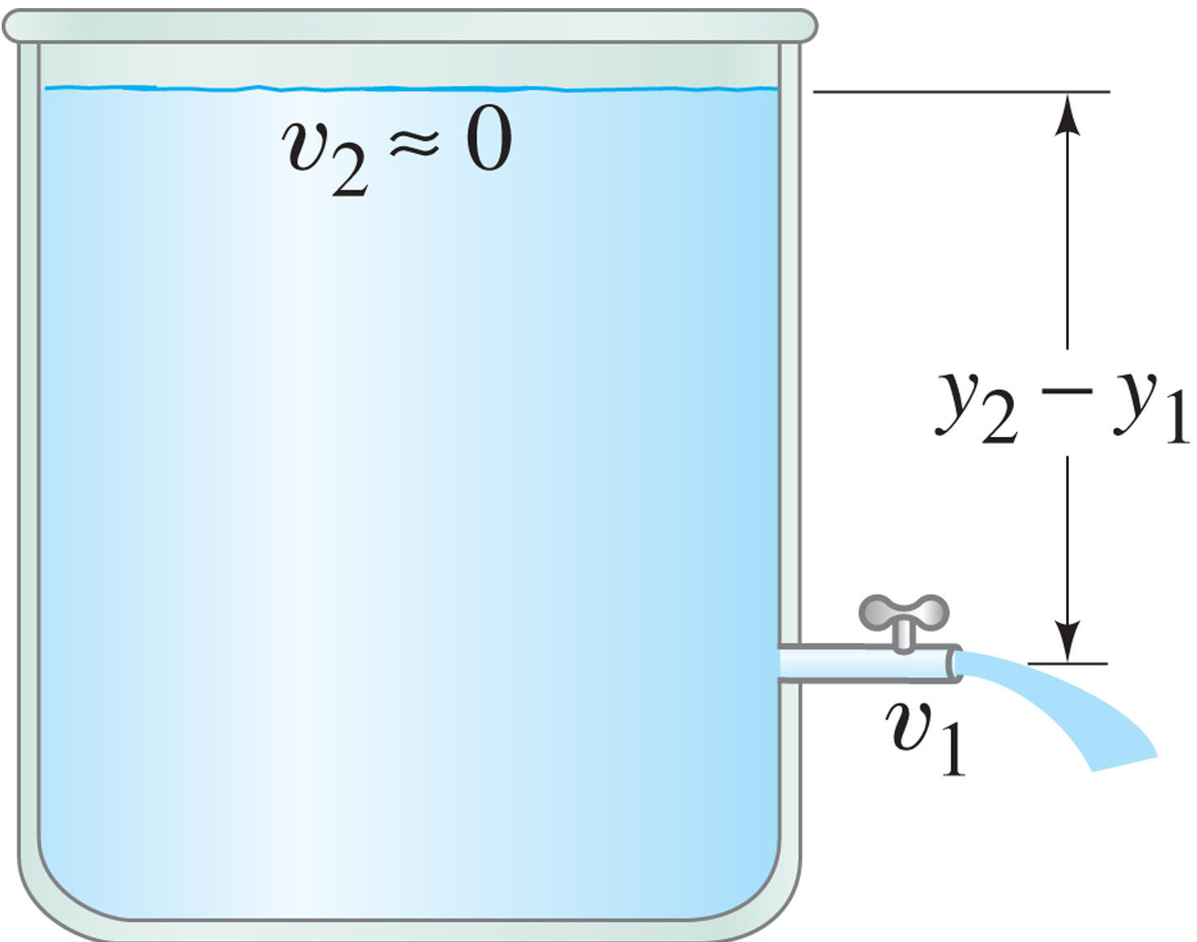

Application: Airplanes generate lift!

Bernoulli discovered that a faster moving fluid has exerts _________________ than a slower moving fluid.
The air (_________) moving of the _______ of the wing encounters an obstacle that it must go around and therefore its speed ______________ and its pressure __________.
The difference in pressure between the bottom and top of the wing results in more _______________ at the bottom, thus pushing the wing ______________ into the sky. This is ________________.
Example:
What is the lift (in Newtons) due to Bernoulli’s Principle on a wing of area 80.0 m² if the air passes over the top and bottom surfaces at speeds of 340. m/s and 290. m/s, respectively?

