``Nessie

A monster snake, 45 m long, hides under water. The picture below shows the area where the monster is hidden. Each square represents 1 meter. Parts of the snake’s body are connected horizontally or vertically across the squares on the picture below. Above the surface, there is only his head (1), tail (45) and 23rd meter part of body (23). The yellow numbers on the margins show how many squares the snake’s body parts in the corresponding row or column occupy. Black squares are stones, where the snake can't be.
So where is the snake?
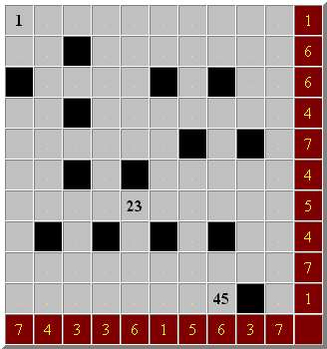

Solution:

