Mock Exam AP PHYSICS 2 Multiple Choice QUESTIONS
AP PHYSICS 2 SECTION I Time—35 minutes 20 Questions
Directions: Assume gravity to be 10 m/s² Answer all twenty questions, which are each weighted equally. No marks are taken off for wrong answers. Place all answers on the bubble sheet provided.
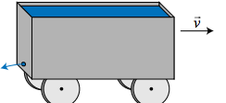
- A cart full of water travels horizontally on a frictionless track with initial velocity v. As shown in the diagram, in the back wall of the cart there is a small opening near the bottom of the wall that allows water to stream out. Considering just the cart itself (and not the water inside it), which of the following most accurately describes the characteristics of the cart? ANS: B

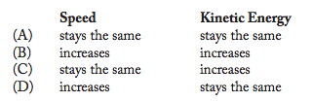
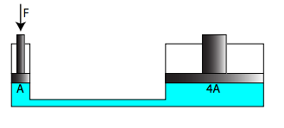
- A reservoir of incompressible fluid is topped by two pistons of non-equal areas, as shown in the diagram at right (not drawn to scale). The larger piston has four times the surface area of the smaller piston. If a force F pushes the smaller piston down by some distance d, which of the following best describes the upward force and distance traveled for the larger piston? ANS: A

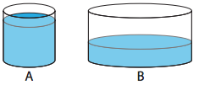
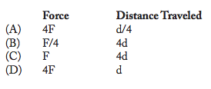
- Two rain barrels, A and B, each contain the same volume of water at the same temperature, as shown at right. A pressure gauge is placed at the bottom of each barrel. Which statement best describes the pressures at the bottom of the barrels?

  - PA < PB since the pressure of the water depends upon the amount of atmosphere above the water.
  - PA = PB since the pressure of the water depends upon the volume of water.
  - PA > PB since the pressure of the water depends upon the water’s depth.
  - Not enough information given

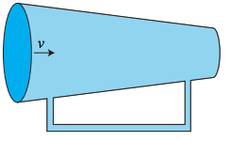
- Water flows through a section of thick piping with some velocity v as shown in the diagram at right. Based on the diagram, in which direction would you expect water to flow through the narrow section?
  - to the right
  - to the left
  - remain stagnant
  - not enough information given

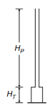
- The figure above shows a pipe of height H_{p} and cross sectional area A_{p} attached to the top of a tank of height H_{T} and cross-sectional area A_{T}. The pipe and tank are completely filled with water. The force exerted by the water on the bottom of the tank depends on which of the given quantities? (Multiple Answers)
  - A_{p}
  - A_{T}
  - H_{p}
  - H_{T}

- A canister of pressurized nitrogen gas at room temperature is cooled in a freezer. More nitrogen gas at room temperature is pumped into the canister until the canister returns to its initial pressure. The sealed canister is then returned to room temperature. A measurement of the pressure in the canister shows that the pressure in the canister is now twice its initial value. Was more gas initially in the canister than was added?
  - Yes
  - No
  - The amount of gas added to the canister is equal to the amount initially in the canister
  - Not enough information is given

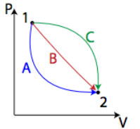
- An ideal gas can move from state 1 to state 2 on a PV diagram by a variety of different pathways. Which of the following are the same regardless of pathway? (Multiple Answers)
  - The work done on the gas.
  - The heat added to the gas.
  - The change in average kinetic energy of the gas molecules.
  - The change in the temperature of the gas.

- A student writes the following information for a process that involves a fixed quantity of ideal gas.

W = -PΔV
ΔU = Q + Q
P = 2.0 x 10⁵ Pa
ΔV= -2.0x10⁻³ m³
ΔU = -600J

Which of the following descriptions bests represents the process?
  - The gas expands at a constant pressure of 200 kPa
  - The gas is cooled at constant volume until its pressure falls to 200 kPa
  - The gas is compressed at a constant pressure of 200 kPa
  - The gas is heated and its pressure increases at constant volume

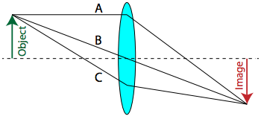
- Light from an object passes through a converging lens and is focused to form an image as shown in the diagram at right. Which light ray reaches the image plane in the least amount of time?
  - Ray A
  - Ray B
  - Ray C
  - They all take the same amount of time.

- Light of frequency 1.5×10¹⁴ Hz travels through air and enters glass perpendicular to its surface. Which of the following changes occur to the ray of light as it enters the glass? (Multiple Answers)
  - wavelength decreases
  - speed of the ray of light decreases
  - light ray bends toward the normal
  - frequency of the ray of light increases

- Observations that indicate visible light has a wavelength much shorter than a centimeter include which of the following? (Multiple Answers)
  - Bright and dark fringes are observed when laser light passes through a diffraction grating.
  - Light is polarized through a liquid crystal display (LCD).
  - Redshift is observed when observing a receding galaxy.
  - A colored pattern is observed when light reflects off a thin film.

- Light of wavelength λ in a vacuum has what wavelength in a material with index of refraction n? ANS: C

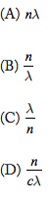
- Which of the following types of nuclear decay particles have the same mass as an electron? (Multiple Answers)
  - Alpha particle
  - Beta particle
  - Positron
  - Gamma Ray

- Which of the following best supports the particle nature of light?
  - Compton Effect
  - Diffraction
  - Doppler Effect
  - Interference
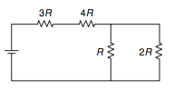
- The figure above shows four resistors connected in a circuit with a battery. Which of the following correctly ranks the potential difference, ΔV, across the four resistors?
  - ΔV₄ > ΔV₃ > ΔV₂ > V₁
  - ΔV₄ > ΔV₃ > ΔV₂ = V₁
  - ΔV₄ = ΔV₃ > ΔV₁ > V₂
  - ΔV₂ = ΔV₁ > ΔV₃ > V₄

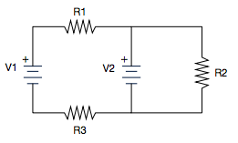
- The figure at right shows a circuit with two batteries and three resistors, all labeled. Which of the following actions will increase the current through resistor R₂? (Multiple Answers)
  - Increasing V₁
  - Increasing V₂
  - Decreasing R₂
  - Decreasing R₃

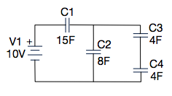
- Determine the effective capacitance of the circuit shown.
  - 19 F
  - 31 F
  - 6 F
  - (184/31) F

- An uniform magnetic field is directed into the plane of the page. A loop of wire is placed in the magnetic field. At no time does the loop leave the magnetic field. Which of the following situations will induce a current in the loop. (Multiple Answers)
  - rotate the loop along an axis that is directed into the page.
  - contract to loop to a smaller area.
  - rotate the loop along an axis that is directed vertically.
  - move the loop along a line that is parallel to the magnetic field.

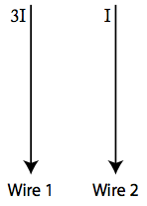
- The currents in two long parallel wires are I and 3I in the directions shown in the diagram at right. The magnetic force on wire 2 due to the current in wire 1 is F. The magnitude and direction of the force on wire 1 due to the current in wire 2 is:
  - F/3 and to the right
  - F and to the left
  - 3F and to the left
  - F and to the right

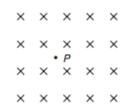
- An electron is at point P in a uniform magnetic field directed into the page, as depicted above. For which of the following states of motion of the electron is the magnetic force exerted on the electron equal to zero? (Multiple Answers)
  - The electron is not moving
  - The electron is moving perpendicularly into the page.
  - The electron is moving perpendicularly out of the page.
  - The electron is moving.

