Projectile Motion Video Analysis
- Insert the movie to analyze
  - Open Logger Pro
  - “Insert” “Movie”
  - “HS-StudentCommon” “Noschese” “College Prep” “02_ArcToss.mov”
- Pop-out the video analysis toolbar
  - Click the show/hide toolbar button at the right corner of the video window.
  - The video analysis toolbar is now showing on the right side of the video window.
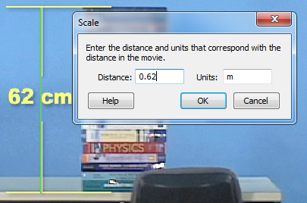
  - If desired, resize the video window by clicking and dragging the corners.
- Set the scale
  - Click the “Set Scale” button on the video analysis toolbar.
  - Click and drag between the two lines
that are 62 cm apart
  - Enter the distance as 0.62 m
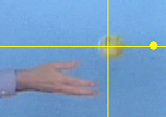
- Set the origin
  - Click the “Set Origin” button on the video analysis toolbar.
  - Click a point on the video to set the
origin. The starting position of the ball
is a good location.
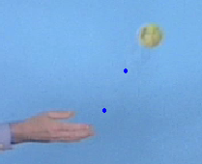
- Track the position of the ball in the video
  - Click the “Add Point” button on the video analysis toolbar.
  - Click on the center of the ball. A blue dot will be placed were you clicked and the video will automatically advance one frame.
  - Click again on the ball in its new position.
  - Repeat until the video is over.

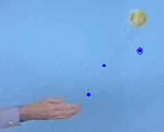
- If you make a mistake tracking the ball:
  - Click the “Select Point” button on the video analysis toolbar.
  - Click the blue dot you wish to delete.
A blue ring will appear around the dot.
  - Press delete.

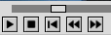
- If you need to move around within the video, use the playback buttons or the scrubber.
Play
Stop
Rewind
Previous Frame
Next Frame
- You will be done when you have 3 graphs – X position, Y position, and Y Velocity.
  - To add additional graphs: “Insert” “Graph”
  - To change which quantity is graphed: Click the y-axis label and choose the desired quantity from the list.
  - To rearrange the graphs to fit neatly on screen: Press CTRL-R
- Use the “Analyze” “Curve Fit” function to find the equation for each of the 3 graphs.
- Use “File” “Page Setup” to ensure printing in Landscape mode.
- Print the page. Be sure to put your name in the pop-up window when prompted.
