6.4 Credit Cards: Assignment

1. Calculate the interest due on the following credit card balances:
a) an unpaid balance of $2076.54 at a rate of 19.50% for 15 days;

b) an unpaid balance of $1007.48 at a rate of 21.50% for 38 days; and

c) an unpaid balance of $2019.64 at a rate of 18.50% for 18 months.

2. Marcia’s credit card company charges 24.00% per annum, counting each day that an amount is owed. Her only purchase was an item for $568.93. She did not pay on the due date, March 10. How much will she owe on the next statement date, April 2, if she doesn’t make any other purchases?

3. Harley used her credit card to make the following purchases during the month. She does not have to pay interest on purchases during the month, only on outstanding balances. Her credit card company charges 18.50% per annum.
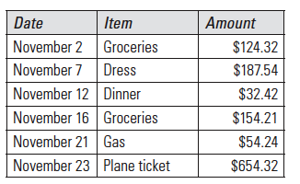

a) What is her balance due on the statement date, November 28?

b) If the minimum payment is 5% or $10.00, whichever is greater, what is Harley’s
minimum payment?

c) If she pays only the minimum and doesn’t use the card between then and the
next statement date, how much will she owe on her December 28 statement?

4. Javier’s credit card charges 24.90% interest per annum. He used his credit card, which had no previous balance, to take out a cash advance of $550.00 on December 10. Interest is calculated starting on the day of the withdrawal.

a) Javier’s next statement is dated December 21. For how many days is interest calculated for the balance on this statement?

b) How much will he owe on his December 21 statement?

c) What is the actual cost of the cash withdrawal, if he pays his bill in full on
January 10?

5. Marie-Josée is charged 21.95% per annum on her credit card balances. She used her card, which had no previous balance, to make the following purchases:

• $28.95 for dinner;
• $45.39 for gas; and
• $106.15 for groceries

These items appeared on her statement dated October 29.

By the due date, Marie-Josée paid the minimum payment (5% or $10.00, whichever
is greater).

On November 12, Marie-Josée made another purchase of $119.65 on her credit card.

If she makes no other purchases or payments, how much will Marie-Josée owe on
her next statement dated November 29?

