Lesson 6.1: Choosing an Account ASSIGNMENT

Use information from the Northwest Bank of Canada table below.

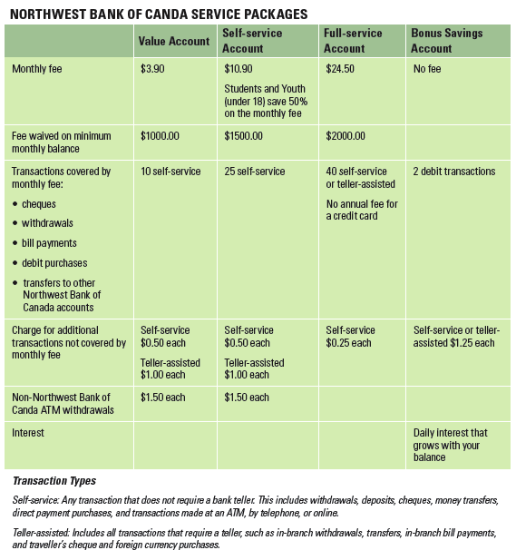

- Marc works for La Société Pommes de Reinette, a non-profit daycare in Calgary, Alberta. He plans to save $300.00 a month towards buying a house. What type of account should he choose? Explain your answer.
____________________________________________________________________________________________

____________________________________________________________________________________________

- Jannik does most of his banking online or at an ATM. Every month he has a minimum balance of $1200.00 and does about 15 transactions. Suggest the account most suitable for his needs and explain your choice.
____________________________________________________________________________________________

____________________________________________________________________________________________

- Kyra has a Self-service Account at the Northwest Bank of Canada with an opening balance of $2150.23 for October. She made the following transactions in the month:

- full-service payment of $250.42 for her utility bill
- payment by cheque of $650.00 for her rent
- purchase of $100.00 worth of traveller’s cheques
- cash withdrawals of $60.00 and $20.00 at her local Northwest Bank of Canada ATM
- cash withdrawal of $100.00 at an ATM which was not a Northwest Bank of Canada ATM; there was an additional $1.50 charge on top of the Northwest Bank of Canada service charge
- payments of $102.24 and $43.20 for groceries, $50.00 for gas, and $7.35 for lunch using her bank card

- payment for a new cycling jacket purchased online for $99.95
- online payment of her phone bill of $36.35

- What are the service charges for Kyra’s transactions?

- What will Kyra’s balance be at the end of the month?

- If Kyra makes a single deposit of $800.00 this month, will she have to pay a monthly fee?

Solutions:
