Dear Gen Y: Your retirement is in trouble
ROB CARRICK - The Globe and Mail

A message to all the young adults struggling to find a place in today’s economy: It gets worse.
A report from Canadian Imperial Bank of Commerce says your retirement is in trouble. When you’re done working, your standard of living could on average be 30 per cent lower than it was in your best earning years.
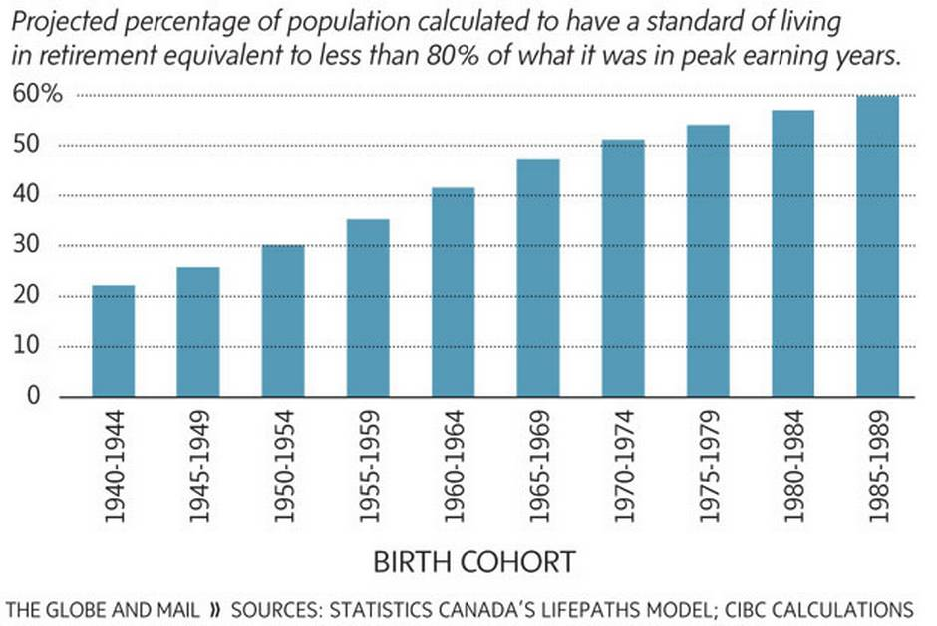
CIBC explains this retirement shortfall as being the result of lower savings rates, lower investment returns and both fewer and lesser quality pension plans in the workplace. The solutions: Increased savings and government action. In fact, CIBC chief executive officer Gerry McCaughey said in speech this week that the Canada Pension Plan should be adjusted so that people can voluntarily add contributions beyond what they’re already kicking in through payroll deduction at work. Great idea, but make those extra contributions automatic.
People born during the Second World War are most likely to have the same standard of living in retirement that they did while working. From there, average living standards in retirement decline gradually. The worst-off segment of the population? “It’s the young guys,” said Benjamin Tal, the CIBC economist who co-authored the report. “If you were born in the 1940s, you’re fine.”
Find a job and save your brains out for retirement, Gen Y. And, educate yourself on the ways the older generation helped you get into this mess. For starters, there’s the idea that the way to build wealth is to buy a home rather than by saving. It worked for the baby boom generation, which has seeded this idea into the financial system and popular culture. It’s an amazingly friction-free process to get a mortgage that ruins your chances of saving properly for retirement, while also having some disposable income to enjoy.
CIBC’s report acknowledges that rising home values have boosted personal net worth, which helps to offset the decline in the savings rate. But it also points out that converting a house to cash is tough because of the need to spend money on a replacement home or cover rent.
The older generation also bears responsibility for damaging the global financial system so badly five years ago that it’s still not working properly. That’s why we continue to have interest rates so low that returns on savings accounts remain firmly between zero and 2 per cent, and why expectations for stock market returns remain subdued.
Low rates and weak stock market returns hold back growth in retirement savings, CIBC notes. This growth slowed after the 1990s, when boomers were fattening their registered retirement savings plans, and then slowed even more after the big market crash in 2008.
Gen Y, the older generation also took away your pensions. CIBC says that one-third of the Canadian work force is now covered by a company pension plan, down from 37 per cent in 1992. Of the pensions that continue to exist, many companies have replaced defined benefit plans for new recruits with defined contribution plans. A defined benefit plan weighs a variety of factors in determining a set monthly pension payout for life after you retire. A defined contribution plan is like a DB plan in that it includes contributions from both employees and employers, but payments in retirement are not guaranteed and subject to fluctuations in financial markets.
Over all, CIBC says almost six million people face a drop of 20 per cent or more in their standard of living in retirement. Don’t confuse this with income – standard of living refers here to the ability to consume the same goods and services as you did while in your peak earnings years, with adjustments made for you being older. “More than 20 per cent is a significant reduction in the standard of living,” said Mr. Tal. For some people, it could, hypothetically, be like a 50-per-cent reduction in their income.
Gen Y, you’re in the worst shape of all. You’ve been putting houses ahead of savings, your investment returns are weak, and you’re losing out on pensions. You’re seeing your government retirement benefits crimped. Last year’s federal budget raised the minimum age for receiving Old Age Security for future retirees while keeping current retirees whole.
Oh, and about that ‘Find a job and start saving’ advice. A survey by Sun Life Financial suggests that only one-quarter of Canadians plan to retire at age 66. In a few years, you could be competing for jobs with your parents.
Gen Y, what’s your message to employers, educators, parents and politicians? I’m opening a forum on my Facebook personal finance community for you to speak up.

