Math 11AW Lesson 3.1B: Surface Area of Prisms Assignment

1. Complete the following table using the prisms below.
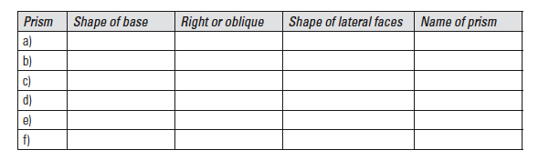

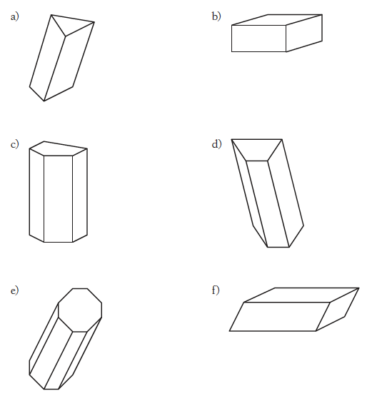

2. Draw nets for the following prisms, and label the dimensions of each side.

3. For each diagram, draw a net and use it to calculate surface area.

