Math 11AW Lesson 3.1B: Surface Area of Prisms NOTES

A prism is a three-dimensional object with:
ends, called ______________, that are congruent and parallel, and
sides, called lateral ________________, that are parallelograms.

- The prism is a right prism if the sides are perpendicular to the bases. The lateral faces will be rectangles.
- If the lateral faces are not perpendicular to the base, it is an oblique prism and the sides will be parallelograms.
- A prism is named by the shape of its base and whether it is right or oblique.

Ex 1) Name the following prisms:

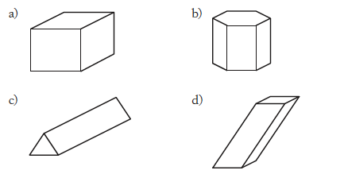
A ____________is a two-dimensional pattern that can be folded to form a three-dimensional shape.

Ex. Think of a pizza box: it is made up of one piece of cardboard, folded into the shape of a right rectangular prism.

The surface area of a prism is the area that it would take up if it were laid out flat, as in its net.

Ex 2) If this right pentagonal prism were made from one piece of cardboard, what would the piece of cardboard look like?

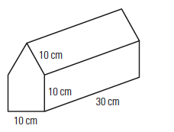

Ex 3) Find the surface area of the right rectangular prism given below.

