***Area and Perimeter Problems Involving Composite Shapes*** Name: _________________

1. Calculate the perimeter of each of the following shapes. Round your answers to one decimal place.





1. Calculate the shaded area of the figures below. Round your answer to the nearest 10th of a unit.



1. A 7-foot by 3-foot doorway is to be cut into the trapezoid shaped wall shown. What is the area of the wall, without the doorway?

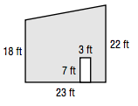

1. Leeor was asked to repaint the sign for his mother’s ice cream shop, so he needs to figure out how much paint he will need. Find the area of the ice cream cone on the sign. Round to the nearest tenth.

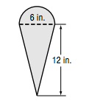

***Use Area and Pythagorean Theorem to find the missing side***

1. Determine the length of each missing side of the triangle. Round your answer to one decimal place.



***Surface Area of Prisms and Cylinders***

1. Calculate the surface area (you can assume that it is a perfect cylinder)

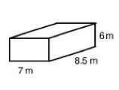



1. Calculate the surface area of the following half cylinder.



1. Calculate the surface area of the following composite shape.

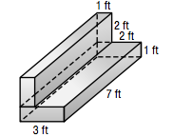

***Surface Area of Right Pyramids and Cones***

1. Find the surface area of the following right pyramids. Round your answers to one decimal place



1. Find the surface area of the following cones





1. Find the surface area of the composite shape

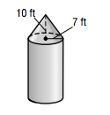

3. Find the surface area of a cone with a height of 4.0 km and a base area of 28.3 km2

***Surface Area of a Sphere***

1. Determine the surface are and volume of the following shapes



1. Find the surface area of the following composite shapes





1. Eight basketballs are put into a holding container. The radius of each basketball is 10cm. How much room will be left in the container if the container is shaped like a square based pyramid with each side of the base measuring 40 cm and with a height of 70 cm?