Math 11AW Lesson 3.1A: Perimeter & Area Assignment

Perimeter - The distance around a two-dimensional shape.

Area - The size of a surface. The amount of space inside the boundary of a flat (2-dimensional) object such as a triangle or circle.

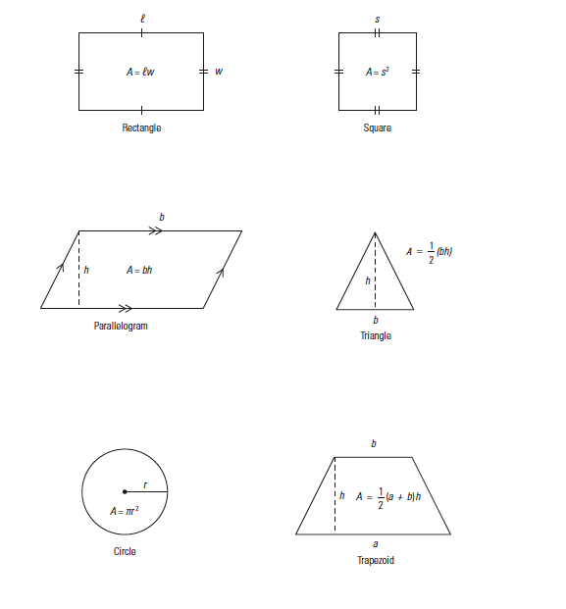
1. Find the area of the following figures. (Show work below)

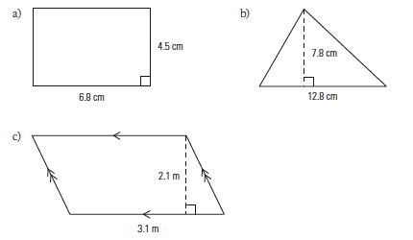

2. Find the area of the following figures.
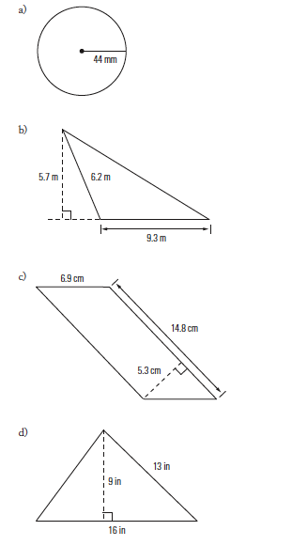
3. For each shape, name the shape and calculate the area.

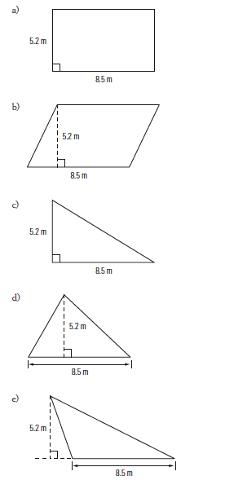
4. Find the area of the following figures.

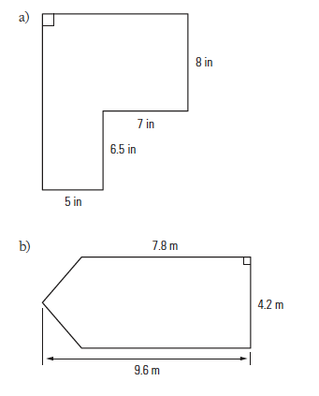
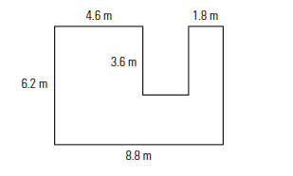
5. Show four different ways you could divide the figure below to calculate its area. Show all measurements. Choose one method to calculate the area

6: Find the area of the following figure. (Break the figure down into shapes you know)

