% COMPOSITION – CHEM 11 IS DOUBLE STUFFED REALLY DOUBLE STUFFED?

Name: _______________________
Blk: __________ Date: __________
Partner: ___________________
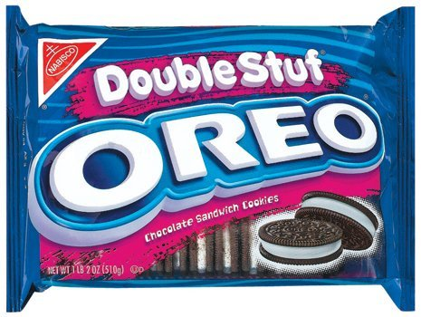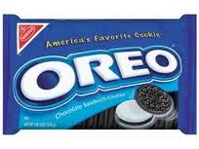

A specific brand of cookie (beginning with the letter O made by Mr. C) claims that their double-stuffed cookie contains twice the amount of filling as their regular brand. But is this claim really true? To better understand the concept of Percent Composition, we are going to study Mr. C’s claim. We are going to determine the percent of cream filling, by mass.

Purpose: To determine if double stuffed cookies contain twice the amount of creamy goodness.

Hypothesis: If we take about a regular Oreo cookie and a double stuffed Oreo cookie we will find the doubled stuffed cookie contains twice the amount of creamy goodness!

Procedures:

- Your teacher will give you one of each type of cookie. Do NOT eat them as you are in the CHEMISTRY LAB!!! Weigh the cookies separately and record this information in the table.

- Collect 4 Weigh Boats per group.

- Start breaking the cookies apart into the 4 Weigh Boats. You will have two piles for each type: one pile for the dough and one pile for the cream filling. Try to scrape off as much of the cream filling from the cookie dough without breaking the dough (and without taking the dough into the cream filling pile). This can be delicate work so be careful. (Do this again for the other type of cookie.)

- When you have your two distinctive piles, take the mass of the dough (for one type) and the cream filling (for one type). Record this information in the table. Do the same thing for the other type of cookie. The mass of the dough and the cream filling should add up to the mass of the intact cookie in Part 1. If not, you left some dough or cream filling behind and this can alter your results.

Data Table:
Type of cookie | Mass of cookie (g) | Mass of dough (g) | Mass of cream filling (g) | % Composition of cream filling by mass
Regular Stuffed
Double Stuffed

Conclusion:
- How is Percent Composition of a molecule by atoms different then Percent Composition of a molecule by mass of? Explain using a molecule as an example.

- Was the hypothesis that Double Stuffed contains twice as much creamy goodness supported or disproven? Explain how you know.

- In order to answer Question 2, did you use the mass of the cream filling OR % composition of the cream filling? Explain your reasoning.

Percent Composition by Mass
Find the percent composition by mass the bold atom and ONLY the bold atoms in the following compounds:

- Ammonium phosphate – (Hydrogen)

- Mg(NO₃)₂

- Potassium permanganate – (Oxygen)

- Calcium oxalate

Percent Composition ANS

Find the percent composition by mass the bold atom in the following compounds:

- Ammonium phosphate – (Hydrogen) – (NH₄)₃PO₄ – MM = 149.0 g/mol H =8.1 %
- Mg(NO₃)₂ MM 148.3 g/mol O = 64.7%
- Potassium permanganate – (Oxygen) KMnO₄ MM = 158.0 g/mol O = 40.5%
- Calcium oxalate CaC₂O₂ MM 128.1 g/mol Ca = 31.3%

