Exponent Laws Name _______________________________
Math 9 Day ____ Period ____ Date _________________
Fill in the table.
 | Expanded form | Exponential form
$$3^{2}×3^{2}$$
$$2^{3}×2^{2}×2$$
$${(-4)}^{4}{(-4)}^{3}{(-4)}^{2}$$
$$\frac{3^{3}}{3^{2}}$$

$$\frac{4^{5}}{4^{3}}$$
$$\frac{{(-2)}^{8}}{{(-2)}^{3}}$$

Karen’s explanation on how to solve $2^{9}×2^{7}$ Karen’s explanation on how to solve $\frac{2^{12}}{2^{4}}$
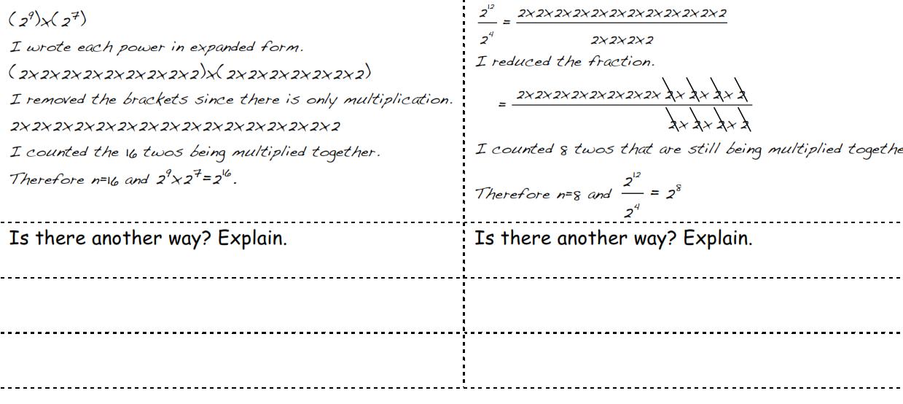
EXPONENT LAW 1 x^{m}x^{n} = x^{m+n}
EXPONENT LAW 2 x^{m}/x^{n} = x^{m-n}

Putting exponent laws 1 and 2 together:
$\frac{{\left(4\right)}^{3}{(4)}^{6}}{{\left(4\right)}^{2}{(4)}^{1}}$ $3^{5}×3^{4}÷3^{2}$

The ONE and ZERO exponents:
What does $2^{1}$ mean?
_____________________________________________________________________________________
The table shows decreasing powers of 10.
Number in words | Standard form | Exponential form (power)
One million | 1 000 000 | $${10}^{6}$$
One hundred thousand | 100 000 | $${10}^{5}$$
Ten thousand | 10 000 | $${10}^{4}$$
One thousand | 1 000 | $${10}^{3}$$
One hundred | 100 | $${10}^{2}$$
Ten | 10 | $${10}^{1}$$
One | 1 | $${10}^{0}$$

Use your patterning skills to complete the patterns below.
Standard form | Exponential form |  | Standard form | Exponential form
16 |  |  |  | $$3^{4}$$
8 |  |  |  | $$3^{3}$$
4 |  |  |  | $$3^{2}$$
2 |  |  |  | $$3^{1}$$
1 |  |  |  | $$3^{0}$$

Write in expanded form:
$\frac{3^{4}}{3^{4}}$=
EXPONENT LAW 3 (x^{m})^{n} = x^{mn}

In-class practice:
Separate piece of paper. Write out question and show work below question.
${ a) (-2+4)}^{0}$ $b) -3^{0}$ c) ${(-3)}^{0}$

$d) (-10)÷5^{0}$ e) ${(-10÷5)}^{0}$ f) ${(4^{0})}^{2}$

$g) \frac{8a^{4}}{4a^{2}}$ h) $3m^{5}×4m^{2}$ i) $\frac{5k^{6}×4k^{3}}{2k^{4}}$

$j) \frac{-36r^{7}}{24r^{5}}$ k) $5y^{3}×2y^{4}×3y^{7}$ l) $\frac{{\left(-2\right)}^{2}{(-2)}^{8}}{{(-2)}^{5}}$

$m) {({11}^{3}+5^{3})}^{0}+(4^{2}×4^{1})$ n) $-{2g}^{6}×(-2g^{3})×4g^{5}$

o) $-7^{0}-\frac{3^{5}}{3^{4}}{ p) 6}^{0}-4^{0}-\frac{2^{3}}{2^{3}}$
Homework: Page 106 # 5 to 11

