Math 9 Name_________________
Unit: Linear Inequalities Day ___ Period ___
Date _________________
Representing Inequalities (Lesson 1 & 2)
Recall that EQUATIONS have an EQUAL sign.
7n + 15 = 2n *Equations have only ONE possible solution.

INEQUALITIES are similar to equations but instead of an equal sign they have an inequality sign and there are usually several possible answers.
Inequality sign Meaning________
x < y x is less than y
x < y
x > y
x > y
x ≠ y

Inequalities can be represented in words, graphically and algebraically.
- Words: All speeds less than or equal to 80km/hour are okay.
Graphically:

Algebraically:

Boundary point- A point that separates the values greater or less than a specific point.
In the 80km/hr example, “80” is the boundary point.

Boundary points on number lines
- Use an OPEN circle if the boundary point is NOT included in the solution.
Open circle
Example: x < 5
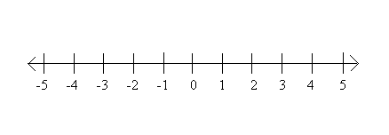
- Use a CLOSED circle if the boundary point IS included in the solution.
Closed circle
Example: x > 4
- For x ≠ 2:
Note: 8 < x is the same as x > 8.
*Keep the “open jaws” of the inequality sign facing the same number.

Practice: Write an inequality in words, graphically (number line) and algebraically.
- Kids on a rollercoaster must be at least 4 feet tall.
- Children 12 and under fly free to Disneyland.

- If you work more than 40 hours a week you get paid overtime.

Representing Double Inequalities

Example 1: Express -2 < x < 3 on a number line.

Example 2: Express the inequality below algebraically.

Example 3: Express the following statement on a number line and algebraically.
“Pay parking between 8am and 6pm.”

Practice questions to do
Pages 346 to 347 # 1ab, 6, 9 to 12, 13ac, 15to 18, 23a, 25ac

