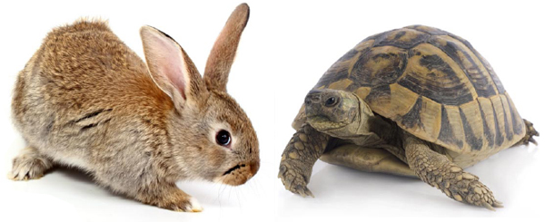
Introduction to Motion-The Hare and the Tortoise Part II

Use the graph below to answer Questions 1-8
A (Tortoise or Hare?) |  | B (Tortoise or Hare?)
Position (m) | Time (s) | Position (m) | Time (s)
0 | 0 | 0 | 0
10 | 100 | 25 | 5
20 | 200 | 50 | 10
30 | 300 | 50 | Asleep
40 | 400 | 50 | Asleep
50 | 500 | 50 | Asleep
60 | 600 | 50 | Asleep
70 | 700 | 50 | Asleep
80 | 800 | 50 | Asleep
90 | 900 | 50 | Asleep
100 | 1000 | 50 | Asleep
110 | 1100 | 50 | Asleep
120 | 1200 | 75 | 1490
130 | 1300 | 100 | 1495
140 | 1400 | 125 | 1500
150 | 1500 | 150 | 1505

Questions:
- Which data set, A or B belongs to the hare? Explain. ___________________

- How long was the race course? ___________________
- How far away was the tree where the hare fell asleep from the finish line? ___________________
- How many minutes did it take the tortoise to run the race? ___________________
- How many minutes did the hare sleep? ___________________
- About how fast do you think the tortoise ran in m/s? (show calculation) ___________________

- How fast was the hare able to run? (show calculation) ___________________

- Create a graph of the Hare’s and Tortoise’s position vs. time based on the data provided.

The following criteria for the graph must be met.
- Title
- X and Y axis labeled with units and title as well as axis numbered
- The majority of the graph is used
- Lines are drawn with rulers
- Each graph (Hare and Tortoise) are labeled (Hint: create a legend)

