Equilibrium and Statics
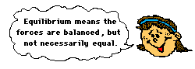
When all the forces that act upon an object are balanced, then the object is said to be in a state of equilibrium. The forces are considered to be balanced if the rightward forces are balanced by the leftward forces and the upward forces are balanced by the downward forces. This however does not necessarily mean that all the forces are equal to each other. Consider the two objects pictured in the force diagram shown below. Note that the two objects are at equilibrium because the forces that act upon them are balanced; however, the individual forces are not equal to each other. The 50 N force is not equal to the 30 N force.
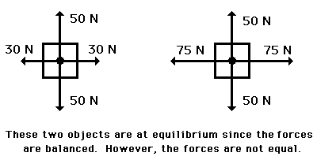
If an object is at equilibrium, then the forces are balanced. Balanced is the key word that is used to describe equilibrium situations. Thus, the net force is zero and the acceleration is 0 m/s/s. Objects at equilibrium must have an acceleration of 0 m/s/s. This extends from Newton's first law of motion. But having an acceleration of 0 m/s/s does not mean the object is at rest. An object at equilibrium is either ...
- at rest and staying at rest, or
- in motion and continuing in motion with the same speed and direction.
This too extends from Newton's first law of motion.

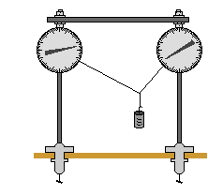
If an object is at rest and is in a state of equilibrium, then we would say that the object is at "static equilibrium." "Static" means stationary or at rest. A common physics lab is to hand an object by two or more strings and to measure the forces that are exerted at angles upon the object to support its weight. The state of the object is analyzed in terms of the forces acting upon the object. The object is a point on a string upon which three forces were acting. See diagram at right. If the object is at equilibrium, then the net force acting upon the object should be 0 Newton. Thus, if all the forces are added together as vectors, then the resultant force (the vector sum) should be 0 Newton. (Recall that the net force is "the vector sum of all the forces" or the resultant of adding all the individual forces head-to-tail.) Thus, an accurately drawn vector addition diagram can be constructed to determine the resultant. Sample data for such a lab are shown below.
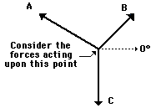 | Force A Force B Force C  Magnitude 3.4 N 9.2 N 9.8 N  Direction 161 deg. 70 deg. 270 deg.
For most students, the resultant was 0 Newton (or at least very close to 0 N). This is what we expected - since the object was at equilibrium, the net force (vector sum of all the forces) should be 0 N.
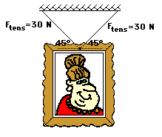
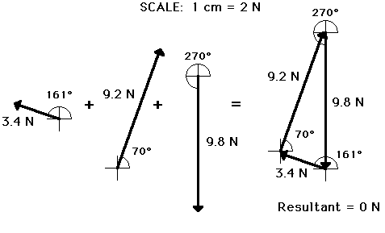
Check your Understanding:

1. The following picture is hanging on a wall. Use trigonometric functions to determine the weight of the picture.

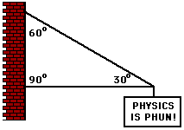
2. The sign below hangs outside the physics classroom, advertising the most important truth to be found inside. The sign is supported by a diagonal cable and a rigid horizontal bar. If the sign has a mass of 50 kg, then determine the tension in the diagonal cable that supports its weight.
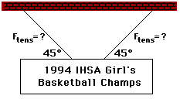

3. The following sign can be found in Glenview. The sign has a mass of 50 kg. Determine the tension in the cables.

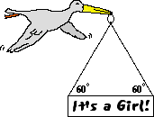
4. After its most recent delivery, the infamous stork announces the good news. If the sign has a mass of 10. kg, then what is the tensional force in each cable? Use trigonometric functions and a sketch to assist in the solution.
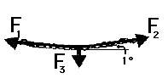
5. Suppose that a student pulls with two large forces (F₁ and F₂) in order to lift a 1-kg book by two cables. If the cables make a 1-degree angle with the horizontal, then what is the tension in the cable?

Answers: 1. 42.4 N 2. 490 N 3. 346 N 4. 56.6 N 5. 281 N

