HAPPY MOLE DAY!!

The week is National Chemistry Week! It's always chosen to coincide with whichever calendar week includes October 23 (or 10/23), since October 23 is "Mole Day".

"Huh? Why would chemists celebrate a furry critter that burrows underground?"
Not that mole. The mole chemists celebrate is a unit. 1 mole = 6.02 x 10²³ of whatever it is you want a mole of.

You can think of a mole as being sort of the chemists' equivalent of a dozen -- it's a convenient sized bundle for working with the kind of stuff chemists work with, namely, atoms and molecules. If they were working with eggs, or shoes, or some other stuff, they would probably use a different unit than the mole.
Remember that atoms are really, really small. They are so small that you've never seen one with your naked eye. (Depending on how you score things like diamonds, you may have seen a molecule with your naked eye, but even most molecules are way beyond the limits of your visual acuity.) If passing Chemistry 11 depended on doing experiments where you had to weigh out single atoms of reagents, there would be no chemists.

Weighing out 6.02 x 10²³ atoms, though, is do-able. 6.02 x 10²³ atoms of carbon weigh 12.01 grams. 6.02 x 10²³ atoms of copper weigh 63.55 grams. 6.02 x 10²³ atoms of helium weigh 4.003 grams.

I don't have any of this memorized. I just turned to my handy, dandy periodic table. Under each element's symbol is listed an atomic weight. Carbon's atomic weight is 12.01. That means a single atom of carbon has a mass of 12.01 atomic mass units (amu). However, since we've already noted that you hardly ever want to deal with one atom at a time (at least if you're a chemist -- maybe physicists would rather deal with single atoms), the more important fact that you can glean from the table is that 6.02 x 10²³ atoms of carbon have a mass of 12.01 grams. Or, simply, 1 mole of carbon is 12.01 g.

Once you recognize that atomic masses tell you how many grams in a mole of an element, you can measure your desired amount of multi-element molecules, too. Table salt is NaCl. Na has atomic mass of 23, Cl has atomic mass of 35.5, so a mole of NaCl (or 6.02 x 10²³molecules of NaCl) is 58.5 g. To find the mass of a mole of H₂O, you have 2 moles of H (atomic weight 1) and one of O (atomic weight 16) -- 18 g of H₂O holding all 6.02 x 10²³molecules.

From this, it's a good bet that mixing an equal number of moles of table salt and water will not yield a saline solution so much as a slightly damp pile of salt.
In addition to being the number of atoms or molecules (or shoes, or eggs, or pencils, etc.) in a mole, 6.02 x 10²³ has a name that sticks in people's heads: Avogadro's number. Avogadro also has a law:

Equal volumes of gases at the same temperature and pressure contain the same number of molecules.

If we're dealing with "ideal gases (gases whose molecules are not too enormous, and which don't have significant attractions between the molecules), at standard temperature and pressure (0 º C and 1 atm), 22.4 liters of gas will contain 6.02 x 10²³ molecules (or 1 mole). So, at standard temperature of pressure, balloons filled with 22.4 L of H₂, N₂, O₂, Cl₂, He, Ne, and Ar will each contain a mole of gas molecules. However, the masses of gasses in these balloons will be different (2 g, 28 g, 32 g, 71 g, 4 g, 20 g, and 40 g, respectively). This means a mole of argon is denser -- by a lot -- than a mole of helium.

That Avogadro's number of [anything] equals a mole of [that stuff] has also given rise to clever marketing, like this:
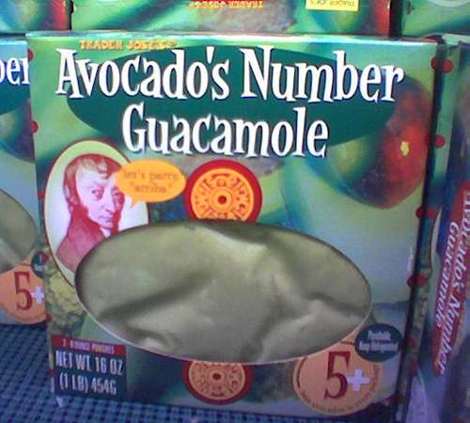
The label clarifies that there are not actually 6.02 x 10²³ avocados in each package of guacamole (it's closer to 5 or 6). But it's a fine store bought guacamole, and the chemistry joke on the package just makes it more appealing.

Speaking of Mole Jokes…
Q: Why is it bad to tell mole jokes?
A: It's mole-itically incorrect
Q: Why was there only one Avogadro?
A: When they made him, they broke the Moled
Q: What kept Avogadro in bed for two months?
A: Moleonucleosis
Q: What element do moles love to study in chemistry?
A: Molybdenum
Q: What is Avogadro's favorite kind of music?
A: Rock 'N' Mole
Happy Mole Day!

