Rules for Drawing Lewis Structures of Molecules (Covalent Compounds)

- Determine the total number of valence electrons for the molecule (valence electrons of all the atoms in the molecule)
Example Molecule: NCl₃ N = 5 x 1 = 5
+ 3 x Cl = 3 x 7 = 21
26

NOTE: If the molecule is a polyatomic ion adjust the number by subtracting one electron for every positive charge and adding one electron for every negative charge on the molecule

- Construct the skeleton of the molecule using lines to indicate single covalent bonds (each line represents 2 electrons) between the atoms. This can be the most challenging step of the process. Follow the following guidelines.
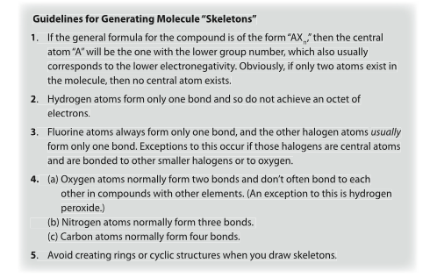
Using the above rules, we see that Nitrogen is the mostly like central atom. The Chlorines surround the central atom.

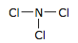

- Subtract the total number of valence electrons used to construct the skeleton from the total number of valance electrons available from step 1. Remember each line (or bond) represents 2 electrons. 26 – (3 x 2) = 20.

- Assume that all the atoms in the molecule obey the octet rule (except hydrogen). Determine the number of additional valence electrons required to give all of those atoms the required eight valence electrons.

Each Chlorine is associated with 2 electrons from it’s bond with Nitrogen, each needs 6 more = 6 x 3 = 18
Nitrogen is associated with 6 electrons from the 3 bonds with Nitrogen, it needs 2 more = 2 x 1 = 2

- If the number of electrons needed matches the number of electrons left from step 4 start to place the electrons in pairs (from the outside atoms in; Chlorine atoms before N atom) where needed to satisfy the octet. If they do not match… stay tuned, we will look at this soon. If the molecule is an ion, place brackets around the ion and add the charge to the top right corner.
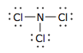
- Check that the total number of valence electrons represented in the diagram matches the total number of valence electrons you began with in step 1.

Quick Check Questions:

- Hydrogen sulphide, H₂S, is a poisonous, foul-smelling, and flammable gas. Why is the molecular skeleton “S-H-H” incorrect for the molecule?

- Determine the total number of valence electrons presented in each of the following molecules

H₂Se | CCl₄ | NF₃ | PCl₅ | SF₆

