Science 10 – Earth Science
17.2 Evidence and Mechanism of Plate tectonics
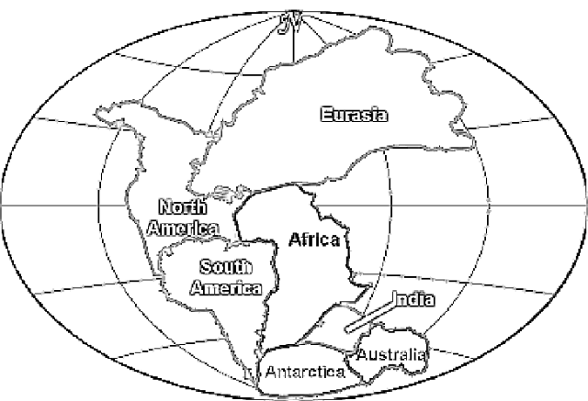
Continental Drift Theory
- Initially the theory was not well accepted.
- Alfred Wegener needed evidence to support his theory!

List the evidence for continental drift and Pangaea, make sure to explain how each supports Wegener’s theory! If it helps draw a picture
- Matching Coal deposits on different continents

- Fossil evidence (ancient fossils on distant coastline - Africa, SA and Australia)

- Rock Evidence (matching mountains – Appalachians in North-East US match those in Britain & Norway and SA and Africa AND coal deposits typical of the tropics in Antarctica

- Geometry Evidence (puzzle fit – mainly Africa and South America)

- Glacial evidence (glaciers scratches on the rocks - evidence of glaciers near the equator – Africa)

Question: What is the difference between the Theory of Continental Drift and the Theory of Plate Tectonics? Continental Drift was proposed first and only states (but does not explain) the splitting up of Pangaea in the current seven continents. Plate Tectonics explains Continental Drift, and also other geologic features such as volcanoes, earthquakes, mountains etc,
Evidence  What evidence do we now have that confirms Plate tectonics? | Mechanism  What actually makes the plates move?  How does it work?
Seafloor spreading is evident through:  - Magnetic Reversals  - Radioactive Dating of the rocks on the oceans floor  - Volcanic eruption patterns  - World Earthquake patterns  - Underwater mountain ranges – from sonar  - Underwater Volcanos | Mantle Convection – movement of plates on conveyer belt like systems caused by heat from the center of the earth  Slab Pull – edge of a plate is subducting or sinking into the mantle  Ridge Push – new magma pushing plates apart at divergent boundaries  