Science 10 – Earth Science
17.2 Evidence and Mechanism of Plate tectonics
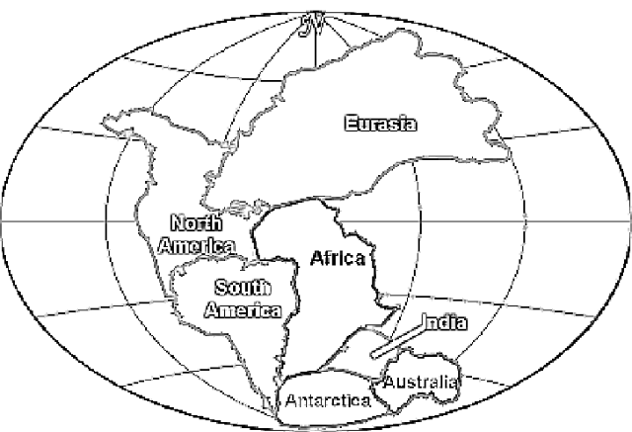
Continental Drift Theory
- Initially the theory was not well accepted.
- Alfred Wegener needed evidence to support his theory!

List the evidence for continental drift and Pangaea, make sure to explain how each supports Wegener’s theory!:

Question: What is the difference between the Theory of Continental Drift and the Theory of Plate Tectonics? _______________________________
________________________________________________________________________________________________________________________
________________________________________________________________________________________________________________________
Evidence  What evidence do we now have that confirms Plate tectonics? | Mechanism  What actually makes the plates move?  How does it work?

