Grade 7 Big Ideas
Concept 1: Coordinates and Design
Beginning | Developing | Accomplished | Exemplary
Does not demonstrate a basic understanding of concept. Substantial errors throughout. | Basic understanding of concepts. Errors and inconsistency reveal some missing understanding of the concepts. | Solid understanding of concepts. Most answers are correct with only a few errors. | Complete and in depth understanding of concepts.

- What are the signs of the coordinates in quadrant III?
- (+, +) b) (-. -) c) (+. -) d) (-, +)

- Ivan plotted the following points on a coordinate grid: (1, 1), (2, 2), (3, 3), and (4, 4). (use the grid to plot the points if you’d like). These points lie on a line that goes through:
- the origin.
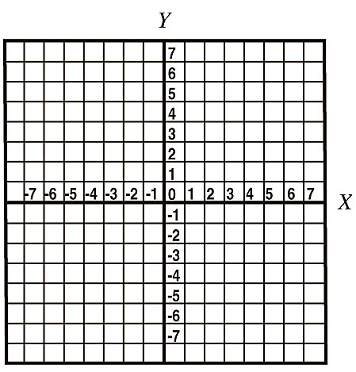
- the x-axis, but not the origin.
- the x-axis at (1, 0) and the y-axis at (0, 1).
- the y-axis, but not the origin

- Draw and label the axes of a coordinate grid by 2s. Plot the following points: A (-5, 2), B (-4, 0), C(-2, -1), D (0, -3), E (1, -4), F (3, -6)
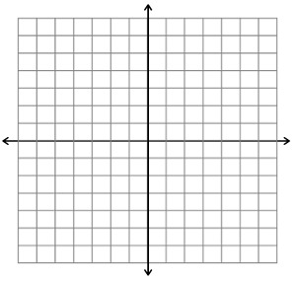

Concept 2 : Operations of Decimal Numbers
Beginning | Developing | Accomplished | Exemplary
Does not demonstrate a basic understanding of concept. Substantial errors throughout. | Basic understanding of concepts. Errors and inconsistency reveal some missing understanding of the concepts. | Solid understanding of concepts. Most answers are correct with only a few errors. | Complete and in depth understanding of concepts.

Can you do the following questions without a calculator? Try!
- Calculate 4.85 + 0.5 – 3.2

- What is the value of the following expression?
3.12 x 4 + 12 ÷1.5 x 2

- Brady bought a ball of string. She found that she could cut it into either 5 or 9 equal pieces without a remainder. If she cuts it into 5 equal pieces, each piece is 3.69 m long. What is the length of each piece if she cuts the string into 9 equal pieces?

Concept 3: Geometry and Measurement
Beginning | Developing | Accomplished | Exemplary
Does not demonstrate a basic understanding of concept. Substantial errors throughout. | Basic understanding of concepts. Errors and inconsistency reveal some missing understanding of the concepts. | Solid understanding of concepts. Most answers are correct with only a few errors. | Complete and in depth understanding of concepts.

- Which line segments are parallel?
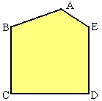

- Describe lines that intersect at 90°

- Angle bisector b) line segment c) perpendicular d) parallel

- An architect measure the angle of a roof to be 132°. If you bisect the angle, what will the new measure be?

- Determine the area of the parallelogram shown. Area of a triangle = (bxh)÷2
Area of a rectangle = l x w

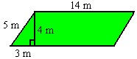

Concept 4: Fractions, Decimals and Percents
Beginning | Developing | Accomplished | Exemplary
Does not demonstrate a basic understanding of concept. Substantial errors throughout. | Basic understanding of concepts. Errors and inconsistency reveal some missing understanding of the concepts. | Solid understanding of concepts. Most answers are correct with only a few errors. | Complete and in depth understanding of concepts.

- Which number is the smallest in value? ½, ¾, 37%, 0.78

- Roberta has $1200 in the bank. Anwar has 75% as much as Roberta. How much does Anwar have?

- Fill in the missing values:

Fraction | Decimal Number | Percent
¼
 | 0.75
 |  | 20%

- Jordan ate of a pizza. Freda ate 0.3 of the pizza and Jonas ate 40% of it. How much of the pizza was left? (in percent)

Concept 5:Probability
Beginning | Developing | Accomplished | Exemplary
Does not demonstrate a basic understanding of concept. Substantial errors throughout. | Basic understanding of concepts. Errors and inconsistency reveal some missing understanding of the concepts. | Solid understanding of concepts. Most answers are correct with only a few errors. | Complete and in depth understanding of concepts.

- A box of candies contains 20 red candies, 30 blue, 15 green, 25 yellow, and 10 brown. If one candy is chosen at random, what is the probability that it is brown? (in percent)

- The lunch menu at Sam's Café is shown. Each customer selects one sandwich and one soup. If selections are made at random, what is the probability that a customer will have a tuna sandwich and vegetable soup? (as a fraction)
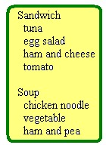

- Four students each tossed the same coin 10 times. Allan tossed 4 heads, Belinda tossed 5 heads, Cumar tossed 7 heads, and Danae tossed 5 heads. What is the experimental probability of tossing a head with this coin? (as a decimal)

Concept 6: Fraction Operations
Beginning | Developing | Accomplished | Exemplary
Does not demonstrate a basic understanding of concept. Substantial errors throughout. | Basic understanding of concepts. Errors and inconsistency reveal some missing understanding of the concepts. | Solid understanding of concepts. Most answers are correct with only a few errors. | Complete and in depth understanding of concepts.

- What is the greatest common factor of 18 and 24?

- Reduce to lowest terms.

- Determine the answer to the addition statement shown in the diagram, in lowest terms.

- Subtract 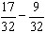. Reduce the answer to lowest terms.

- Add 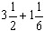. Reduce the answer to lowest terms.

- What addition statement is represented by the diagram? 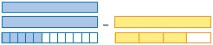

Concept 7:Circles
Beginning | Developing | Accomplished | Exemplary
Does not demonstrate a basic understanding of concept. Substantial errors throughout. | Basic understanding of concepts. Errors and inconsistency reveal some missing understanding of the concepts. | Solid understanding of concepts. Most answers are correct with only a few errors. | Complete and in depth understanding of concepts.

Circumference = 2 л r or C = d Area = л r ²
- What is the diameter of the circle shown? 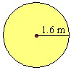

- What is the circumference of a circle with a radius of 3 m?

- What is the area of a circle with a diameter of 4 cm?

- The student choices for food at the school picnic are shown in the circle graph. What percent of students wanted subs?
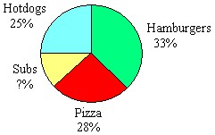

Concept 8: Integers
Beginning | Developing | Accomplished | Exemplary
Does not demonstrate a basic understanding of concept. Substantial errors throughout. | Basic understanding of concepts. Errors and inconsistency reveal some missing understanding of the concepts. | Solid understanding of concepts. Most answers are correct with only a few errors. | Complete and in depth understanding of concepts.

- Which addition statement is represented by the integer chips?

- Subtract (–7) – (–8).

- Michel opened an ice-cream cart at the beach. During his first week, he gave away free samples, and lost $120. During the second week, he made a profit of $180. Determine Michel's total profit or loss over the first two weeks of operation.

- The temperature in Whitehorse, Yukon was –12º C at noon. By midnight, the temperature had dropped by 14º C. What was the temperature at midnight?

Concept 9: Patterns and Expressions
Beginning | Developing | Accomplished | Exemplary
Does not demonstrate a basic understanding of concept. Substantial errors throughout. | Basic understanding of concepts. Errors and inconsistency reveal some missing understanding of the concepts. | Solid understanding of concepts. Most answers are correct with only a few errors. | Complete and in depth understanding of concepts.

- Ben has b dollars in his bank account. Nelida has $10 less than twice as much. Write an expression that models the amount in Nelida's account.

- A canoe rental at Crystal Lake Marina costs $10 plus $5 per hour. What is the cost of renting a canoe for 3 hours?

- Which table of values matches the graph
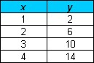
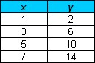

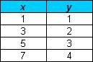
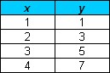
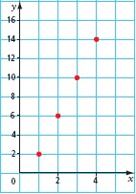

35. Which linear relation matches the graph?
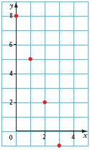
a) y = 3x + 8
b) y = –3x + 8
c) y = 3x – 8
d) y = –3x – 8
Concept 10 :Solving Equations
Beginning | Developing | Accomplished | Exemplary
Does not demonstrate a basic understanding of concept. Substantial errors throughout. | Basic understanding of concepts. Errors and inconsistency reveal some missing understanding of the concepts. | Solid understanding of concepts. Most answers are correct with only a few errors. | Complete and in depth understanding of concepts.

36. What is the solution to x – 2 = 5?

- Which of these equations has the solution a = 3?

- a + 1 = 2

- a + 1 = –2

- a – 1 = 2

- a + 2 = 1

- Jay is painting his cottage yellow with blue trim. He calculates that he needs 5 more cans of yellow than blue. He bought a total of 25 cans at the paint store. Let b represent the number of cans of blue paint. Which equation models this situation?

- b +b + 5 = 25

- b + 5b = 25

- b + 25b = 5

- 5b = 25

Concept 11 :Working with Data
Beginning | Developing | Accomplished | Exemplary
Does not demonstrate a basic understanding of concept. Substantial errors throughout. | Basic understanding of concepts. Errors and inconsistency reveal some missing understanding of the concepts. | Solid understanding of concepts. Most answers are correct with only a few errors. | Complete and in depth understanding of concepts.

- The number of contracts for the Heavy Rock Paving company each month for the past year are shown. What is the mean number of contracts per month?
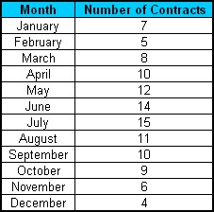

- What is the mode in the above data?

- The lowest value in a data set is 5.6. The range is 3.8. What is the highest value?

- Sunjay received a mean of 70% in mathematics. He recalled that four of his tests had marks of 70%, 72%, 78%, and 68%. What was the mark on the fifth test?

