**Unit 3 – Fluids: Quiz 3a**

/5

You have a couple of garden hoses connected together to water your back yard. Because you're (***as I am***) a physics nerd, you put a gauge where the two hoses connect to each other. The hose ends with your sprinkler. When you put a crimp in the hose to stop water flow, you noticed that the gauge pressure registered 5.00 x103 Pa. ***When you release the crimp what is the velocity of the water flowing out?***

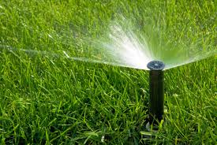

Answer:

