**Fluids: Quiz 2c**

/5

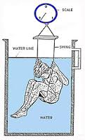

In order to determine an athletics body fat they are often first weighed in air and then again underwater. One such athlete is measured to weigh 720 N in air and then 48 N under water. ***Find the buoyant force acting on her body and find her average density.***

******Answer:

Or order to determine an athletics body fat they are often first weighed in air and then again underwater. One such athlete is measured to weigh 720 N in air and then 48 N under water. ***Find the buoyant force acting on her body and find her average density.***

