**Unit 3 – Fluids: Quiz 1c**

/5

1. 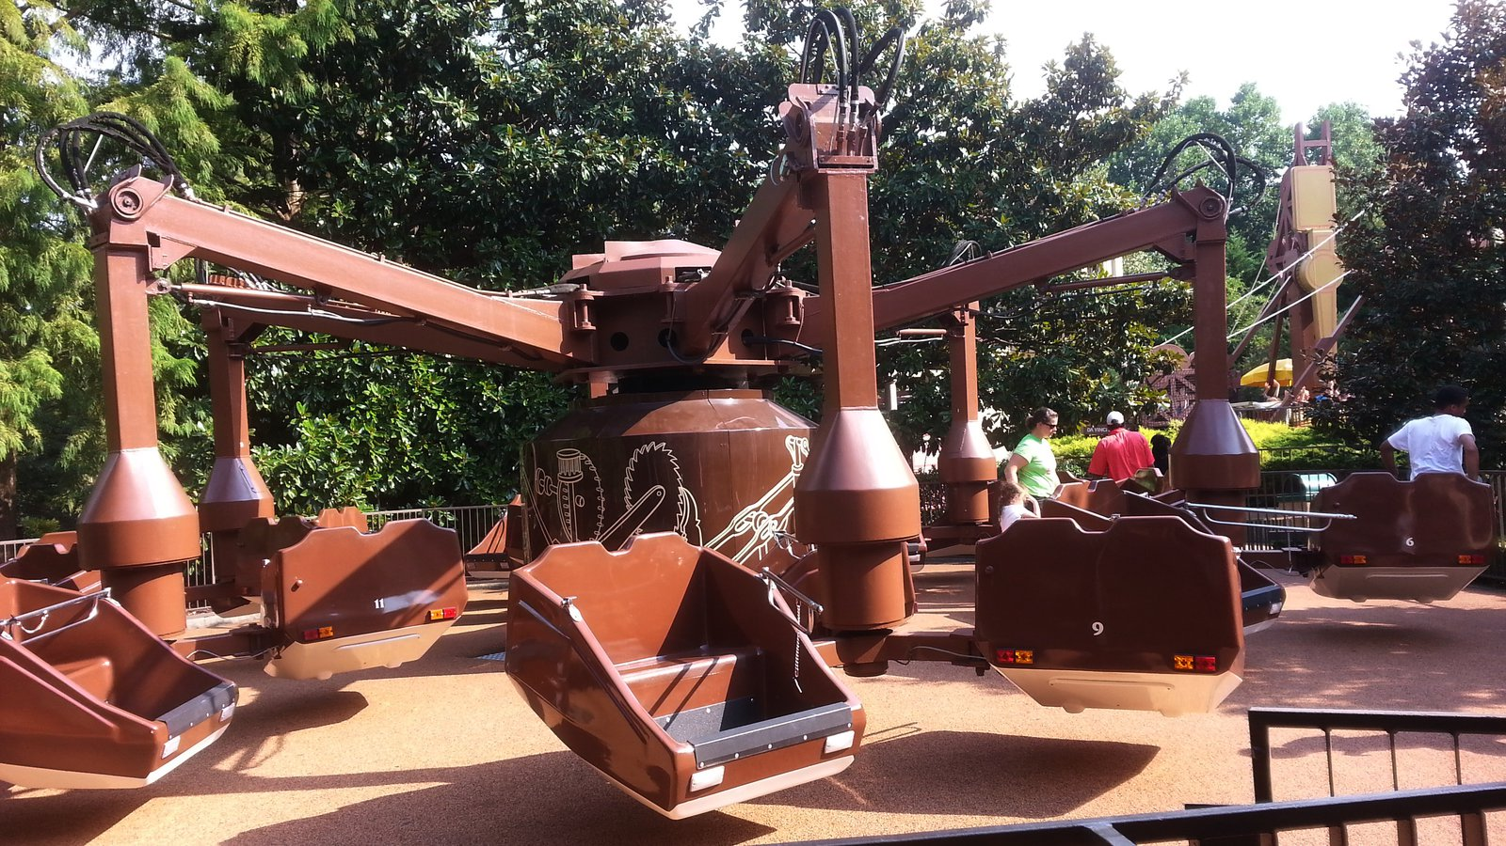One of the best rides at Busch Gardens in Orlando Florida is the Flying Machine. The Flying Machine is lifted by a hydraulic jack. The operator activates the ride by applying a force of 72N to a 45.0 cm2 cylindrical piston, which holds the 20,000N ride off the ground. What is the area of the piston that holds the ride if the process is 90% efficent?
2. A cylinder with a radius of 5.0 cm contains 15 cm of water (1000 kg/m3). Gasoline (760 kg/m3) is then poured on top until the total depth of the liquid is 45 cm. What is the gauge pressure at the bottom of the cylinder.

Answer:

1. One of the best rides at Busch Gardens in Orlando Florida is the Flying Machine. The Flying Machine is lifted by a hydraulic jack. The operator activates the ride by applying a force of 72N to a 45.0 cm2 cylindrical piston, which holds the 20,000N ride off the ground. What is the area of the piston that holds the ride if the process is 90% efficent?





1. A cylinder with a radius of 5.0 cm contains 15 cm of water (1000 kg/m3). Gasoline (760 kg/m3) is then poured on top until the total depth of the liquid is 45 cm. What is the gauge pressure at the bottom of the cylinder.



