Chapter 4 Review
1. Determine the following:
sin 2˚ = _________  sin 10˚ = _________  sin 50˚ = _________  sin 60˚ = _________ | sin 178˚ = __________  sin 170˚ = __________  sin 130˚ = __________  sin 120˚ = __________
cos 2˚ = $____________$  cos 10˚ = _________  cos 50˚ = _________  cos 60˚ = _________ | cos 178˚ = __________  cos 170˚ = __________  cos 130˚ = __________  cos 120˚ = __________

In Summary: For any angle $θ$
sin $θ$ = ______________________
cos $θ$ = ______________________

2. Calculate the value(s) for $∠A$ that satisfy each of the equations listed.
Give your answer to the nearest degree.

a) sin A = 0.6428 __________________________
b) cos A = 0.4226 __________________________
c) sin A = 0.9659 __________________________

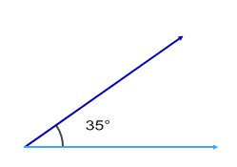
3. Given $∠A=35°$ and $b=20cm$ B
a) Determine the height of the triangle to the
20 cm
nearest tenth of a centimeter.

A

b) Determine and illustrate the number c) Determine and illustrate the number
of triangles that can be drawn if $a=9cm$. of triangles that can be drawn if $a=25cm$

d) Determine and illustrate the number of triangles that can be drawn if $a=15cm$

4. Determine the measure of $∠A$ to the nearest degree.

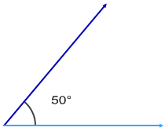
5. Given $∠A=50°$ and $b=20cm$
If $a=17$, determine the number
20 cm
of triangle (zero, one, or two) that
are possible for these measurements.
Draw the triangle(s) to support your
answer. Determine side c and $∠C$.
A

6. Given $∠A=40°$ and $b=15cm$ and $a=13$, determine the number of triangle (zero, one, or two) that are possible for these measurements.

Draw the triangle(s) to support your answer. Determine side c and $∠C$.

