Enbridge Northern Gateway

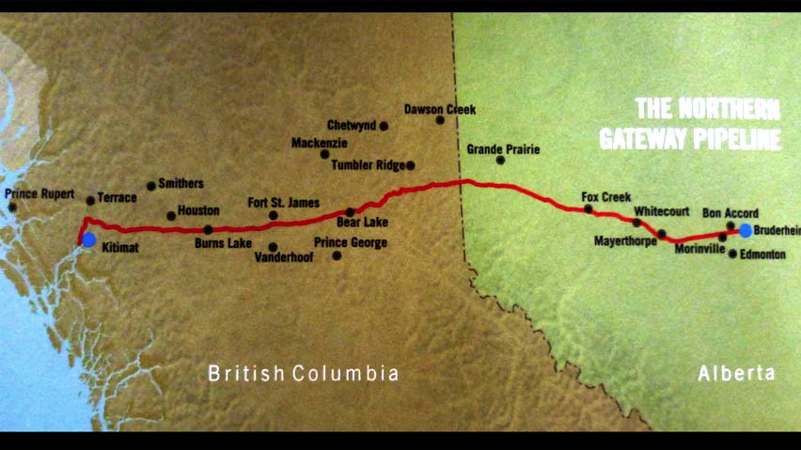

The Enbridge Northern Gateway Pipelines Project is a proposal to construct twin pipeline running from Bruderheim, Alberta, to Kitimat, British Columbia. The eastbound pipeline would import natural gas condensate and the westbound pipeline would export bitumen from the Athabasca oil sands diluted with the condensate to the new marine terminal in Kitimat where it would be transported to Asian markets by oil tankers. The project was proposed in mid-2000s and has been postponed several times. The project would be developed by Enbridge Inc., a Canadian crude oil and liquids pipeline company.
Enbridge claims that the pipeline and terminal, if completed, would provide 104 permanent operating positions created within the company and 113 positions with the associated marine services. First Nations groups, environmentalists and oil sands opponents, among others, denounce the project because of the environmental, economic, social and cultural risks posed by the pipeline. Proponents argue the pipeline would instead provide aboriginal groups with equity ownership, training, employment, Community Trust and stewardship programs. The Douglas Channel that leads into Kitimat and surrounding northwest coast waters pose safety and weather hazards for oil tankers.
The proposal has been heavily criticized by native groups, as the pipeline would traverse much of their traditional lands and threaten habitat for wild salmon. Groups like the Yinka Dene Alliance have been organized to campaign against the project. In December 2010, 66 First Nations bands in British Columbia, including many along the proposed pipeline route, signed the Save The Fraser Declaration in opposition to the project, and 40 more have signed up in support since that time. The proposal is also opposed by numerous non-governmental organizations (NGOs), citing not only Enbridge's spotty history with pipeline installation and numerous spills but also grave concerns over oil sands expansion and the associated risks in transportation.
http://en.wikipedia.org/wiki/Enbridge_Northern_Gateway_Pipelines

The Facts

About the pipeline and tanker project
- Enbridge’s Northern Gateway pipeline would carry over half a million barrels of crude oil per day from the tar sands to the rugged BC coast.
- The proposed pipeline would facilitate tar sands expansion by 30%, Canada’s fasting growing source of greenhouse gas emissions.
- If built, the Northern Gateway pipeline would cross over 1,000 streams and rivers, including the salmon-bearing Fraser and Skeena watersheds.
- The pipeline would bring crude oil tankers to BC’s north coast (where the Great Bear Rainforest is located) for the first time ever.

Public opposition to Enbridge Northern Gateway
- In March 2010, nine Coastal First Nations declared a ban on tanker traffic and promised to do whatever it takes to stop the Enbridge pipeline.
- Over 130 First Nations have signed on to the Fraser Declaration banning tar sands from being transported through their territories.
- According to a 2010 poll, 80 per cent of British Columbians support a ban on oil tanker traffic on BC’s North Coast.
- The Union of BC Municipalities passed two resolutions against Enbridge’s pipeline and tanker project, and potentially impacted municipalities have since passed their own resolutions (including Smithers, Terrace, Masset, Prince Rupert, and Skeena-Queen Charlotte Regional District).
- At Enbridge’s 2009 AGM, former CEO Patrick Daniel stated that he did not want to proceed with a project that is “opposed and of concern to others.” Interestingly, Patrick Daniel retired in February 2012.

Enbridge has a history of environmental damage
- Between 1999 and 2008, Enbridge has had over 610 spills that released approximately 21 million litres (132,000 barrels) of hydrocarbon, the organic compound in oil, gas or bitumn
- In July 2010 they spilled nearly 4 million litres of tar sands into the Kalamazoo River that has yet to be re-opened.
- In 2009, Enbridge had 103 reportable spills, leaks and releases, and 91 spills in 2010.
- In 2009, US affiliate Enbridge Energy Partners agreed to pay $1.1 million to settle a lawsuit brought against the company by the state of Wisconsin for 545 environmental violations. Wisconsin’s Department of Justice, Attorney General J.B. Van Hollen said “…the incidents of violation were numerous and widespread, and resulted in impacts to the streams and wetlands throughout the various watersheds.”
- In 2011, an Inuit hunter in the Northwest Territories came across an oil spill that Enbridge initially claimed was only 4 barrels through a “pin-hole” leak. The spill is now estimated to have spilled over 1,500 barrels of oil¹.

http://forestethics.org/enbridge-the-facts
Using the One World vocabulary words below, list the issues surrounding this controversial topic.
Moral

Ethical

Social

Economic

Political

Environmental

Cultural

