Physics 12 - Lawson NAME ______________________________________
NEWTON’S LAWS Intro - WORKSHEET

I. NEWTON’S FIRST LAW OF MOTION

- Newton’s first law of motion is also known as the LAW OF ______________________________________________.
Newton’s first law says:
An object at rest stays at rest and an object in motion stays in motion with the same speed and in the same direction unless acted upon by an unbalanced force

- What is inertia? _________________________________________________________________________________

- What property of an object determines how much inertia it has? _____________________________________

- Which of the following has more inertia?
  - Bowling ball or Tennis ball
  - Hammer or Feather

II. NEWTON’S SECOND LAW OF MOTION

- Newton’s second law of motion is also known as the LAW OF ___________________________________________.

The acceleration of an object as produced by a net force is directly proportional to the magnitude of the net force, in the same direction as the net force, and inversely proportional to the mass of the object.

- The greater the force that is applied, the ____________________ the acceleration.
- The lesser the force that is applied, the _____________________ the acceleration.
- If the same force is applied to an object with a large mass, it will have a _______________________ acceleration.
- If the same force is applied to an object with a small mass, it will have a _______________________ acceleration.
- The equation that is used to solve second law problems is F = ma.
  - What do each of the variables mean?
F = ______________________ m = _________________________ a = __________________________
  - What unit of measurement must be used with each variable?
F = ______________________ m = _________________________ a = __________________________

III. NEWTON’S THIRD LAW OF MOTION
- Newton’s third law of motion is also known as the LAW OF _______________________________________________.
For every action, there is an equal and opposite reaction.

- Newton’s third law states that forces must ALWAYS occur in ___________________________.
- Listed below are ACTION forces. What is the REACTION force.
  - Your bottom pushing on your desk seat: _______________________________________________
  - A bat hitting a baseball _______________________________________________
  - Your finger pressing on your phone screen while texting _______________________________________________

IV. UNDERSTANDING…..
Label each of the following images/descriptions below as being examples of 1st, 2nd, or 3rd law. Then EXPLAIN your answer!
1st law 2nd law 3rd law
Explanation: ____________________________________________________________________________________________________________________________________________________________________________________________________________________________

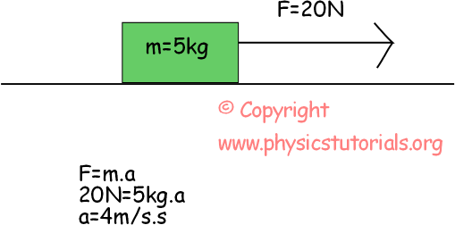

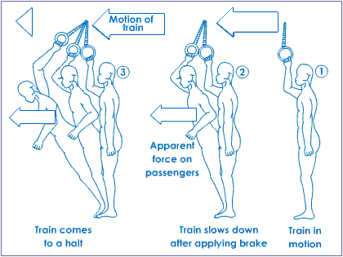
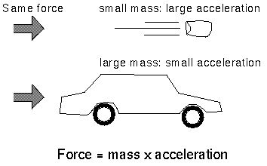
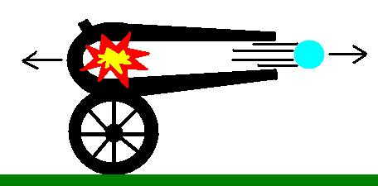
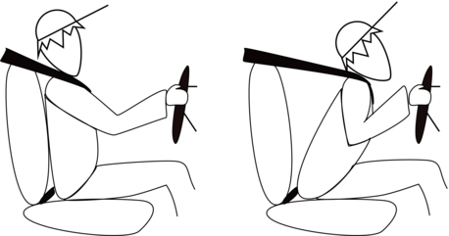
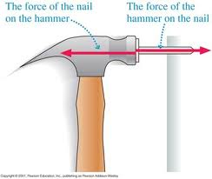
1st law 2nd law 3rd law
Explanation: ____________________________________________________________________________________________________________________________________________________________________________________________________________________________

1st law 2nd law 3rd law
Explanation: ____________________________________________________________________________________________________________________________________________________________________________________________________________________________

1st law 2nd law 3rd law
Explanation: ____________________________________________________________________________________________________________________________________________________________________________________________________________________________

1st law 2nd law 3rd law
Explanation: ____________________________________________________________________________________________________________________________________________________________________________________________________________________________

1st law 2nd law 3rd law
Explanation: ____________________________________________________________________________________________________________________________________________________________________________________________________________________________

