Math 11 A&W – Graphing Analysis Assignment Name: ________________
Name: ________________

Working in pairs you will create the following graphs based on the data provided

All graphs must contain the following:

- Chart Title
- Labeled Axis’s (x and y) with unit where applicable
- Legend
- Correct data on the x and y axis

Create each graph on a separate sheet of the workbook (ask me if you need clarification)

Save the file on a USB I will provide under the following Math11A&WGraphingNameName.xlsx

Chart 1: Vertical Bar/Column Graph

Favorite type of Pizza

Type of Pizza | Frequency
Pepperoni | 15
Hawaiian | 10
Sausage | 7
Vegetarian | 6
Cheese | 4

Chart 2: Broken Line Graph

Facebook Stock Price

Month | Stock Price ($)
May | 29.6
June | 31.1
July | 21.7
Aug | 18.1
Sept | 21.7
Oct | 21.8

Chart 3: Circle Graph

Favorite Types of Movies

Genre | %
Comedy | 27
Action | 18
Romance | 14
Drama | 14
Horror | 11
Foreign | 8
Science Fiction | 8

Chart 4: Triple Bar Graph

Calories, Carbs and Protein of three different Desert

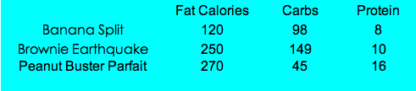

**see me if you need a little help with this one

