Station 1: Graph the Following (shade the feasible region

3x + y – 2 < 0 y < -3x + 7 x > 0 y > 0



Station 2: Graph the Following (shade the feasible region)

y > 3x – 5 y > 1x + 1

y < -2x + 4 2

y < - 1x + 2

3



Station 3: Graph the Following (shade the feasible region)

y > 2x – 1 y < 2x

y < -x + 2 y < 1x + 3

x > 0 2

y > 0 x < 0

y < 0



Station 4: Solve the Following

Baskets of fruit are being prepared to sell.

• Each basket contains at least 8 apples and more than 4 oranges.

• Apples cost 25¢ each, and oranges cost 40¢ each.

• The budget allows no more than $6, in total, for the fruit in each basket.

Graph the solution

a. Variables d. Feasible Region

______________________________________________

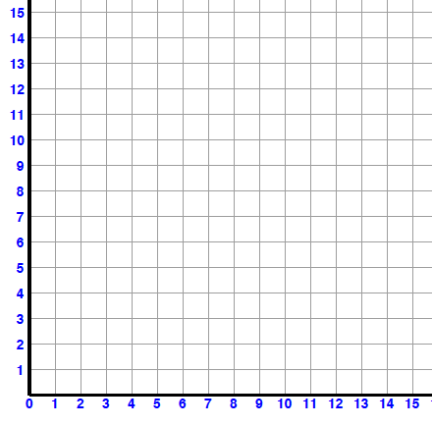______________________________________________

b. Equations

______________________________________________

______________________________________________

______________________________________________

c. Profit Statement

______________________________________________

______________________________________________

Station 5: Solve the Following

A student council is ordering signs for the winter dance. Signs can be made in letter size or poster size. No more than 30 of each size are wanted. No more than 50 signs are needed altogether. Letter-size signs cost $8.75 each, and poster-size signs cost $14.50 each. Graph the solution to find the key points. Find the max.

a. Variables d. Feasible Region

______________________________________________

______________________________________________

b. Equations

______________________________________________

______________________________________________

______________________________________________

c. Profit Statement

______________________________________________

______________________________________________

Station 6: Multiple Choice

1. How would you graph the solution set for the linear inequality *y* + 5*x*  2?

|  |  |
| --- | --- |
| a. | Draw a dashed boundary line *y* = –5*x* + 2, then shade above the line. |
| b. | Draw a solid boundary line *y* = –5*x* + 2, then shade above the line. |
| c. | Draw a solid boundary line *y* = –5*x* + 2, then shade below the line. |
| d. | Draw a dashed boundary line *y* = –5*x* + 2, then shade below the line. |

1. Identify the point of intersection for the following system of linear inequalities.

*y* – 3*x* = 12, *x* + *y* = 0



|  |  |
| --- | --- |
| a. | (3, –3) |
| b. | (1, –1) |
| c. | (–1, 1) |
| d. | (–3, 3) |

1. The following model represents an optimization problem. Determine the ***minimum solution***.

*A* = *y* – 2*x* + 10

|  |  |
| --- | --- |
| a. | (–10, –50) |
| b. | (0, 25) |
| c. | (68, 8) |
| d. | (34, 4) |

1. A vending machine sells juice and pop.

• The machine holds, at most, 200 cans of drinks.

• Sales from the vending machine show that at least 3 cans of juice are sold for each can of pop.

• Each can of juice sells for $1.50, and each can of pop sells for $1.00.

Let *x* represent the number of cans of pop.

Let *y* represent the number of cans of juice.

Which of the following is a constraint of this optimization problem? (one of the equations)

|  |  |
| --- | --- |
| a. | *x* + *y*  200 |
| b. | *x* + *y*  200 |
| c. | 2*x* + *y*  200 |
| d. | *x* + 2*y*  200 |