AW Math 11 Review Booklet
Unit 1: Displaying Numerical Data on Graphs

2.1 Broken Line Graphs

1. A weather observer records, observes, and transmits weather information such as temperature and precipitation levels. Weather observers often work at local airports and provide weather information to government, media, and the public. A weather observer for Banff, AB, obtained the following information on average monthly precipitation there.
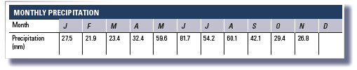
a) Graph this information on a broken line graph.

b) What month would be best for camping? Skiing? Hiking? Justify your choices.
Camping: ___________________________________________________

Skiing: ____________________________________________________

Hiking: ____________________________________________________
c) Use the graph to predict what the average amount of precipitation might have been in December. What assumptions have you made?
________________

___________________________________________________________________

2. Julie started working as a community government assistant housing manager for the city of Brandon, Manitoba, in April of last year. Her boss has been asked to write a report on the average number of people placed in community housing monthly. Julie has been given the task of recording the number of people who have been placed in community housing each month.
a) In which month were the most people placed?
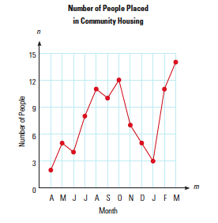
How many people were placed?

___________________

___________________
b) In which month were the fewest people placed? How many people were placed?

___________________

___________________
c) Can you make any prediction about a trend in the number of people placed in community housing, and if so, what would it be?

__________________________________

__________________________________

3. Consider the graph below.
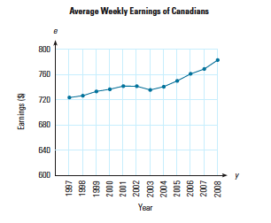
- a) What does the graph tell you?
__________________________________

__________________________________

- b) What were the approximate average weekly earnings of a Canadian during 2003?

- ___________________
- c) Describe the general trend in weekly earnings from 1997 to 2008. Why might this trend exist?
__________________________________

__________________________________

d) How might the way this graph is constructed be misleading?

____________________________________________________________________

2.2 Bar Graphs

4. Ms. Runson posted a graph on her notice board.

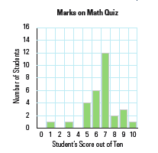
a) What does the graph tell you?

__________________________________

__________________________________

b) How many students wrote a perfect paper?

___________________
c) What was the most common score?

___________________
d) How many students got 0 on the quiz?

___________________
e) How many students wrote Ms. Bunson’s quiz?
___________________

5. Kay saw the following graph displaying graduation rates of boys and girls at three local high schools. She concluded that girls have a better graduation rate than boys and that School B is a much better school based on its graduation rate.

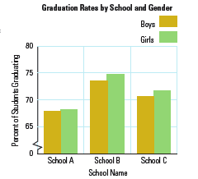
a) Do you agree or disagree with Kay’s conclusions? Justify your response.

__________________________________

__________________________________
b) What are the graduation rates in each school?

School A: Girls ________ Boys ________

School B: Girls ________ Boys ________

School C: Girls ________ Boys ________

2.3 Histograms

6. During the winter, Simone spends every second of her spare time snowboarding. When not on the mountain, she works as the housekeeping manager at a hotel in Nelson, BC. As a manager, Simone is responsible for recording the number of hours the housekeepers work to ensure they are paid the correct amount. During the winter, when business is slower than it is in the summer, the housekeepers work part-time hours. Simone graphs their hours on a histogram on a weekly basis.

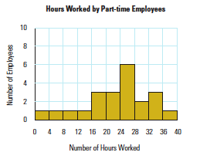
- a) How many people worked less than 16 hours?

- ___________________
- b) What was the most common number of hours worked by the part-time housekeepers?

- ___________________
- c) How many people were working part-time, assuming that Simone recorded the hours for all the housekeepers?

- ___________________

7. Consider the following histogram.

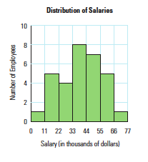
- a) What information does it display?

__________________________________

__________________________________

- b) How many employees earn less than $33 000.00?

- ___________________
- c) What appears to be the highest salary that an employee can earn?

- ___________________

2.4 Circle Graphs

8. Orillia has kept track of the amount of time she spends on different activities throughout the day and has recorded it on the following table.
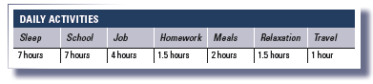
Display the information on a circle graph.

Step 1: To make a circle graph, the first thing you must do is determine the percentage of the day Orillia is involved in each activity.

Step 2: Determine how many degrees of the circle are included in the given percentage. Recall that there are 360 degrees in a circle.

Step 3: Now draw your graph. Draw a circle and use a protractor to determine the number of degrees. Colour each sector a different colour or use a different fill pattern.

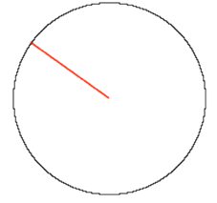

9. Raymond works in the tourism industry. His information shows him that five of the most popular countries for Canadians to visit are Mexico, the United Kingdom, France, Cuba, and the Dominican Republic. The following graph indicates the percentage of visits to each of these countries.
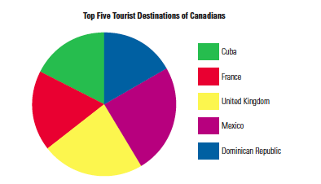

a) Which country is most popular with Canadian tourists?
- ___________________
b) Approximately what percentage of people visiting these countries visited Cuba?
- ___________________
c) This graph indicates the percentage of visits to the various countries. List at least two things you cannot determine from the graph.
- ___________________

- ___________________
10. Marc is the foreman on a construction site. He is concerned that some workers are accidentally injured at work and has prepared the graph below to indicate percentages of workers from each occupation who were injured on the job in the past five years.
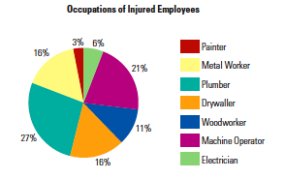

a) If a total of 33 workers were injured, how many of them were electricians?

- ___________________
b) What percentage of the injured workers were painters?

- ___________________
c) Which appears to be the most dangerous job? Can you say this for certain? Why or why not?
- ___________________

- ___________________

___________________________________________________________________

