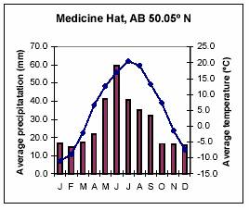
What to study for the Chapter 3 Checkpoint
- Reading a Biome Map
- Climatographs (ppt and temp)

- Factors that affect climate
  - Latitude
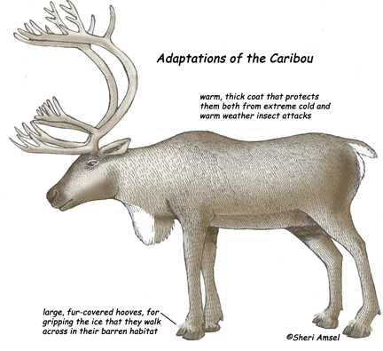
  - Proximity to water
  - Proximity to mountains and elevation

- Adaptations/Natural Selections leading to evolution (over many generations)
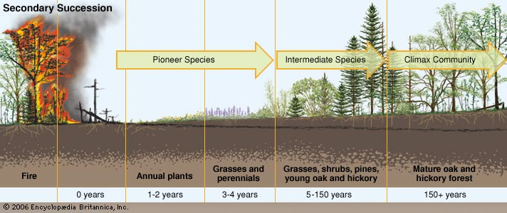
- Succession (prim vs. sec)

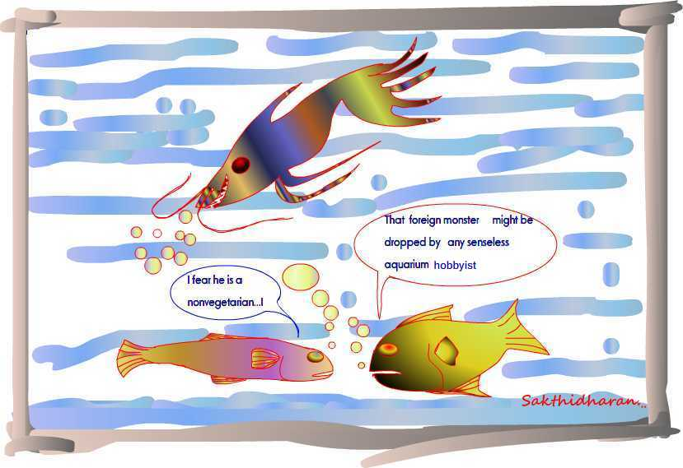
- Foreign/Invasive Species

- Competition

