Math 11 Apprenticeship & Workplace
CHAPTER 7: Personal Budgets

* You’ll be handing in this booklet on test day. Please keep it neat and organized!

Lesson 1: Reviewing Prior Concepts

Employment Income

Gross Income: ______________________________________________________________

Net Income: ________________________________________________________________

Ex. 1: Terry earns a wage of $14.40 per hour. He is paid time and a half for any hours over 40 in a work week. Calculate Terry’s gross pay if he works:

a) 25 hours in a work week

b) 40 hours in a work week

c) 46 hours in a work week

Percent Increase, Decrease, and Compound Interest

Ex. 2: $250.00 is increased by 8%. What is the new value? What if it is decreased by 8%?

Ex. 3: Joe earns $1045.34 for a job. He needs to pay 30% in income tax.

a) What is Joe’s net pay?

b) What percent of the gross pay is his net pay?

Solving Proportions

Ex. 4 Jonathan earns $48 500.00 in 12 months. How much does he earn in 10 months?

PRACTICE

- You earn $12.00 per hour. You are paid time and a half for any hours over 40 in a work week. Calculate your gross pay if you work:

a) 25 hours in a work week

b) 41 hours in a work week

c) 45 hours in a work week

- Amy works at an electronics store and earns a base salary of $1250.00 per month plus 1.5% commission on all sales. Calculate Amy’s gross monthly income in September when she sold $48 000.00 in merchandise.

- $420 is decreased by 30%. What is the new value?

- $1290.00 is increased by 4.5%. What is the new value?

- Jackie’s investment gained 5.25% in value over the past year. One year ago, the investment was valued at $13 550.00. What is the value of the investment now?

- Rich invests $9000.00 earning 6.5% interest per year, compounded annually. Calculate the accumulated amount after:

a) 1 year

b) 3 years

- Solve for x in each proportion:

a) b) c)

- If $340.00 represents 22% of Jill’s monthly income, how much is 15% of her monthly income?

Lesson 2: Preparing to Make a Budget

A budget helps you keep track of what you spend and earn.

- A budget compares expenses to income. A budget can show a:

____________ : income is greater than expenses, or

____________ : income is less than expenses.

- A budget helps you decide where you can reduce spending.
- A budget can help you plan and achieve financial goals.
fixed expenses: a cost that remains the same every month.

variable expenses: a cost that changes from month to month.

recurring expenses: costs that happen over and over
How can you analyze your expenses?

When creating a budget, you need to determine:

- your total expenses
- your fixed and variable expenses
- your total income from all sources.

Ex. 1: In the list below, complete each of the following:
- Circle the fixed expenses.
- Underline the variable expenses.
- Check any recurring expenses.

Car payment Clothing Cellphone Restaurants

Groceries Gas Movies Rent

Video Games Recreation Utilities Gym Membership

Insurance Gifts Vacation Car Repairs

- Which expenses in the above list have priority over the others? List the 5 most important expenses.

Ex. 2: Tiffany is a pharmacy technician. She tracked her expenses and income for a month. She has started a monthly budget. Continue Tiffany’s budget.
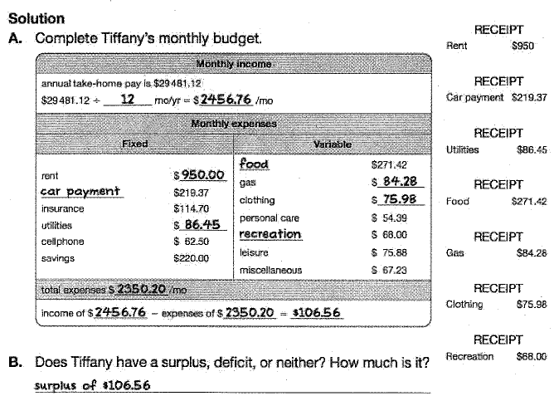
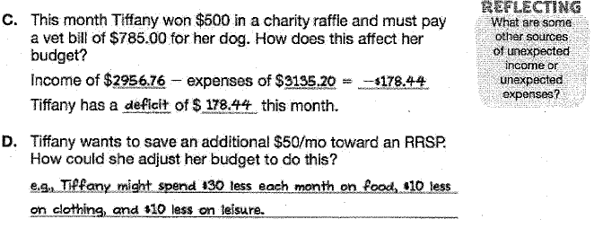

Financial planners say to save by “paying yourself” 10% of your salary each month. Why do you think they suggest this?

Complete BUILD YOUR SKILLS (pg. 309-310) # 1 – 4 on the following page
Lesson 3: The Budgeting Process

Because a budget is mostly based on estimates (since most expenses are ___________________), it is best to plan to have money leftover.

Conservative budget: a budget that underestimates income and overestimates expenses.

Ex. 1: Observe the following record of financial transactions:

Groceries: $300.00 | Transportation:$45.00 | Rent: $800.00
Paycheque: $1150.00 | Clothes: $25.00 | Entertainment: $320.00
Restaurant meals: $80.00 | Paycheque: $1050.00 | Utilities: $65.00
Cell phone: $75.00 | Internet and TV: $115.00 | Savings: $150.00

- How could you use these financial records to create a monthly budget?

- How do you know whether the expenses and income are balanced?

- If the income and expenses are not balanced, what could you do to adjust the budget?

- Do you think a budget based on just these data will be accurate? How could the budget be made more reliable?

We will research an activity together as a class and complete Activity 7.2 on Page 320-321. We will record our information on the following page and make a circle graph.

Our hobby or sport: ___________________________________________________________

Associated fees:

Lesson 4: Analyzing a Budget

Discuss the ideas:
Sylvester and Aisha both live in apartments. Sylvester’s semi-monthly net pay is $950.00 and Aisha’s is $750.00

- Which of them is likely to spend a larger percentage of his or her monthly income on basic needs (housing, food, transportation, clothing)? Explain your reasoning.

- If Aisha completes her training as a pharmacy technician and earns an annual net salary of $22 900.00, by what percentage has her monthly income increased? What are some adjustments she might make to her budget?

- Sylvester is paying off his student loan, which has an annual interest rate of 4.5%. Will he pay it off sooner if he pays $75.00 semi-monthly or $150.00 monthly? How would he budget differently for the two payment methods?

Ex. 1: Jessica’s annual savings are $2750.00 and account for 5% of her net pay. She would like to increase her savings to 12%.

a) How much will Jessica save annually if she makes this change?

b) How much will she save weekly?

c) What is Jessica’s net annual income?

d) Is saving 12% of this net annual income a reasonable amount?

Ex. 2: Michelle works her a landscaping business. Her take-home pay is $420.00 per week. She rents an apartment in a popular location and uses a bicycle and public transit for transportation. Michelle has been tracking her spending and finds that her approximate weekly expenses are:

Rent: $230.00 | Food: $50.00 | Savings: $20.00 | Cell phone: $10.00
Transportation: $10.00 | Debts: $30.00 | Entertainment/other: $70.00

Michelle has researched spending guidelines, shown here:
Donations | 10-15% | Food | 5-15% | Personal | 5-10%
Savings | 5-10% | Transportation | 10-15% | Recreation | 5-10%
Housing | 25-35% | Clothing | 2-7% | Debt payment | 5-10%
Utilities | 5-10% | Medical/health | 5-10%

- What changes would need to be made so that Michelle’s spending is within guidelines?
- What is the maximum amount that Michelle should be spending on rent weekly?
- Show Michelle’s spending on a circle graph.

Complete the Worksheet on the following page

