The 10 weirdest physics facts, from relativity to quantum physics

People who think science is dull are wrong. Here are 10 reasons why.

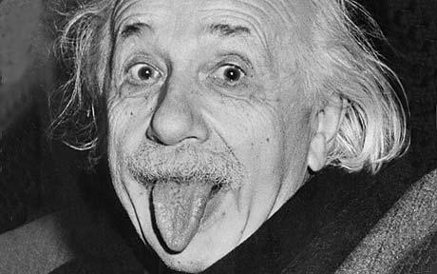

Albert Einstein, who pointed out that the faster you move, the heavier you get Photo: AFP/GETTY By Tom Chivers

Physics is weird. There is no denying that. Particles that don’t exist except as probabilities; time that changes according to how fast you’re moving; cats that are both alive and dead until you open a box.
We’ve put together a collection of 10 of the strangest facts we can find, with the kind help of cosmologist and writer Marcus Chown, author of We Need To Talk About Kelvin, and an assortment of Twitter users.
The humanities-graduate writer of this piece would like to stress that this is his work, so any glaring factual errors he has included are his own as well. If you spot any, feel free to point them out in the comment box below.
Equally, if you feel we’ve missed any of your favourite physics weirdnesses off the list, do tell us that as well.

If the Sun were made of bananas, it would be just as hot

The Sun is hot, as the more astute of you will have noticed. It is hot because its enormous weight – about a billion billion billion tons – creates vast gravity, putting its core under colossal pressure. Just as a bicycle pump gets warm when you pump it, the pressure increases the temperature. Enormous pressure leads to enormous temperature.
If, instead of hydrogen, you got a billion billion billion tons of bananas and hung it in space, it would create just as much pressure, and therefore just as high a temperature. So it would make very little difference to the heat whether you made the Sun out of hydrogen, or bananas, or patio furniture.

All the matter that makes up the human race could fit in a sugar cube

Atoms are 99.9999999999999 per cent empty space. As Tom Stoppard put it: "Make a fist, and if your fist is as big as the nucleus of an atom, then the atom is as big as St Paul's, and if it happens to be a hydrogen atom, then it has a single electron flitting about like a moth in an empty cathedral, now by the dome, now by the altar."
If you forced all the atoms together, removing the space between them, crushing them down so the all those vast empty cathedrals were compressed into the first-sized nuclei, a single teaspoon or sugar cube of the resulting mass would weigh five billion tons; about ten times the weight of all the humans who are currently alive.
Incidentally, that is exactly what has happened in a neutron star, the super-dense mass left over after a certain kind of supernova.

Events in the future can affect what happened in the past
The weirdness of the quantum world is well documented. The double slit experiment, showing that light behaves as both a wave and a particle, is odd enough – particularly when it is shown that observing it makes it one or the other.
But it gets stranger. According to an experiment proposed by the physicist John Wheeler in 1978 and carried out by researchers in 2007, observing a particle now can change what happened to another one – in the past.
According to the double slit experiment, if you observe which of two slits light passes through, you force it to behave like a particle. If you don’t, and observe where it lands on a screen behind the slits, it behaves like a wave.
But if you wait for it to pass through the slit, and then observe which way it came through, it will retroactively force it to have passed through one or the other. In other words, causality is working backwards: the present is affecting the past.
Of course in the lab this only has an effect over indescribably tiny fractions of a second. But Wheeler suggested that light from distant stars that has bent around a gravitational well in between could be observed in the same way: which could mean that observing something now and changing what happened thousands, or even millions, of years in the past.
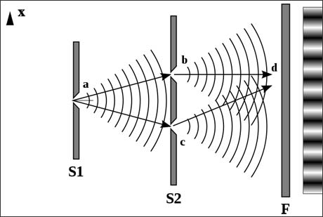

Almost the entire Universe is missing

There are probably more than 100 billion galaxies in the cosmos. Each of those galaxies has between 10 million and a trillion stars in it. Our sun, a rather small and feeble star (a “yellow dwarf”, indeed), weighs around a billion billion billion tons, and most are much bigger. There is an awful lot of visible matter in the Universe.
But it only accounts for about two per cent of its mass.

We know there is more, because it has gravity. Despite the huge amount of visible matter, it is nowhere near enough to account for the gravitational pull we can see exerted on other galaxies. The other stuff is called “dark matter”, and there seems to be around six times as much as ordinary matter.

To make matters even more confusing, the rest is something else called “dark energy”, which is needed to explain the apparent expansion of the Universe. Nobody knows what dark matter or dark energy is.

Things can travel faster than light; and light doesn’t always travel very fast

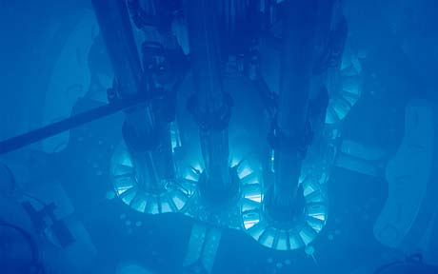

The speed of light in a vacuum is a constant: 300,000km a second. However, light does not always travel through a vacuum. In water, for example, photons travel at around three-quarters that speed.
In nuclear reactors, some particles are forced up to very high speeds, often within a fraction of the speed of light. If they are passing through an insulating medium that slows light down, they can actually travel faster than the light around them.

When this happens, they cause a blue glow, known as “Cherenkov radiation ”, which is (sort of) comparable to a sonic boom but with light. This is why nuclear reactors glow in the dark.
Incidentally, the slowest light has ever been recorded travelling was 17 meters per second – about 38 miles an hour – through rubidium cooled to almost absolute zero, when it forms a strange state of matter called a Bose-Einstein condensate.

Light has also been brought to a complete stop in the same fashion, but since that wasn't moving at all, we didn't feel we could describe that as "the slowest it has been recorded travelling".

There are an infinite number of me’s writing this, and an infinite number of you’s reading it

According to the current standard model of cosmology, the observable universe – containing all the billions of galaxies and trillions upon trillions of stars mentioned above – is just one of an infinite number of universes existing side-by-side, like soap bubbles in a foam.

Because they are infinite, every possible history must have played out. But more than that, the number of possible histories is finite, because there have been a finite number of events with a finite number of outcomes. The number is huge, but it is finite. So this exact event, where this author writes these words and you read them, must have happened an infinite number of times.

Even more amazingly, we can work out how far away our nearest doppelganger is. It is, to put it mildly, a large distance: 10 to the power of 10 to the power of 28 meters. That number, in case you were wondering, is one followed by 10 billion billion billion zeroes

Black holes aren’t black

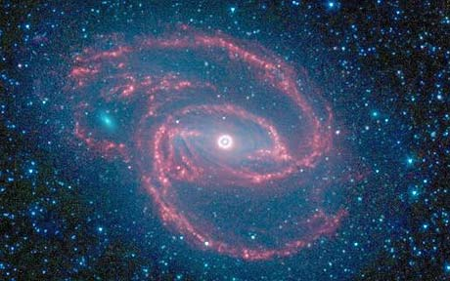

They’re very dark, sure, but they aren’t black. They glow, slightly, giving off light across the whole spectrum, including visible light.

This radiation is called “Hawking radiation”, after the former Lucasian Professor of Mathematics at Cambridge University Stephen Hawking, who first proposed its existence. Because they are constantly giving this off, and therefore losing mass, black holes will eventually evaporate altogether if they don’t have another source of mass to sustain them; for example interstellar gas or light.

Smaller black holes are expected to emit radiation faster compared to their mass than larger ones, so if – as some theories predict – the Large Hadron Collider creates minuscule holes through particle collisions, they will evaporate almost immediately. Scientists would then be able to observe their decay through the radiation.

The fundamental description of the universe does not account for a past, present or future

According to the special theory of relativity, there is no such thing as a present, or a future, or a past. Time frames are relative: I have one, you have one, the third planet of Gliese 581 has one. Ours are similar because we are moving at similar speeds.

If we were moving at very different speeds, we would find that one of us aged quicker than the other. Similarly, if one of us was closer than the other to a major gravity well like the Earth, we would age slower than someone who wasn’t.
GPS satellites, of course, are both moving quickly and at significant distances from Earth. So their internal clocks show a different time to the receivers on the ground. A lot of computing power has to go into making your sat-nav work around the theory of special relativity.
A particle here can affect one on the other side of the universe, instantaneously

When an electron meets its antimatter twin, a positron, the two are annihilated in a tiny flash of energy. Two photons fly away from the blast.

Subatomic particles like photons and quarks have a quality known as “spin”. It’s not that they’re really spinning – it’s not clear that would even mean anything at that level – but they behave as if they do. When two are created simultaneously the direction of their spin has to cancel each other out: one doing the opposite of the other.
Due to the unpredictability of quantum behaviour, it is impossible to say in advance which will go “anticlockwise” and the other “clockwise”. More than that, until the spin of one is observed, they are both doing both.

It gets weirder, however. When you do observe one, it will suddenly be going clockwise or anticlockwise. And whichever way it is going, its twin will start spinning the other way, instantly, even if it is on the other side of the universe. This has actually been shown to happen in experiment (albeit on the other side of a laboratory, not a universe).

The faster you move, the heavier you get

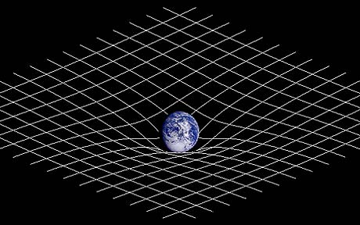

If you run really fast, you gain weight. Not permanently, or it would make a mockery of diet and exercise plans, but momentarily, and only a tiny amount.

Light speed is the speed limit of the universe. So if something is travelling close to the speed of light, and you give it a push, it can’t go very much faster. But you’ve given it extra energy, and that energy has to go somewhere.
Where it goes is mass. According to relativity, mass and energy are equivalent. So the more energy you put in, the greater the mass becomes. This is negligible at human speeds – Usain Bolt is not noticeably heavier when running than when still – but once you reach an appreciable fraction of the speed of light, your mass starts to increase rapidly.

