Human Resources Canada faces 4 lawsuits over lost data

Names, birthdates, loan balances and social insurance numbers of 583,000 people missing

CBC News

Posted: Jan 22, 2013 9:27 AM ET

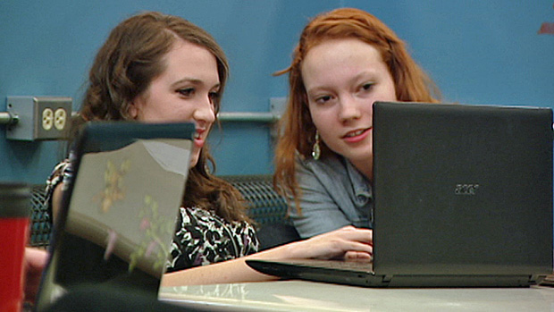More than 40,000 students who went to the University of Windsor alone took loans between 2000 and 2006, the years affected by the lost information. (CBC News)

A trio of Canadian law firms is the latest to launch a multi-million-dollar, class-action lawsuit on behalf of nearly 600,000 people whose personal data was lost by Human Resources Canada.
Strosberg Sutts, Strosberg LLP in Windsor, Ont., along with Branch Macmaster LLP of Vancouver and Falconer Charney LLP of Toronto have jointly opened the case.
Similar suits have been launched in Newfoundland, Ottawa and Calgary.
Last November, a portable hard drive vanished from Human Resources Canada. It contained personal information about 583,000 people who received Canada Student Loans between 2000 and 2006.
Names, birthdates, loan balances and social insurance numbers went missing. Personal contact information for 250 HRSDC employees is also missing.
The government said no banking or medical information was on the hard drive.

Punitive damages
The suit filed by the trio of firms seeks $600 million in compensation. That's approximately $1,000 per person affected by the loss.
"Borrowers may be entitled to compensation for the breach of their privacy, damages for identity theft and/or damages to their credit reputation, damages for the costs incurred to prevent identity theft, damages for the time spent changing your personal information such as your Social Insurance Number, damages for emotional distress/inconvenience, and/or compensation for out of pocket expenses," reads a message on Branch Macmaster's website. "Punitive damages will also be claimed because the Government failed to disclose the breach of privacy for two months."
The data went missing on Nov. 5, 2012, but the public wasn't notified about the incident until Jan. 11 of this year.
More than 40,000 students who went to the University of Windsor alone took loans between 2000 and 2006, the years affected by the lost information. At St. Clair College, also in Windsor, at least 10,000 students took out OSAP loans during that time.
Lindsay Gyori is a former student from Windsor and worries about identity theft.
"I have no control over who that person is or what that person might do with my information, so it is alarming," she said. "And now I have to make modifications to my life in terms of monitoring all of my accounts and information to make sure that the transactions that have gone through are through me only."

People urged to get credit checks
Meanwhile, St. John's lawyer Bob Buckingham filed a statement of claim Jan. 17 on behalf of all the affected Canadians.
Buckingham said a lawsuit would push the government to cover credit protection safeguards for the affected Canadians and compensate them for the stress and fear of those involved.
A spokeswoman for Human Resources and Skills Development Canada said people can ask the government to request a free credit report from a credit bureau be mailed to them, and can also ask that their social insurance number be flagged in the event unusual activity is noted. Neither of these options will provide real-time credit updates, however.
Canada's assistant privacy commissioner, Chantal Bernier, said the loss of so much personal data is "unprecedented," adding that her office is investigating the incident.
"This is one of the biggest breaches we've ever seen," Bernier told CBC News last week.

