How Teens Can Become Millionaires

Disciplined saving early in life will reap millions … literally!
from daveramsey.com on 12 Mar 2010

As you approach adulthood and start to think about your future, are you really ready to be financially responsible for yourself? If you answered no, you’re not alone. The Jump$tart Coalition administered a basic financial literacy test to high school seniors, and less than half of the students correctly answered the questions. Another study found that over 75% of college students believe they are not ready to make smart financial decisions for themselves.

Pretty scary, isn’t it? If you think about it, most of your friends probably don’t know how to balance a checkbook. In fact, very few teens actually have a savings account or know what long-term investing means. Do you?
A 2009 Capital One survey discovered that 50% of teens wished they knew more about personal finances. Whether you have never stepped foot in a bank or you are actively saving and investing for your future, all it takes is a little effort and a lot of patience to become confident in your financial decisions.

A Millionaire’s Best Friend

One awesome thing that you can take advantage of is compound interest. It may sound like an intimidating term, but it really isn’t once you know what it means. Here’s a little secret: compound interest is a millionaire’s best friend. It's really free money. Seriously. But don’t take our word for it. Just check out this story of Ben and Arthur to understand the power of compound interest.

Ben and Arthur were friends who grew up together. They both knew that they needed to start thinking about the future. At age 19, Ben decided to invest $2,000 every year for eight years. He picked investment funds that averaged a 12% interest rate. Then, at age 26, Ben stopped putting money into his investments. So he put a total of $16,000 into his investment funds.
Now Arthur didn’t start investing until age 27. Just like Ben, he put $2,000 into his investment funds every year until he turned 65. He got the same 12% interest rate as Ben, but he invested 23 more years than Ben did. So Arthur invested a total of $78,000 over 39 years.

When both Ben and Arthur turned 65, they decided to compare their investment accounts. Who do you think had more? Ben, with his total of $16,000 invested over eight years, or Arthur, who invested $78,000 over 39 years?
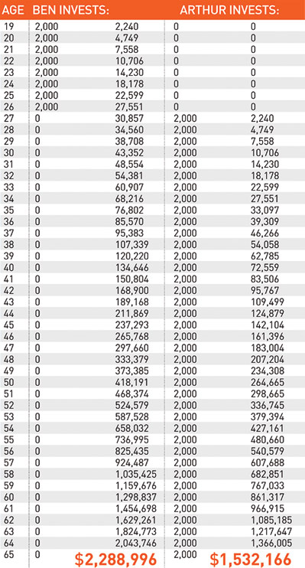
Believe it or not, Ben came out ahead … $700,000 ahead! Arthur had a total of $1,532,166, while Ben had a total of $2,288,996. How did he do it?

Starting early is the key. He put in less money but started eight years earlier. That’s compound interest for you! It turns $16,000 into almost $2.3 million! Since Ben invested earlier, the interest kicked in sooner.

What You Can Do Now

The trick is to start as soon as possible. A survey by Charles Schwab found that 24% of teens believe that since they are young, saving money isn’t important. Looks like we just blew that theory out of the water! That same survey also discovered that only 22% of teens say they know how to invest money to make it grow. Why not change that stat and learn how to become a smart investor with your money? Talk to your parents or teachers about how to open up a long-term investment account so you can become a millionaire, too. And remember, waiting just means you make less money in the end. So get moving!

